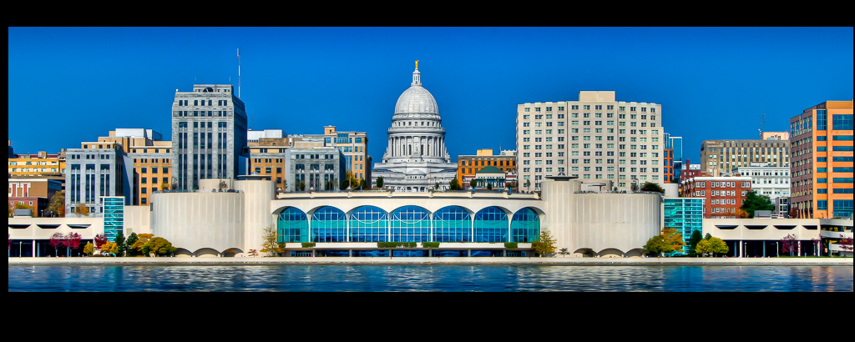
DOA-DPM
2017
SAAIP Report

Prepared
Department of Administration-Division of Personnel Management
101 East Wilson, 4th Floor, Madison, WI 53707

by
The Division of Personnel Management
Bureau of Equity and Inclusion

2017 SAAIP

With a focus on historically underrepresented workforce populations, the Summer Affirmative Action Internship Program (SAAIP) provides students with practical on-the-job experience, training, and exposure to the state’s workforce.

Since the inception of the program in 1974, the objective and commitment to students, agencies, and diversity have remained solid. The Bureau of Equity and Inclusion (BEI) constantly seeks ways to improve our outreach and overall program to ensure a productive and great experience for all participating entities.

The Division of Personnel Management (DPM) is dedicated on the outreach and recruiting of students for state employment. Through active promotions at college career fairs, interactions with student organizations and university inclusion offices, the pool of applicants has been filled with talent. Amending our recruitment process and incorporating the state’s Wisc.Jobs website has enhanced the experience for all involved.

DPM thanks and applauds the efforts and participation of all agencies that opened their doors and provided great opportunities and mentorship to the cohort of 2017 interns. In 2017, we had interest from nearly 700 students. The amount and variety of positions sponsored by the state agencies continue to grow and to be the driving force of SAAIP.

The program received 648 applicants, up 30% from 2016 (499). Ultimately, the total number of eligible applicants filtered to 485, still 38% higher than the 2016 total (351). The following pages contain the summary of the 2017 SAAIP participant demographics.

2017 SAAIP Metrics:
Eligibility
Eligible Applicants Ethnicity
Black | 110
Asian | 50
Native Amer. | 3
Hispanic | 40
White | 243
Undisclosed | 39
Total | 485

To be eligible to participate in the SAAIP, you must be a student enrolled at a 2 or 4 year college/university.

Persons Ineligible Ethnicity
Black | 38
Asian | 23
Native Amer. | 1
Hispanic | 9
White | 76
Undisclosed | 10
Total | 163

Contributors to the “persons ineligible” total for 2017 consisted of:
* Incomplete application - No Student Status Verification form and or no resume submitted

Eligible Applicants by Gender
Women | 316
Men | 153
Undisclosed | 16
Total | 485

Applicants
Total Headcount of Applicants for 2017
Black | 101
Asian | 52
Native Amer. | 4
Hispanic | 30
White | 265
Unknown | 47
Total | 648

Hires

Hires by Ethnicity Head Count
Black | 12
Asian | 14
Native Amer. | 1
Hispanic | 4
White | 44
Undisclosed | 3
Total | 77

Hires Head Count by Gender
Women | 48
Men | 26
Undisclosed | 3
Total | 77

Colleges and Universities Statistics

*This is a view of the top Twenty-two colleges and universities that the pool of applicants represented in 2017.

School | Headcount of Hires
UW Madison | 21
UW Milwaukee | 12
Other | 10
Madison Area Technical College | 10
UW Whitewater | 4
UW Stevens Point | 3
UW Stout | 2
UW Platteville | 2
UW LaCrosse | 2
Marquette University | 2

Agencies and Positions

Agency
Department of Administration
Department of Corrections
Department of Employee Trust Funds
Department of Health Services
Department of Justice
Department of Military Affairs
Department of Natural Resources
Department of Public Instruction
Department of Revenue
Department of Workforce Development
UW Colleges and Extension

Positions

The 2017 internships offered a wide variety of opportunities for interns. We had over 100 positions offered across the state. For the year, 77 positions were filled. The gap between what was offered and what was eventually filled can mostly be explained by cancelled positions due to budget concerns.

2017 Sample of Positions
Engineering
Human Resources Assistant
IS Comprehensive Support Technician
Natural Resources Program Assistant- Bureau of Water Quality- Wastewater
Program and Policy Analyst
Program Operations Associate
Social Worker
Special Events Intern
Trust Fund Assistant

Summary

The 2017 SAAIP was a successful campaign. The overall satisfaction obtained through our feedback survey was 4.2 out of 5.0. Below are other results of our evaluation:
 |  |  | Satisfaction with SAAIP agency form | Communication With BEI Staff | Referral Process | Timeline Process | SAAIP Seminar | Overall Satisfaction
Average Response Score |  |  | 4.0 | 4.0 | 4.1 | 3.9 | 3.7 | 4.2

The applicant web portal, Wisc.Jobs.org continues to be a strong and vital component to the process and the success. The successes of 2017 reside in continued growth in application diversification and applicants from various colleges and universities.
The ineligible rate continues to decrease, which translates into increased applicants to refer and make part of the selection and hire process. Below are our trends by ethnicity over the past 4 years which illustrates our growth.

The 2018 SAAIP process will begin again in October with recruiting and soliciting applications of positions from agencies. Through collaboration and technology innovation, DPM-BEI is determined to continue to look for opportunities and strategies to improve SAAIP.
We look forward to continuing our mission to bring diverse talent to the State of Wisconsin agencies while providing an up-close view and hands on work experience to students.

