Division of Personnel Management
Contact:
Department of Administration,
Division of Personnel Management
101 East Wilson Street, 4th Floor
P.O. Box 7855
Madison, WI 53707-7855

Website: http://dpm.wi.gov
Telephone: (608) 266-9820

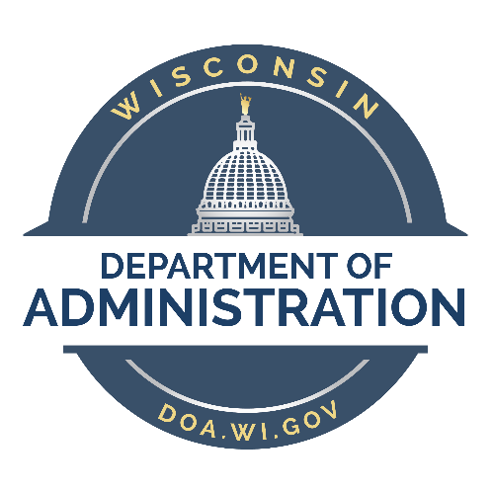

State Council on Affirmative Action Report

January 1, 2017 – December 31, 2017

July 2018

This report summarizes the Council’s activities and highlights during 2017 and covers the annual diversity awards.

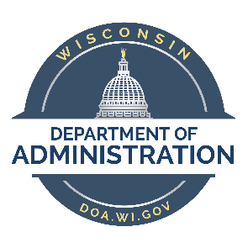 | STATE OF WISCONSIN  DEPARTMENT OF ADMINISTRATION  Scott Walker, Governor  Ellen Nowak, Secretary  Gregory L. Gracz, Division Administrator

June 2018

The Honorable Scott Walker Governor, State of Wisconsin

The Honorable Roger Roth President, Wisconsin Senate

The Honorable Robin J. Vos Speaker, Wisconsin Assembly

Gentlemen:

I am pleased to present to you the January 1, 2017 – December 31, 2017 annual report for the State Council on Affirmative Action. The Division of Personnel Management, (DPM) is required under s. 15.017(3) Wis, Stats. and s. 230.46 Wis. Stats. to prepare a report summarizing the Council’s activities and highlight the 2017 annual diversity awards.

The Council’s mission is to foster progress towards an equitable and diverse workforce in state government and the University of Wisconsin system. Its efforts complement the mission of Division of Personnel Management (DPM), Bureau of Equity and Inclusion to promote innovative human resources leadership and strategic direction.

I look forward to a continued working relationship with the Council as we serve the citizens of our great State.

Sincerely,

Ellen Nowak Gregory L. Gracz
Secretary Administrator

TABLE OF CONTENTS

State Council on Affirmative Action (SCAA) Mission……………………. |  | 1
SCAA Membership……………………………………………………………………… |  | 2
Message from the SCAA Chair……………………………………………………. |  | 3
Activity Highlights………………………………………………………………………. |  | 4
- Council Meeting Summary – May 2, 2017
- Council Meeting Summary – June 17, 2017
- 18th Annual Diversity Awards – October 2017
Goals for the SCAA…..…………………………………………………………………. |  | 6
Staff Services to the SCAA….………………………………………………….……. |  | 7

Attachments: 2017 Diversity Awards and Ann Lydecker Award Submissions

SCAA MISSION

The State Council on Affirmative Action was created by Chapter 196, Laws of 1977,
s. 230.46, Wis. Stats., describes the duties of the Council as follows:

“The council on affirmative action shall serve in a direct advisory capacity to the Administrator and as part of that relationship shall evaluate the progress of affirmative action programs throughout the civil service system, seek compliance with state and federal regulations and recommend improvements in the state’s affirmative action efforts as an employer. In carrying out its responsibilities, the council may recommend legislation, consult with agency personnel and other interested persons, conduct hearings and take other appropriate action to promote affirmative action. The council shall report at least once per year to the governor and the legislature.”

The Council’s overall purpose is to foster measurable progress towards an equitable and diverse work force in state government.

SCAA MEMBERSHIP

“There is created in the division of personnel management in the department of administration a council on affirmative action consisting of 15 members appointed for 3-year terms. A majority of members shall be public members and a majority of members shall be minority persons, women, or persons with disabilities, appointed with consideration to the appropriate representation of each group. The president of the senate, the speaker of the assembly, the minority leader of the senate, and the minority leader of the assembly each shall appoint one member and the remaining members shall be appointed by the governor.” s. 15.107(3) Wis.
Stats.

Members of the State Council on Affirmative Action from January 1, 2017 – December 31, 2017:

Shiva Bidar – Sielaff  Chief Diversity Officer  UW Health  Alenka Dries  Equal Opportunity Program Specialist  State of Wisconsin - Department of Revenue  Fabiola Hamdan, MSSW  Dane County Community Senior Social Worker  Joining Forces For Families  Joni Mathews  HR Dir. DMA/Brigadier General  Wisconsin National Guard  Patricia Matthews  Vice President – Acquisition Market Manager  First Citizens Bank | Lisa Mortenson  Equal Opportunity Program Specialist–Senior  State of Wisconsin – Department of Health Services  Adin Palau  Recruitment Manager  University of Wisconsin – Madison  Corinda Rainey-Moore  Wisconsin Council on Children and Families  Outreach and Engagement Coordinator  Nia Trammell, Esq.  Administrative Law Judge  Office of Worker's Compensation Hearings

Message from SCAA Chair, Adin Palau

January 2018

Through the last four decades, the State Council on Affirmative Action has served as a preeminent vehicle to promote an equitable and diverse workforce in state government. In 2017, the Council reestablished functions with new council members. Our new members come from diverse professional backgrounds and sectors, their unique perspectives and experiences enrich the functions of our council greatly.

Our Council continues to foster the relationship with the Affirmative Action Advisory Councils (AAAC) and the Bureau of Equity and Inclusion to provide strategic direction and support the statewide efforts to enhance Wisconsin’s workforce, remove barriers to work, and meet the state’s current and future workforce needs.

We continue to seek ways to promote the promising practices that move our state forward. On October 26, 2017, we celebrated the 18th Annual Diversity Awards. This ceremony afforded us the opportunity to recognize state agencies, technical colleges and UW campuses for diversity program achievements. Honorees this year included the Department of Health Services for their contributions to the recruitment, retention and promotion of a diverse workforce, and Milwaukee Area Technical College for increasing opportunities for eligible students who want to attend college and prepare for a career.

One of our goals for 2018 is to create engagement opportunities with private, nonprofit and public-sector leaders from across the state to generate strategic initiatives to sustain Wisconsin’s competitiveness through the lenses of equity and inclusion.

We will be aiming to take a fresh look at how our state can produce and attract the talent needed to sustain our elevated levels of growth, and ensure that Wisconsin remains a national leader in job creation, labor force participation, and equity and inclusion practices.

SCAA ACTIVITY HIGHLIGHTS

Council Meeting – May 2nd, 2017

BEI staff provided updates, which included the overview of DPM, BEI, and function of the Council/ BEI.

The Council discussed outreach strategies to increase agencies and universities participation in the Diversity Awards program. The Council approved the selection of the officers of the Council. The process will be to Self-nominate or nominate those who may have interest in Roles

The 2017 Diversity Award program was discussed, the submissions received for the year, tentative dates of the program, and updates to the annual Diversity Award Honors publication.

Council Meeting – June 17, 2017

The Council discussed the process for initially screening the Diversity Award submissions. BEI staff provided updates, which included the overview of DPM, BEI, and function of the Council/ BEI.

The Council received an update on submissions received for Diversity and Ann Lydecker Awards.

Diversity Awards

- 18th Annual Diversity Awards – October 2017

The 18th annual Diversity Awards ceremony was held on October 26, 2017 at the State Capitol, Senate Parlor Room in Madison. The Council established the Diversity Award program in 2000 to recognize the achievements of outstanding affirmative action and equal employment opportunity practices among state agencies and University of Wisconsin system campuses.

The honors are awarded as follows: The Diversity Award is given to the highest ranked agency; the Ann Lydecker Award is given to the highest ranked university.

Eleven agencies and universities submitted programs for consideration for the 18th annual awards. They included:
  - Department of Health Services
  - Department of Tourism
  - Department of Transportation
  - Milwaukee Area Technical College
  - Moraine Park Technical College
  - Northcentral Technical College
  - University of Wisconsin – Eau Claire
  - University of Wisconsin – Milwaukee
  - University of Wisconsin – Oshkosh
  - University of Wisconsin – Stout
  - University of Wisconsin – Whitewater

The Diversity Award was awarded to the Department of Health Services (DHS) for its Milwaukee enrollment Services (MilES) program. The Pathways to Leadership Program supports the department efforts to recruit, retain and promote a diverse workforce.
Deputy Secretary, Tom Engels accepted the award for DHS.

The Program Achievement Award was awarded to the Department of Health Services (DHS) for its Southern Wisconsin Center – RCT Recruitment Initiative. This program supports the recruitment of resident care technicians and ensures sustainable strategies to retain talent. Deputy Secretary, Tom Engels accepted the award for DHS.

The Ann Lydecker Educational Diversity Award was awarded to Milwaukee Area Technical College (MATC) for its Promise Program. This program creates opportunities for eligible students who want to attend college and prepare for a career. The award was accepted by President Vicki Martin.

The Program Achievement Award was awarded to Milwaukee Area Technical College (MATC) for its Re-entry Program, this program offers education and training for at-risk learners and Re-entry individuals. The award was accepted by President Vicki Martin.

GOALS FOR SCAA

Continue to monitor and evaluate affirmative action progress for universities and state agencies.

- Continue to develop and strengthen the working relationship with agency and university affirmative action officers and affirmative action advisory committees.

- Continue follow-up discussions with state EEO/AA Officers to ensure that proper leadership and support is available to perform job description functions.

- Further increase the number of universities and state agencies participating in the diversity award process.

- Increase council membership.

- Recommend legislation to promote affirmative action.

STAFF SERVICES FOR THE SCAA

Staff services to the Council are provided by the Division of Personnel Management, Bureau of Equity and Inclusion, 101 East Wilson Street, 4th Floor, Madison, Wisconsin 53707-7855. Staff include:

Delores Butler, (email: delorese.butler@wisconsin.gov) Jeanette Johnson, (email: jeanette.johnson@wisconsin.gov)

Inquiries regarding this report can be addressed to:

Jeanette Johnson
Director
Bureau of Equity and Inclusion jeanette.johnson@wisconsin.gov

