

***Wisconsin State Government careers in***

**Healthcare**

*Want to use your skills to really make a difference?*

*Help us reinvent the way government serves the people.*

We Need You

**benefits of state employment**

* Certified Nursing Assistants
* Medical Assistants
* Licensed Practical Nurses
* Registered Nurses
* Nursing Supervisors
* Respiratory Therapists

Delete text and place photo here.

Paid Time Off: start with **over 6 weeks** of paid time off and earn more with years of service.

Insurance: health, life, dental, and more types of coverage.

Retirement: Well-funded pension through Wisconsin Retirement System.

And More: student loan forgiveness, employee reimbursement accounts, flex scheduling, promotional and transfer opportunities, education and training, and commuter benefits.

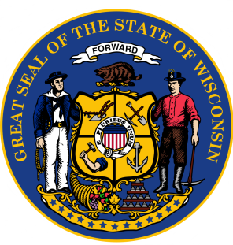

More information: [wiscjobs@wisconsin.gov](mailto:wiscjobs@wisconsin.gov) | [https://wisc.jobs](https://wisc.jobs/)

Wisconsin State Government employs over 3,600 healthcare staff in multiple facilities across Wisconsin.

We offer work/life balance, opportunities for career growth, and the chance impact our citizens and veterans.

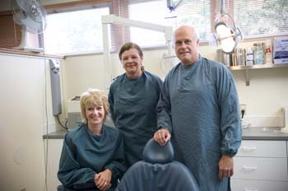



*Find your next job at*