

***Wisconsin State Government careers in***

**Information Technology**

*Want to use your IT skills to really make a difference?*

*Help us reinvent the way government serves the people.*

We Need You

**benefits of state employment**

* Web/App Developers
* Security Analysts
* Software Architects
* PeopleSoft ERP Developers
* Database Admins
* Mainframe Admins
* Network Admins

Delete text and place photo here.

* Graphics/Multimedia
* Customer Service Reps
* Telecommunications
* Server Technicians
* IT Procurement
* Business Analysts
* Project Managers
* IT Managers

Delete text and place photo here.

Paid Time Off: start with **over 6 weeks** of paid time off and earn more with years of service.

Insurance: health, life, dental, and more.

Retirement: Well-funded pension through Wisconsin Retirement System.

And More: student loan forgiveness, employee reimbursement accounts, flex scheduling, promotional and transfer opportunities, education and training, and commuter benefits.



More information: [wiscjobs@wisconsin.gov](mailto:wiscjobs@wisconsin.gov) | <https://wisc.jobs/>

Wisconsin State Government employs over 1300 IT staff in multiple locations across Wisconsin.

We offer work/life balance, opportunities for career growth, and the chance to work on huge, unique, cutting edge projects.

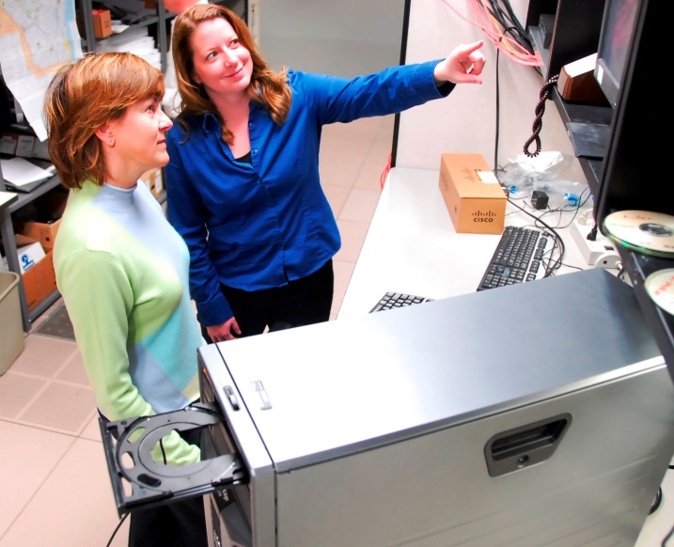



*Find your next job at*