Ways to Improve Recruitments: Starting with the Job Post
- Take your standard post and:
  - Keep It Short. Shorter job posts (1-300 words) receive 8.4% more applications per view than average (McLaren, 2019). Use clear, direct language that is easy for candidates to scan. Don’t list redundant or obvious qualifications like “must be able to prioritize work to meet deadlines” or make an exhaustive list of every possible task (LinkedIn Talent Solutions, n.d.).
    - Consider a link to the Position Description (PD)
    - Make sentences manageable by staying concise

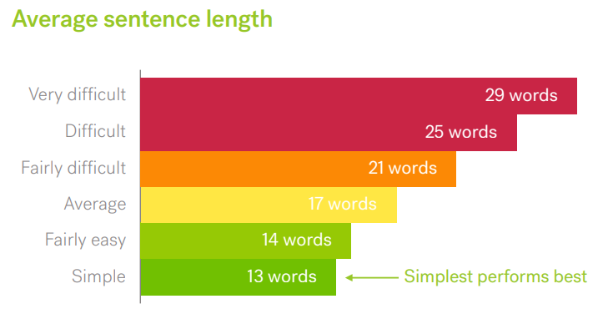
Figure 1: Average Sentence Length (Textio, 2020)

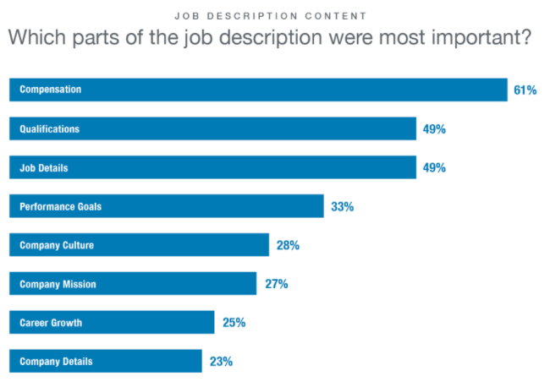
    - Focus on what matters: qualifications and job details. i.e., paint a picture of the job
Figure 2: Job description content (McLaren, 2019)
  - Keep it real. Tone of job posts should match the agency’s culture. As a government agency, a casual job post might come across as unprofessional. The tone should give candidates an authentic feel for the atmosphere at your agency.

  - Be mindful of the words you use. Nip gender-coded job descriptions in the bud and stay ahead of trending language.
    - Masculine-coded words and phrases like aggressive, dominant, outspoken, and rock star and feminine-coded words like collaborate, compassion, and interpersonal (Gaucher, Friesen, & Kay, 2011)
    - Tools - Gender Decoder

  - Save culture for later by adding a few highlights.
    - 27% of candidates will use your website to discover insights into your culture. Make sure they complement each other.
    - Research what employees say about working at your agency and reflect those values.

  - Emphasize Opportunity
    - Applicants want to earn respect, to create and achieve something and to contribute
    - Many people want to learn from their work
    - Weave in the opportunities your agency provides to their staff

  - Be Optimistic. Phrases like opportunity to innovate and a chance to learn and improve have a positive tone.

  - Arouse Emotions
    - People crave stories of triumph, connection and compassion
    - Stories add a human element to your job post
    - Include a statement about commitment to diversity to create a sense of belonging. Emphasize why diversity matters and not rely on generic language.
Example: We serve the people of Wisconsin and hire great people from a wide variety of backgrounds. Not only because it is the right thing to do, but because it makes our agency stronger.
  - Stress Strengths
    - Everyone wants to work for a winner
    - Ferret out the agency’s strengths and incorporate them into your posts

- Use industry-standard or recognizable job titles

- Make a recruitment video–great way to give candidates a sense of what working at your agency is like and what the mission and values are.

- Promote on Mondays and don’t have the deadline on Sunday.

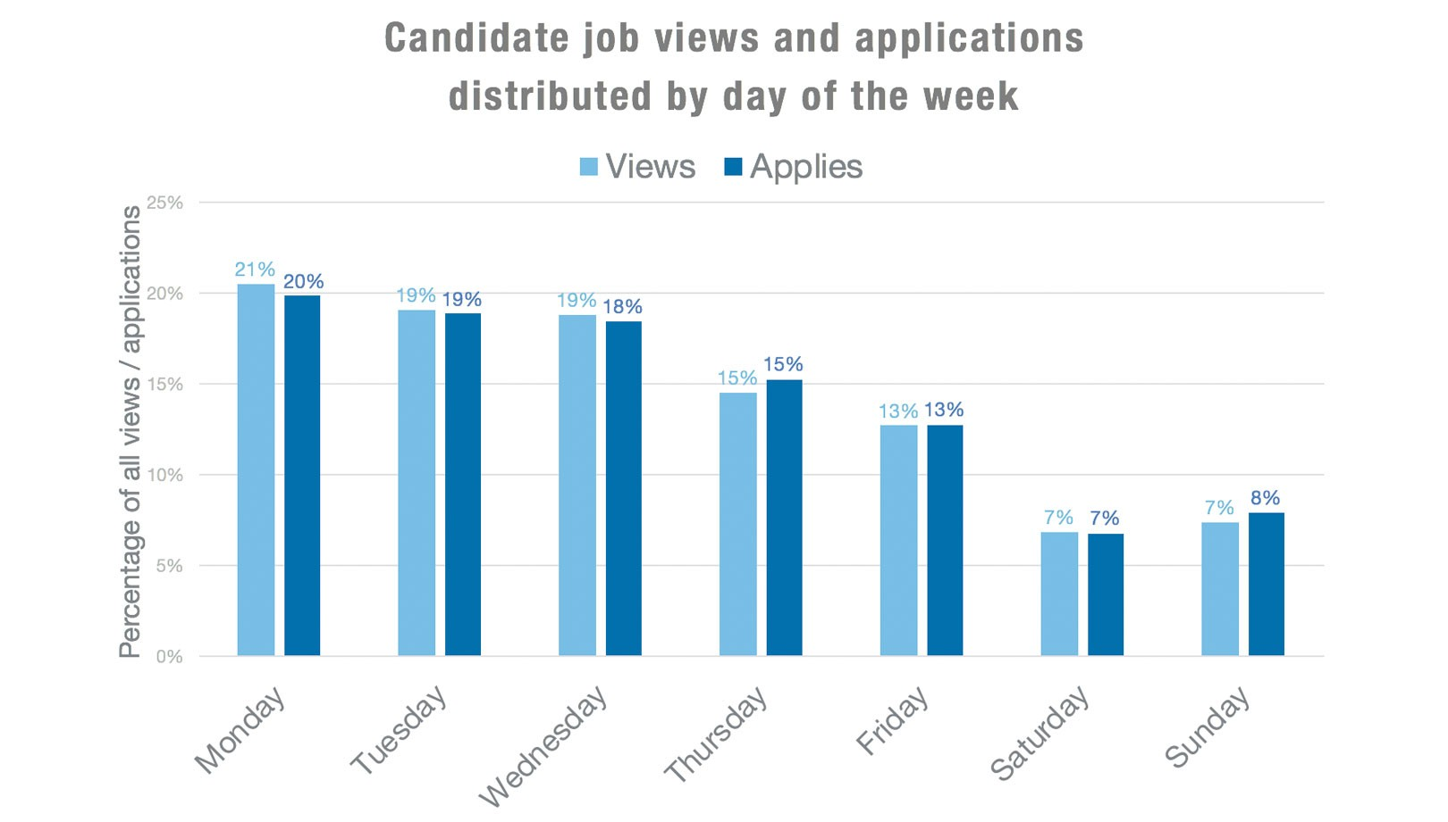
Figure 3: Job views and applications (McLaren, 2019)

Year | Monday | Tuesday | Wednesday | Thursday | Friday | Saturday | Sunday | Grand Total
2021 | 19.45% | 17.18% | 16.30% | 15.78% | 12.69% | 7.84% | 10.76% | 100.00%
2022 | 20.36% | 17.35% | 16.34% | 14.60% | 12.06% | 7.45% | 11.84% | 100.00%
2023 | 21.30% | 17.54% | 16.82% | 15.72% | 12.09% | 6.43% | 10.10% | 100.00%
Grand Total | 20.46% | 17.37% | 16.50% | 15.30% | 12.23% | 7.19% | 10.94% | 100.00%
Figure 4: Wisc.Jobs application volume by day of week

