Frequently Asked Questions
Q: Does Wisconsin Department of Employee Trust Funds (ETF) collect only the tax on the dollar amounts of unsubstantiated claims?
A: No, ETF collects the dollar amount of the unsubstantiated claims accordingly to federal regulations.
Resources:
    - Unsubstantiated Claims Recovery Process document on the Optum Financial ETF employee microsite (www.myoptumfinancial.com/etf) > 2022 Plan Year Unsubstantiated Claims Information section (on the Home page)
    - Unsubstantiated Recovery Process Guide - State of WI Unsub Claims Process (optum.com)

Q: In what ways can participants provide Optum Financial with their substantiation?
A: Participants can substantiate their 2022 unsubstantiated claims online, on the mobile app, or via fax and mail through run-out, March 31, 2023. They may also mail in repayment.
- Online portal at www.myoptumfinancial.com/etf
- Mobile app: Optum Financial
- Fax: 443-681-4601
- Mail using the Employee Reimbursement Account Claim Form: Claims Department, P.O. Box 622317, Orlando, FL 32862-2317
- Mail for providing repayment: Repayment Department, P.O. Box 872168, Kansas City, MO 64187-2168

Q: What if a participant makes a payment during the period of the payroll withholding?
A: If a participant makes a payment during payroll withholding, payroll withholding will not stop. Any overpayments will be refunded by Optum Financial to the participant in late April/early May 2023. Your employer is not able to stop 2023 payroll withholding once a participant has provided substantiation or repayment for the claim(s).

Q: Can someone substantiate a claim after payroll withholding?
A: Yes, participants can substantiate claims after payroll withholding has started; however, payroll withholding will not stop. Your employer is not able to stop 2023 payroll withholding once a participant has provided substantiation or repayment for the claim(s).

Q: Why are overpayments refunded in late April/early May when a participant has resolved their 2022 unsubstantiated claims?
A: Optum Financial processes 2022 substantiated claims against payroll withholding after the runout period closes. This allows for Optum Financial to accurately refund any overpayments to participants in late April/early May 2023.

Q: Do participants need to send in a form with their substantiation or repayment?
A: No, a form is not necessary; however, participants must submit the following along with their substantiation or repayment: ▪ Claim ID ▪ Dollar Amount ▪ Participant Name.
This will allow Optum Financial to apply the repayment to the appropriate claim.

Q: Are there any financial hardship exceptions that allow for future payroll withholdings not to take place?
A: Participants should reach out to their Payroll/Benefits Specialist if they are experiencing financial hardship.

Q: If funds are being withheld by the payroll centers during runout, why is Optum Financial allowing participants to repay the claim or provide substantiation after December 31st?
A: ETF’s plan design must allow a runout period. This allows participants until March 31st of the following plan year to substantiate and repay prior year’s claims.

Q: If the participant did not receive an email or letter about their unsubstantiated claim where can they learn more?
A: Optum Financial ETF employee microsite (www.myoptumfinancial.com/etf) > 2022 Plan Year Unsubstantiated Claims Information section (on the Home page)
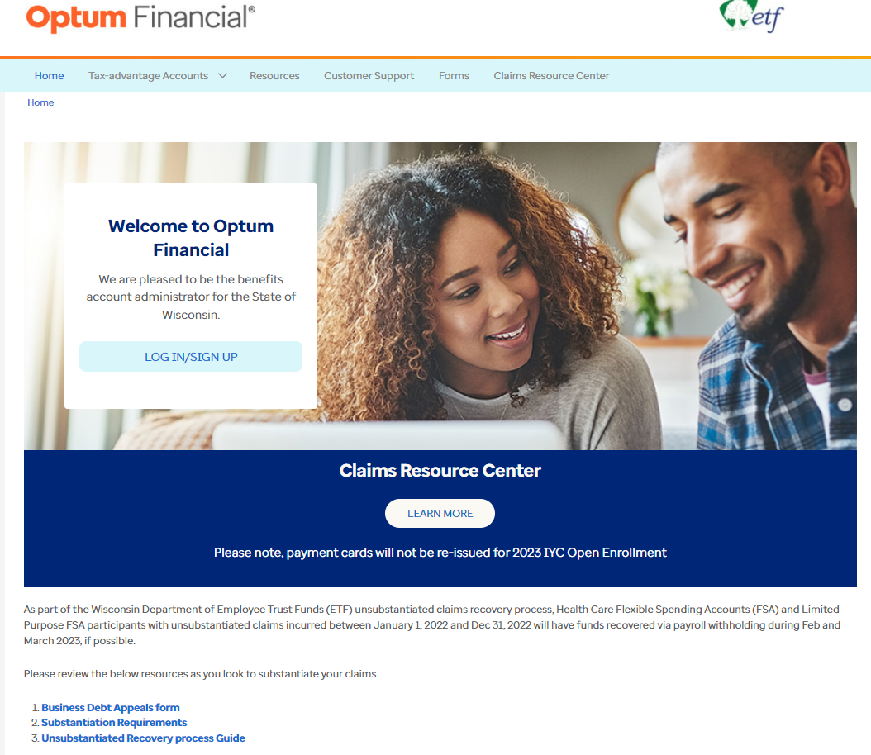

- Business Debt Appeals Form - Debt Appeal (optum.com)
- Substantiation Requirements - SubstantiationRequireForm_StateOfWI (optum.com)
- Unsubstantiated Recovery Process Guide - State of WI Unsub Claims Process (optum.com)

If the participant wishes to provide their feedback on unsubstantiated claims, they can reach out to Wisconsin Department of Employee Trust Funds at 877-533-5020.

