Contents
Applicant Notification Expectations: 1
Notify Ineligible Applicants 2
Notify Eligible Applicants 4
Where do all the notifications go? 5
Applicant Disposition and Corresponding Status 5
Applicant Notification Templates 6

Applicant Notification Expectations:
- Ineligible Applicants: Send a reject notification to applicants that did not pass initial assessment. Use the “send correspondence” feature within TAM to send correspondence to all applicants at a rejected status (see attachment).

- Eligible Applicants: Send a notification to applicants that have made the register to advise them that they are eligible for further consideration.

- Non-Selected Certified Applicants and Non-Selected Registrants: After a hire is made, send a non-select notification to all registrants (do not exclude registrants that were not certified or that were certified but not interviewed). This communication should be delivered only after the job offer has been accepted and the hire has been made.

Notifications for continuous recruitments should be pushed out to applicants when eligibility is determined. If there are multiple review dates or applicants are reviewed as they come in, notifications should be sent in a timely manner after those application materials are evaluated.

Note: WHRH Chapter 212 addresses sending notification to certified applicants that were not selected. This has created situations where some applicants (on the register, but not certified) did not receive a non-select letter. This guidance is intended to ensure that all applicants receive a final notice of their eligibility.

Notify Ineligible Applicants
- Go to the Applicants Tab of the job opening

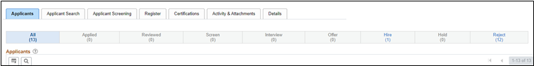

- Select all non-selected applicants and click on Group Action – Recruiting Actions – Reject Applicant
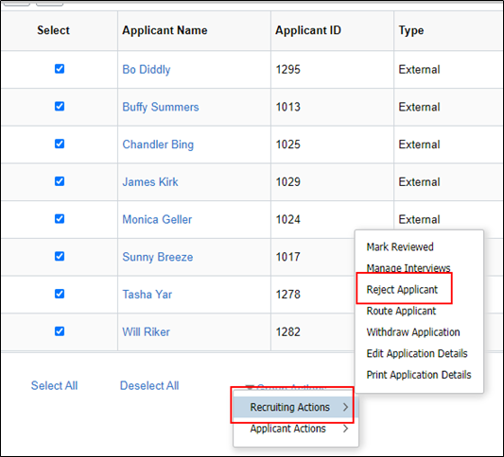

- All applicants selected will display
- Select the applicable reason; if after initial screening, select Ineligible – Basic Eligibility; if after post-certification steps, such as interviews, select Not Selected
- Click Reject and Correspond
- Applicant information automatically populates in Recipient Information, and you can enter the email message and preview.

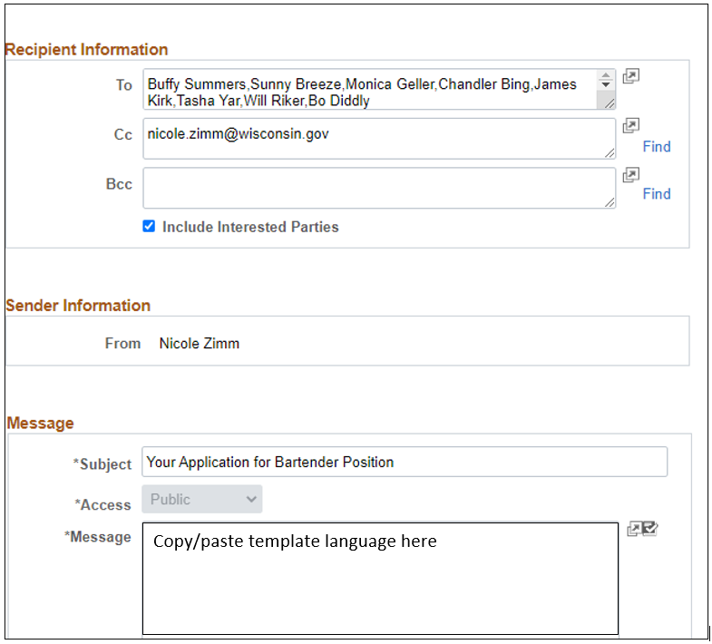

Notify Eligible Applicants
- Create the register. See the Registers job aid for details.
- Email the registrants.
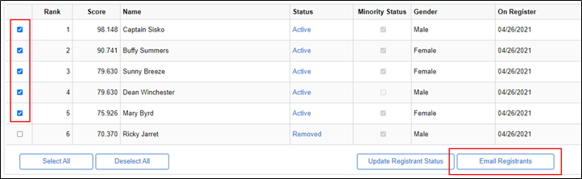

- You will be brought to the Send Correspondence page.
- The applicants who will receive the message will be listed at the top of the page (you can also click on the spreadsheet icon to download the list).
- Enter the Subject and Message. Please note this message is plain text but you can include links.

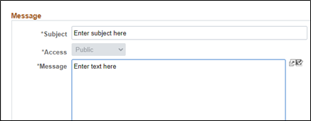

- Add any applicable attachments by clicking Add Attachment and uploaded the document(s).
- Click Preview to review your message before sending.
- Click Send once you are ready to send the message.
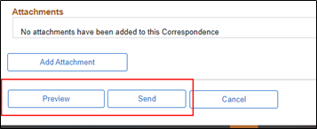

Where do all the notifications go?
- All correspondence sent to Applicants can be accessed from the Applicants Tab
- Click on the Applicant’s Name to access the Manage Applicant page and go to the Notes tab
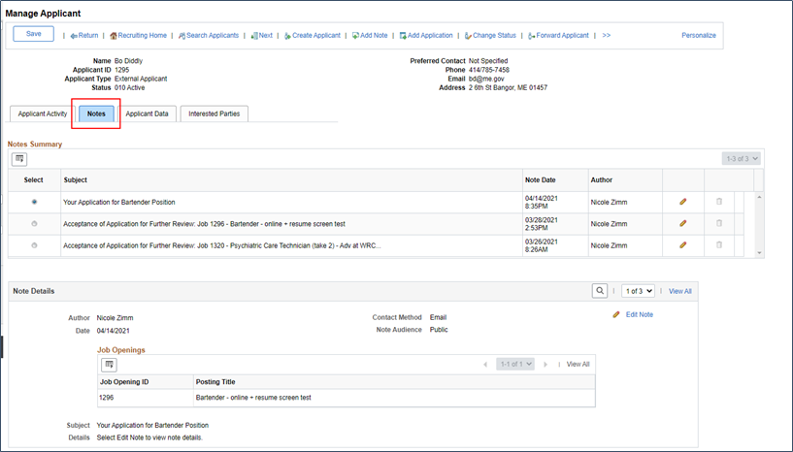

Applicant Disposition and Corresponding Status
As the applicant Disposition is changed in the job opening, the applicant’s Application Status will change in the My Job Applications section of their account. A complete list of Dispositions and corresponding Applicant Statuses is outlined in the Candidate Application Status job aid.

Applicant Notification Templates

Notification for Ineligible Applicants – those that did not pass the assessment

Subject: Not Eligible for Further Consideration [Job ID / Title of Job Posting]

Thank you for your interest in employment with the State of Wisconsin. After a review of your application materials, it has been determined that you are not eligible for further consideration in the selection process for this position.

At this time, there is no further action you need to take.

Although you are not eligible for this position, we encourage you to continue to pursue opportunities with the State of Wisconsin.

Regards,
[Name]
[Title]
[Email / Phone]

Notification for Eligible Applicants – those on the Register

Subject: Eligible for Further Consideration [Job ID / Title of Job Posting]

Thank you for your interest in employment with the State of Wisconsin. Your application materials have been reviewed and you were deemed eligible for further consideration.

You will be contacted again only if you are invited to participate in the next step of the selection process.

If you do not receive a second email right away, understand you are still under consideration and should not withdraw your application because you may be contacted in the near future if more interviews are needed.

No further action is needed at this time.

Regards,
[Name]
[Title]
[Email / Phone]

Notification for Non-Selected Applicants (Recruitment Closed / Offer Accepted) – those on the Register

Subject: Non-Select Notification for [Job ID / Title of Job Posting]

We have concluded the selection process and have chosen another candidate that best meets the needs of the position.

Although you were not chosen for this position, we encourage you to continue to pursue opportunities with the State of Wisconsin.

Regards,
[Name]
[Title]
[Email / Phone]

