

Administrative Sabbatical Election Process
Job Aid REV. 10/2/2026

Version History
Version 1 Date 12/14/18 Editor Stacie Happel Description Initial Release
Version 2 Date 10/26/20 Editor Brenda Williams Description 2020 Annual Update
Version 2.1 Date 10/30/20 Editor Brenda Williams Description 2020 Annual Update – Additional Sections Added
Version 3 Date 10/15/21 Editor Brenda Williams Description 2021 Annual Update
Varion 3.1 Date 11/15/21 Editor Brenda Williams Description 2021 Annual Update – Additional Sections Added
Version 3.2 Date 12/14/21 Editor Brenda Williams Description 2021 Annual Update – Additional Sections Added
Version 3.3 Date 1/4/22 Editor Brenda Williams Description 2021 Annual Update – Additional Sections Added
Version 4 Date 10/18/22 Editor Brenda Williams Description 2022 Annual Update
Version 5 Date 10/3/23 Editor Brenda Williams Description 2023 Annual Update
Version 6 Date 10/3/24 Editor Brenda Williams Description 2024 Annual Update
Version 7 Date 9/26/25 Editor Brenda Williams Description 2025 Annual Update
Version 8 Date 10/2/26 Editor Brenda Williams Description 2026 Annual Update

Table of Contents
NOTES 2
CLARIFICATIONS 3
SEC 704.060 PRORATION SUMMARY 4
REQUESTING A CHANGE TO SABBATICAL ELIGIBILITY AMOUNTS 5
ENROLLMENT PERIOD THROUGH EMPLOYEE SELF SERVICE 6
AUTOMATED EMAIL ANNOUNCEMENT OF ELIGIBILITY – EMPLOYEE MESSAGING 7
ENTERING SABBATICAL ELECTIONS AFTER THE ESS PERIOD HAS CLOSED 8

CHANGING SABBATICAL ELECTIONS AFTER THE ESS PERIOD HAS CLOSED …………………………………………….…………………………...…….11

REVIEWING SABBATICAL ELECTIONS…………………….………………………………………………………………………………………………………….…..…..…12

REVIEWING FOR INELIGIBLE SABBATICAL ELECTIONS…………………………………………………………………………………………………………..…...…13

REQUESTING A SABBATICAL ELECTION AFTER THE LAST PAY PERIOD OF THE YEAR HAS CONFIRMED.……………………………………….…16
TRC USED FROM PAYABLE TIME TO CALCULATE ELIGIBLE HOURS …………………………………….…………………………………………………..…17
SABBATICAL and CASHOUT ELIGIBILITY………………………………………………………………………………….……………………………………………………20
QUERIES……………………………………………………………………………………………………………………………………………………………………………..….…23
WI_ABS_SABB_PRELIM_ELIG
WI_ABS_SABB_FINAL_ELIG
WI_ABS_SABBATICAL_ELECTIONS
WI_ABS_SABBATICAL_NO_ELECTIONS

Role:
Agency Payroll and Benefits Specialist
Notes:
- What is Sabbatical Leave? Annual leave which was deferred during the year earned to be used in a subsequent year to extend the annual leave, unless used for termination leave. (s. ER 18.01(7), Wis. Adm. Code.)
- The Sabbatical Eligibility amounts (hours) in HCM/STAR lists employees who are eligible to convert unused annual leave (vacation) hours to sabbatical and/or cash pay elections. The amounts are finalized each year as of the October B payroll per the DOA Central Payroll Calendar. For 2026 it is PP2026B21.
- It is recommended that all Sabbatical elections are entered by the employee through Employee Self Service (ESS).
- The system will not allow the employee to make an election in ESS for more than the current annual leave (vacation) balance. If the annual leave balance drops below the election amount the Sabbatical event will process at the lower annual leave balance. The Cash pay election amount will take priority over the Sabbatical election amount.
- If an election needs to be changed, and the ESS Sabbatical election period is still open, the employee can cancel their original Sabbatical election (WI_SABBTCL_ELECT) made in ESS using the Cancel Absences tile and then enter a new election in the Sabbatical tile.
- There is no approval needed for the Sabbatical elections. The sabbatical and/or cash pay elections will process in the last bi-weekly pay period of the calendar year (normally PP26) and will be included on the employee’s final calendar year check.
- If an election needs to be entered or changed after the ESS enrollment period has closed, the agency payroll must make the entries through the Create and Maintain screen in HCM/STAR. (See instructions below.)
- If employees need to use unanticipated leave after the Sabbatical process has been finalized (PP01 thru 12/31) and don’t have sufficient annual leave balances, they should enter sabbatical for the leave time. Agencies Payroll should not key manual absence adjustments to swap balances. Sabbatical balance will be increased the evening we finalize PP26.
- Low Exception: The Sabbatical Election shows as a Saturday absence, employees that have a work schedule on Saturdays will have a low exception on their timesheet if their sabbatical election exceeds their scheduled hours. You may simply ignore this exception.
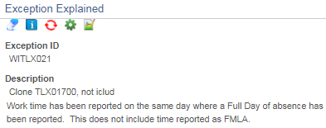
Clarifications:
- For policy refer to Wisconsin Human Resources Handbook Chapter 704 Annual Leave Options.
  - Permanent and Project Crafts workers are not eligible to convert annual leave to sabbatical/termination leave.
  - Weekend Classification workers are not eligible to convert annual leave to sabbatical/termination leave.
- The eligible sabbatical cash amount is up to 40 hours, not to exceed either the leave option hours generated at the 200 hr. or 216 hr. annual leave accrual rates for the calendar year; or the unused annual leave balance. Cash-out payments are paid using base hourly rate (add-on pay not included), are not reported as retirement earnings, and may be taxed up to 22%.
  - Effective as of 2025, The cash-out payments shall be based on an employee’s base pay rate as of the last day of the bi-weekly pay period that is associated with the last paycheck dated on or before December 31 of the calendar year for which the option is taken. This will be bi-weekly pay period 26 except for the years with 27 bi-weekly pay periods.
- In 2022 the Sabbatical process was enhanced so the Eligible Sabbatical Hours calculated in STAR are now based on actual hours in pay status up to 80 hours in a pay period through October B + the estimated hours for the remaining pay periods (through PP26) based on their FTE as of the October B payroll.*
  - October B payroll based on the DOA Central Payroll Calendar. Oct B is either PP21 or PP22. If PP21 then the calculation is PP1 – PP21 + the estimated hours for the remaining 5 pay periods (PP22-PP26). Or, if Oct B is PP22 then the calculation is PP1 – PP22 + the estimated hours for the remaining 4 pay periods (PP23-PP26).
- In 2022 agencies no longer need to adjust for LWOP, FTE changes, or part-time employees working above their FTE. We also programmed the system for employees who have an anniversary that moves them to a new Sabbatical Factor mid-year, so that all eligible paid hours in that pay period would be calculated at the new Sabbatical Factor.
- In 2023 we implemented the following changes:
  - The Actual Hours Paid are being pulled from the Payable Time instead of from the Absence Time.
  - We were able to program the system to split the actual hours within the anniversary pay period by prior to/on-after anniversary date using both Sabbatical Factors in the calculation. This gives us the correct eligible hours under each Sabbatical Factor. For employees with more than 80 hours in that pay period, the system counts the actual hours on/after the anniversary date first, and then any remaining hours up to 80 hours from the prior to anniversary date eligible hours.
- In 2024 we have implemented the following change to the 520-hours of sick leave option. The 40 eligible sabbatical hours will be prorated for “part-time” employees based on their actual hours in pay status for the year, regardless of their actual FTE status. This means an employee in a 1.0 FTE position, that is in pay status less than 2080 hours, will receive a pro-rated portion of the 40 hours.
  - DPM policy has simplified their “interpretation” of the proration rules. All eligible sabbatical hours (40, 60, 80 and 120) will be prorated as described above*. Only employees in pay status, 2080 hours or more, receive the full eligible sabbatical hours, with no proration.
- The WI SABBSICK BAL field on the Results by Calendar Group screen in HCM/STAR tracks the employee’s eligible sabbatical sick leave balance based on an annual update after the October B pay period processes. An employee who attains a 520-hour WI_SICK_BAL for the first time midyear but drops below the required sick leave balance when sabbatical eligibility is determined when October B pay period processes, WILL NOT be eligible under the sabbatical 520-hour sick leave option.
  - Once an employee has become eligible for the sabbatical 520-hour sick leave option, their balance shown as WI SABBSICK BAL field on the Results by Calendar Group screen will not be reduced even if their sick leave balance drops below the sick leave hour requirement in the future. The employee will remain eligible for the 520-hour sick leave option until they become eligible for another sabbatical leave option, if they remain in a position that is eligible for this provision.
- An employee has a break in service and is rehired mid-year with sufficient continuous service or sick leave balance to be eligible for the Sabbatical Election in the year of rehire.
  - Since the system now bases the eligible sabbatical leave hours on actual paid hours up to 80 hours in a pay period this employee’s eligible sabbatical hour will calculate correctly in the year of rehire.
- An unclassified employee that becomes classified for the first time must serve an original 6-month classified position and may not use annual leave during that time except to use annual leave previously accrued in the unclassified or UW position.
  - DPM has determined, the employee may put annual leave into the sabbatical account, because banking the annual leave in sabbatical is not “taking” the annual leave under ER 18.02(3). The term/sabbatical options under ER 18.03(5) do not mention any contingency regarding probation. However, the annual leave converted to sabbatical leave CANNOT be taken as paid time off until after the first 6-months of the original probation are complete.
  - The cash pay election is not allowed, because that process uses the annual leave rather than transferring it into a different account. Also, there is the concern of potential termination during the 6-months, under ER 18.02(3) terminating employees “have not acquired eligibility to . . . receive any payment for the annual leave credits earned during his 6-month period.”

SEC. 704.060 SABBATICAL PRORATION SUMMARY
- The number of eligible sabbatical hours shall be prorated at the pertinent annual leave accrual rate or rates for employees who are in pay status less than 2080 hours during the year (PP1 – PP26).
- The number of eligible sabbatical hours shall be prorated for all eligible employees when a new annual leave accrual rate is reached during a year. (Anniversary Year or FLSA change causing movement to a new Sabbatical Factor.)
- 520-hours of sick leave option:
  - There is no proration of the 40 eligible sabbatical hours option for full-time employees who reach the 520-hour option for the first time or for full-time employees who reaches the 160 hour annual accrual rate for the first time if the employee is also eligible due to current or past sick leave accumulation of 520 hours. (Full-time is based on actual hours in pay status for a total of 2080 hours or more, not FTE.)
  - There will be proration of the 40 eligible sabbatical hours option for part-time employees based on their actual hours in pay status to date and projected hours for the remainder of the calendar year.
  - The 40 eligible sabbatical hours will be prorated for “part-time” employees based on their hours in pay status for the year, regardless of their actual FTE. This means an employee in a 1.0 FTE position that is in pay status less than 2080 hours will receive a pro-rated portion of the 40 hours.
- Employees who begin a calendar year at a level not allowing a cash pay election option but reach a cash pay election option during the calendar year may convert to cash pay hours only those sabbatical leave hours generated for use after reaching the cash pay level.
  - Clarified for 2025: If an employee moves from a sabbatical factor level that allows for a cash pay election to a level that does not allow for the cash pay election by year end, this employee is NOT eligible for any cashout for the entire year. This is consistent with falling from sabbatical option eligibility during the year and therefore not being eligible at all for the entire calendar year.
- Eligible cash pay hours option under the 200 hour and 216 hour annual leave accrual rates:
  - As of 2021, eligible cash pay hours will no longer be prorated for part-time employees or those in pay status less than 2080 hours.
  - Eligible cash pay hours are up to 40 hours, not to exceed either the eligible sabbatical leave hours generated at the 200 hour or 216 hour annual leave accrual rates for the calendar year; or the unused annual leave balance.
- Eligible sabbatical hours and cash pay hours are calculated as whole hours by dropping fractions of an hour. (Round down.)

SABBATICAL LEAVE OPTIONS AND FACTORS
Sabbatical Leave Options | Sabbatical Factors | Exempt | Nonexempt | Vacation Factors
40-hour rate* | 0.019231 | 5-14 yrs. | 10-19 yrs. | *104, *120, *144, 160, 176 & 184
60-hour rate (40 hrs Cash Option) | 0.028846 | Troopers | Troopers | Troopers
80-hour rate (40 hrs Cash Option) | 0.038462 | 15-19 yrs. | 20-24 yrs. | 200
120-hour rate (40 hrs Cash Option) | 0.057692 | 20+ yrs. | 25+ yrs. | 216
*520-hour Sick Leave Option

REQUESTING CHANGE TO SABBATICAL ELIGIBILITY AMOUNTS
The sabbatical eligibility amounts in HCM/STAR are used to forecast a Sabbatical election. The following situations require the Sabbatical eligibility amounts to be adjusted by DOA CP.
- Employees in multiple part-time appointments will have leave eligibility in each Empl Record. DOA CP will make the updates to the Sabbatical amounts that are required
  - DOA CP will review these employees to ensure the combined Eligible Sabbatical Hours and Cash Hours do not exceed the maximum eligible hours allowed.
  - DOA CP will move all eligible Sabbatical Hours and Cash Hours to the lowest eligible Empl Record. The employee makes one election that includes eligible hours from all eligible positions.
The following situations require agency payroll staff to manually calculate annual leave prorations using the Eligibility Change Request worksheet:
- Employees who have had a FLSA change in the current calendar year should have their Sabbatical eligibility prorated based on the change.
  - Use WI_ABS_MIDYEAR_FLSA_CHANGE query to identify these employees. Instructions on working this query are included on the Sabbatical Eligibility Change Request worksheet.
  - DPM is requiring agencies to account for any known FTE and/or FLSA changes for the 5 remaining pay periods (PP22-26). Unanticipated changes to FTE and/or FLSA discovered after the worksheet due date does not need to be reported.
  - If moving to a higher Sabbatical Factor please remember Cash Eligible hours are not prorated. Cash hours are based on the sabbatical hours eligible under the Sabbatical Factors 0.038462 or 0.057692, up to 40 hours
- An employee has 2 positions where one is on a LOA to fill a project or unclassified position and the other is the active project or unclassified position, submit a request to remove the eligibility from the LOA position. The eligibility should be assigned to the active project or unclassified appointment.
- An employee has a break in service and is rehired after Oct B or the employee transfers from an affiliate after Oct B but has sufficient prior continuous service or sick leave balance to be eligible for the Sabbatical Eligibility. Submit the request to add the eligible sabbatical hours.
  - If an employee transfers into your agency in the current year from another affiliate that is not on the STAR system, you will need to submit a request to include the additional Sabbatical hours earned against the hours in pay status with the other affiliate.
- An employee swaps leave to increase their annual leave (vacation) balance; or to increase their sick leave balance to meet the 520-hour sick leave requirement for the first time by the October B payroll. Leave swaps must be entered by 11/27/2026.

The instructions and the Sabbatical Eligibility Change Request worksheet are provided with the Procedures for Processing Sabbatical and Cash Pay Elections memo sent to the DOA DL Payroll Statewide Agency Distribution list in October. The worksheet includes the calculations and examples for requesting changes to the sabbatical eligibility amounts. Please try to have most of your initial reviews completed and requests for changes submitted by 11/6/2026, which will allow DOA CP to key the changes before ESS opens, since changes could require the employee to resubmit their elections. Please submit to: doacentralpayroll@wisconsin.gov, as soon as possible, but no later than 11/27/2026.
Note: The Investment Board does not use the Absence module in HCM/STAR and the Wisconsin Court System does not use the ESS process for Sabbatical Election. Neither group need to use the Change Request worksheet.

ENROLLMENT PERIOD THROUGH EMPLOYEE SELF SERVICE
The 2026 enrollment period will be 11/11 to 12/02/2026. All employees should enter their sabbatical options directly into HCM/STAR through Employee Self Service (ESS). The Sabbatical announcement can be seen on the Announcement tile in ESS. The announcement will have a link to the ESS Sabbatical/Cash Pay Elections Job Aid. There will be two automated email announcements sent to eligible employees. See below for additional information.
Only elections entered through ESS will create a Sabbatical Confirmation Statement. When an employee makes their election a confirmation statement is immediately generated and available for the employee to see within HCM ESS. A separate email is not generated to the employee. Confirmation statements are not generated through administrative entries which is why ESS entries should be made whenever possible.
Employees have available in ESS > My Payroll > “Sabbatical Confirmation Statmt” which provides a historical lookback at the employees’ confirmation statements for elections made through ESS. The tile is available year-round.
Agency payroll staff can view these statements as well under the Reports & Queries header:
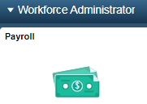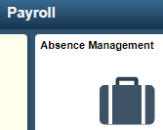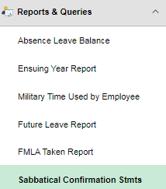
Note: Wisconsin Court System does not use the ESS process for Sabbatical Election.

Automated Email Announcement of Eligibility – Employee Messaging
We will be sending automated email messages to eligible employees as follows:
November 11, 2026
You are receiving this email because you are eligible for the Sabbatical Election, which allows you to convert eligible 2026 vacation hours to sabbatical leave. The election period is open in Employee Self Service (ESS) from November 11 to December 2, 2026. If you intend to make an election, you must enter your sabbatical election no later than Wednesday, December 2, 2026.
Vacation hours converted to Sabbatical leave can be carried over year to year without restriction, eliminating the concern of losing unused vacation. Sabbatical leave can be used in a subsequent year, be used to extend a termination date, or be paid out as a lump sum payment upon termination. Vacation and sabbatical balances will be updated on December 16, 2026.
If you are also eligible for the cash payment option and you elect to convert eligible 2026 vacation to cash, you will receive payment on the December 23, 2026, check date. Sabbatical cash payments are paid using your base hourly rate (excludes any add-on pay), are not reported as retirement earnings, and may be taxed up to 22%. If you are eligible for this option, it will be indicated on the sabbatical election page.
At the time you make the election, ESS will not allow you to elect more than the current vacation balance. If the vacation balance drops below the elected amount at the time of processing, your conversion amount will be reduced to stay within the available vacation balance. The cash pay election amount will take priority over the Sabbatical election amount.
November 25, 2026
You are receiving this email because you are eligible for the Sabbatical Election. The election period is closing in Employee Self Service (ESS) as of the end of the day on Wednesday December 2, 2026. We show a Sabbatical election has not been made yet. In ESS click on the "My Time" tile, then click on the "Sabbatical" tile for more detail.
Agencies can use the following queries to pull a list of employees that received the emails.
11/11/2026 - WI_ABS_SABB_EMAIL_AUDIT126
11/27/2026 - WI_ABS_SABB_EMAIL_AUDIT226

ENTERING SABBATICAL ELECTIONS AFTER THE ESS PERIOD HAS CLOSED
We encourage employees to use ESS in making their election, but if you have an employee that is on LOA or otherwise do not have access to ESS, you may make the entry for the employee. You do not need to wait until the ESS period is closed.

Use the Create and Maintain Absences screen:
Navigation using tiles:
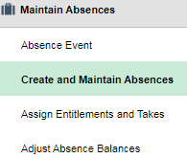
Navigation from NavBar: Main Menu > Global Payroll & Absence Mgmt > Payee Data > Maintain Absences > Create and Maintain Absences

Step 1 - Click on “Personalize”.
(If you have not removed this personalization from last year, this should still exist for you, and you can skip to Step 4.)
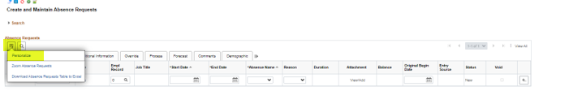
Step 2 - On the Column Order table select “Config Decimal 1” and “Config Decimal 2” and use the up arrow to move them below “Empl Record”. Scroll to the bottom and click “OK”.
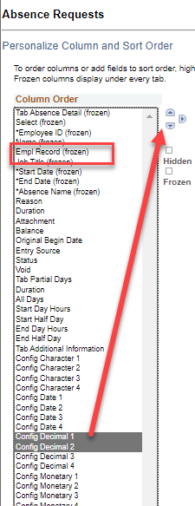 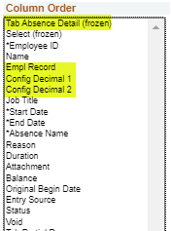
Step 3 - Click on the “+” button to the right to add more rows if entering more than one employee.
Step 4 - Determine the number of additional rows you would like to add and click “OK”. It is recommended not to exceed 20 rows at a time or forecasting will take longer.
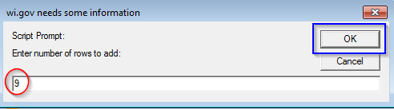

Step 5 - Complete the election entries:
Use the following checklist to avoid receiving an ineligible message:
- Make sure the elections entered do not exceed the Sabbatical Eligible amounts.
- Make sure the total amount elected does not exceed the current vacation balance shown on the page.
- Key entries in whole hours.
- Use the correct Begin/Start Date of 12/12/2026 (last Saturday of pay period 26).
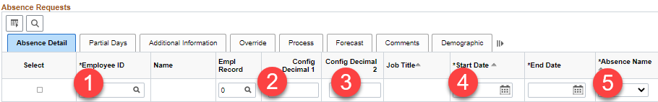
- Enter the employee’s Empl ID & Empl Record. The Name and Job Title will automatically fill in.
- Config Decimal 1 = Total election hours (both sabbatical and cash)
- Config Decimal 2 = Cash election hours (left blank if no cash election)
- Start Date must be 12/12/2026.
- Select “Sabbatical Election” for the Absence Name. The current (vacation) balance will automatically fill in.
Step 6 - Once all the elections are entered for employees in these newly created rows, click “Select All” at the bottom left corner:
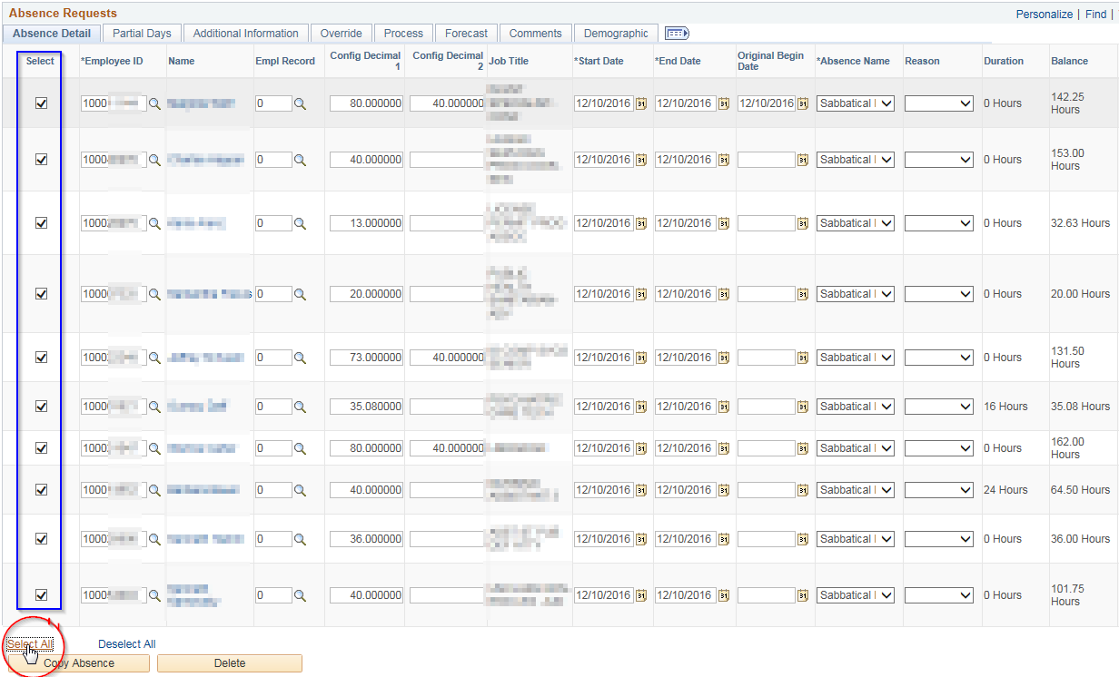
Step 7 - Once all employees have a check in the Select box, click the “Forecast & Submit” button.
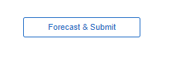
Step 8 - Click “Yes” on this pop-up:
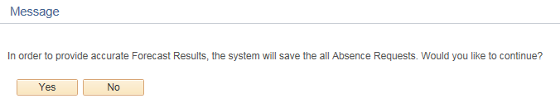
All elections should be Eligible and Approved. If they are not, see “Reviewing Ineligible Sabbatical Elections” for troubleshooting.

CHANGING SABBATICAL ELECTIONS AFTER THE ESS PERIOD HAS CLOSED
Use Create and Maintain Absences screen:
Navigation using NavBar: Main Menu > Global Payroll & Absence Mgmt > Payee Data > Maintain Absences > Create and Maintain Absences. Navigation using tiles can be found under the earlier Use the Create & Maintain Absence Screen section.
Step 1 - Expand the search area by clicking the arrow in front of the word Search: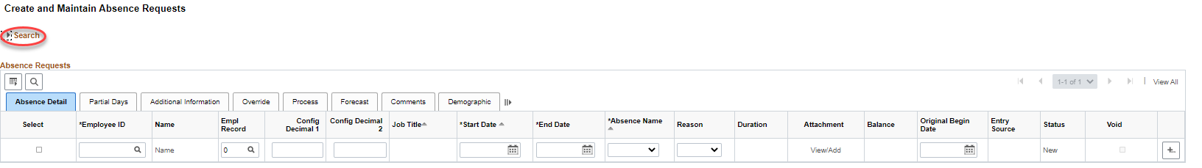
Step 2 - Complete the search parameters: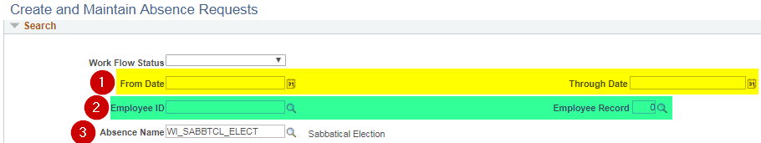
- Enter the valid sabbatical election date in both the “From Date” and “Through Date” , which is 12/12/2026.
- Enter the Employee ID and Employee Record you wish to change.
- Select WI_SABBTCL_ELECT for the “Absence Name”.
Step 3: - Change Config Decimal 1 (Total election hours (both sabbatical and cash) and/or Config Decimal 2 (Cash election hours {left blank if no cash election}) as appropriate. If you need to set the Config columns up, refer to pg. 6 instructions.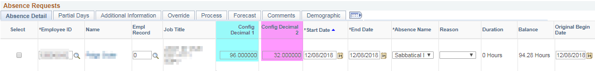Step 4 - Once you have your change(s) keyed, click the “Select” box to the left of the employee: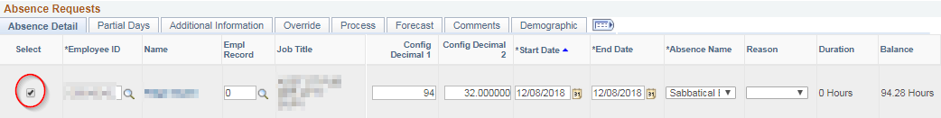
Step 5 - Click the “Forecast & Submit” button at the bottom of the page.
Step 6 - Click “Yes” on this pop-up:
The election should be Eligible and Approved. If it is not, see “Reviewing Sabbatical Elections” for troubleshooting.

REVIEWING SABBATICAL ELECTIONS
Employees have until 12/2/2026 to enter elections through ESS. To review all your employees’ elections, use the WI_ABS_SABBATICAL_ELECTIONS query. To see what an individual employee entered, go to the Create and Maintain screen.
Use Create and Maintain Absences screen:
Navigation: Main Menu > Global Payroll & Absence Mgmt > Payee Data > Maintain Absences > Create and Maintain Absences
From Date: Use Date of the Current Year’s Election Date of 12/12/2026
Absence Name: WI_SABBTCL_ELECT
Employee Record: You will have to run for each active Empl Rcd you have. I.e., 1, 2, 3 etc.…
Department: You may enter if you want to look by Department. Otherwise, leave blank.
Pay Group: If you have only access to your Pay Group this can be left blank. If you have access to multiple Pay Groups, you may enter the 3 digit number.
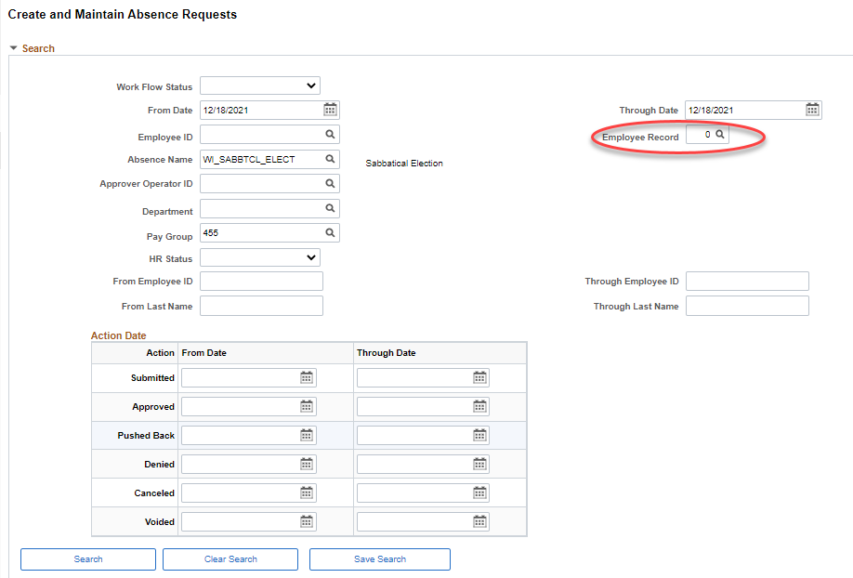
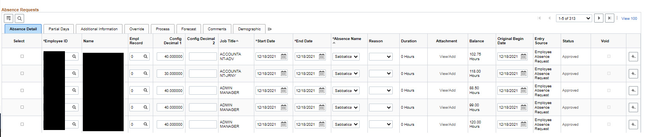

REVIEWING FOR INELIGIBLE SABBATICAL ELECTIONS
This should be completed by 12/04/2026 (employees have until 12/2/2026 to enter elections thru ESS)
Use Create and Maintain Absences screen:
Navigation: Main Menu > Global Payroll & Absence Mgmt > Payee Data > Maintain Absences > Create and Maintain Absences
Once forecasting is complete, select the Forecast tab to see the Forecast Values.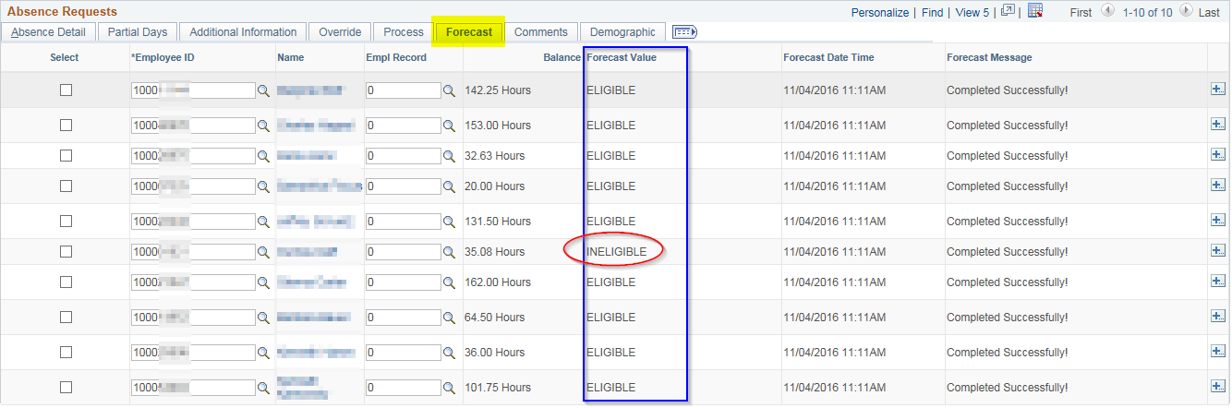
Example 1, Employee Didn’t Use Whole Hours
Although this employee’s current vacation balance is 35.08 the report accurately shows 35.00 whole hours, and we are forecasting based on the Sabbatical Eligible amounts. You can fix this by changing the election to 35.00 and re-forecasting.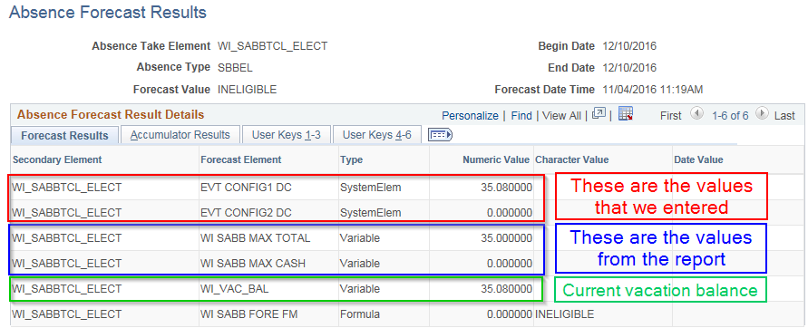
Example 2, Sabbatical Eligible amount more than current vacation balance so employee election was too high
Although the Sabbatical Eligible amount is 31 hours, the current vacation balance is now only 5.25 hours. You can fix this by changing the election to 5.00 and re-forecasting.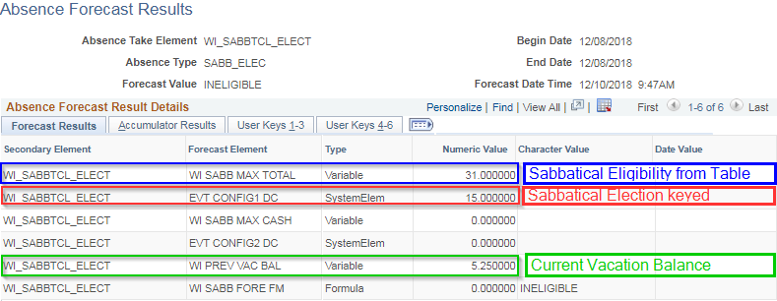
Example 3, Vacation swap with other leave creates additional balance/eligibility for sabbatical election.
Although the current vacation balance is 30.69 hours the Sabbatical Eligible amount is 26 hours. You can fix this by requesting a change to the Sabbatical Eligibility amount using the Sabbatical Eligibility Change Request. Once the update has been made to the amount then re-forecasting the current election.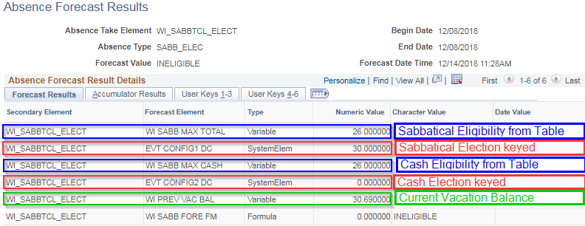

Go back to the Create and Maintain Absences page to fix the election and re-forecast for the employees that were originally “Ineligible” (just check the select box in front of each of their names before re-forecasting). Once all Forecast Values are “Eligible” then you can “Select All” again and click “Submit” at the bottom of the page. This will flip the status from Saved to Approved.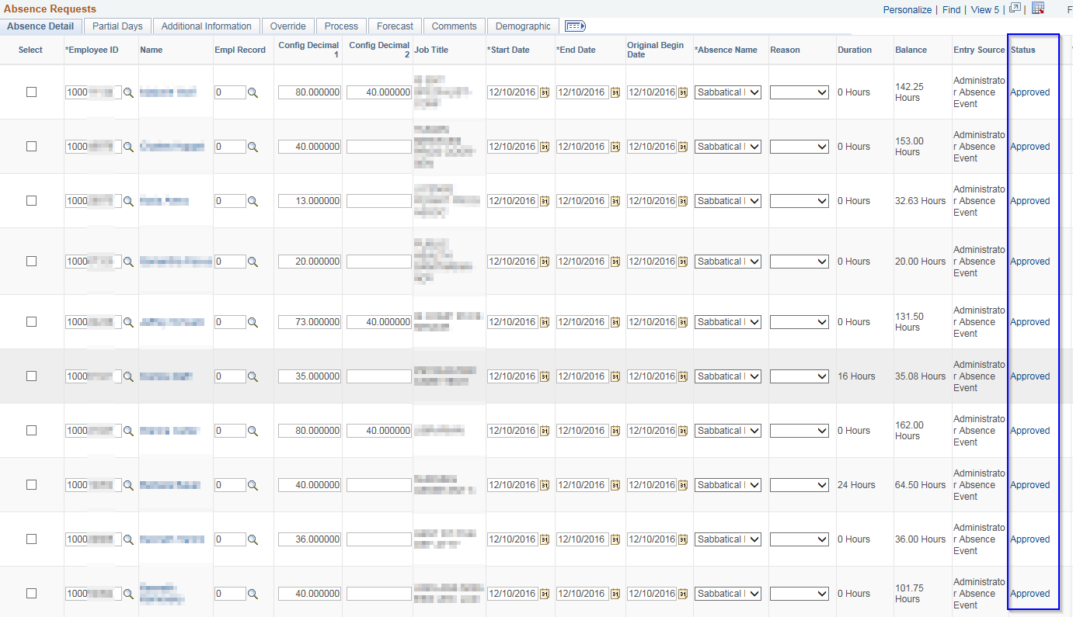

Troubleshooting
- If you find that the status becomes Submitted instead of Approved…delete the entry and start over.
- If you get an error about their schedule (and their schedule is correct) request DOA Central Payroll to make the entry through the Absence Event page instead of the Create and Maintain Absences screen.
- You will find Config Decimal 1 and Config Decimal 2 under the Detail link.
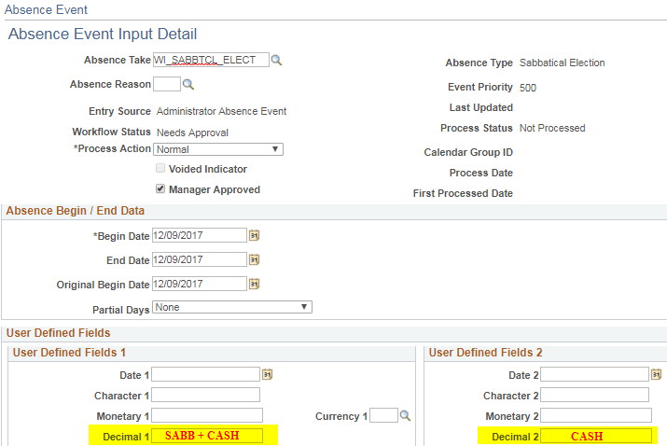

REQUESTING A SABB ELECTION AFTER THE LAST PAY PERIOD OF THE YEAR HAS CONFIRMED
Any Adds/Changes/Deletes needed for a sabbatical election is keyed in the same manner as entering it before PP26 absence confirmed. We do not create manual adjustments for sabbatical elections. On the Create and Maintain screen, for the Start Date, use the last day of the final pay period of the calendar year. For 2026 this is PP26 with an End Date of 12/12/2026.
If you find that a sabbatical election was missed or keyed incorrectly, please make the correction on the Create and Maintain screen and it will process in the next pay period. Because we are using the 12/12/2026 date for the entry, an absence retro trigger will be created, and the leave balances will be adjusted in the PP26 Calendar ID on the Results by Calendar screen. Remember that a confirmation statement is only generated when the employee makes the entry through ESS. Late cash payment elections processed by the Agency Payroll will be paid and taxed in the calendar year when the election is processed.
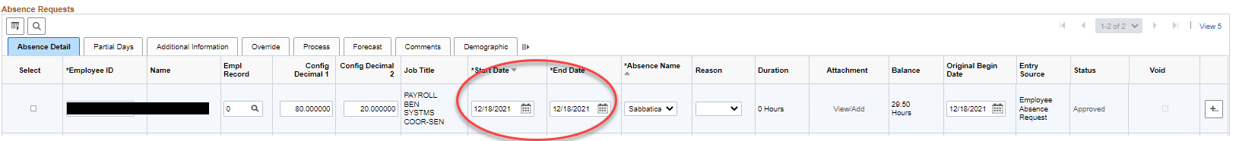
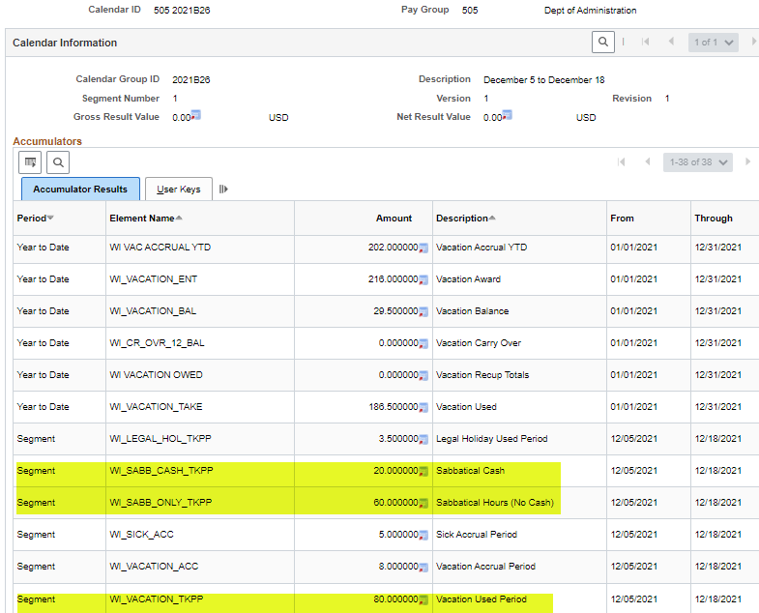

TRCs USED FROM PAYABLE TIME TO CALCULATE ELIGIBLE HOURS
The Actual Hours Paid are being pulled from the Payable Time. By pulling from the Payable Time, we can include all payable hours for the anniversary year, splitting the hours between prior to/on-after anniversary date. The Sabbatical Year is based on actual hours in pay status up to 80 hours in a pay period for PP01 through October B + the estimated hours for the remaining pay periods through PP26 -based on their FTE as of the October B payroll.
If when reviewing the results from the WI_ABS_SABB_FINAL_ELIG query, you want to see what makes up a specific employee’s Actual Hours you can use the WI_TL_PAYABLE_ELIG_SABB_HOURS query.
The WI_TL_PAYABLE_ELIG_SABB_HOURS includes the TRCs listed below. It is not picking up retro changes to the timesheet made after the October B pay period has been finalized. The query will pick-up over 80 hours in a pay period, so if the total from the query is greater than the Total EE hours (Column Q) on the WI_ABBS_SABB_FINAL_ELIG query, you will have to manually total the Hours column on the WI_TL_PAYABLE_ELIG_SABB_HOURS query by PP to see if that is the difference. This query is not meant to be used for verifying every employee on the WI_ABS_SABB_FINAL_ELIG query.
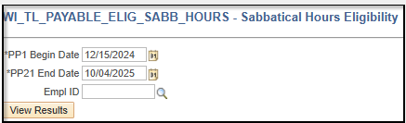

NEW FOR 2026: We have created the WI_TL_PAY_SABB_HRS_PPSUMMARY query. This query will provide a summary of payable hours by employee per pay period for PP1 – PP21 (2027 will be through PP22). For Exempt employees, hours reported as "Payable Time as Exempt Hours over FTE Not Paid" will not be included in the results. 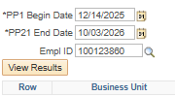
For reviewing the actual hours of an employee from the WI_ABS_SABB_FINAL_ELIG query use the dates indicated below.

TRCs used in the calculation are as follows (Status Distributed or Taken):
23036
ADMPY
BNMRW
CATPD
CLLBK
CMP15 - Comp Total Hrs Worked (Status Closed)
CMPER - Comp Time Earned Straight (Status Closed)
CMPUS - Comp Time Used
COVA
COVF1
COVF4
COVM1
COVN1
COVS1
COVS2
COVS3
E15CA
E15CM
EXAM
EXCMP
EXCSH
HLREG
IAS16
JURY
LGHOL
LGLED
LVSWP
MERIT
MIL30
MILAC
MILNP
MILPD
ORGDN
OTHLF
OTOCA
OTOCM
PLLWK
PPEXC
PSHOL
REGLR
REGOT
RMVOT
ROFTE
SBBTC
SICK
VACTN
VOTE
WLEAC
WLEAU
HLCUS
INTV
MLOTH

If your agency review employees’ Sabbatical Eligibility throughout the year, you can run the WI_ABS_SABB_PRELIM_ELIG query any time after the first time the Sabbatical process is run in the new calendar year. We intend to run the Sabb Eligibility process following the finalization of PP3 through October B. In October B we will finalize the Sabbatical Eligibility process. The WI_TL_PAYABLE_ELIG_SABB_HOURS query can be used to see what hours make up the employee’s Actual Hours. End Date should match the date used in the WI_ABS_SABB_PREM_ELIG query. The Begin Date is always PP1 and the End Date is the last day of the pay period that has been confirmed and the Sabbatical Eligibility process has been run.

SABBATICAL AND CASHOUT ELIGIBILITY
All Employees (excluding State Patrol Troopers and Inspectors)
The number of hours available for use in the following categories shall be prorated at the pertinent annual leave rate or rates for employees who are in pay status less than 2080 hours during the calendar year.
520 Hr. Sick Leave AccuMulation*
This includes all employees on the leave accounting system who had in the previous year or have a balance of 520 hours of sick leave accrued at the end of the October B pay period.
- These employees are eligible to put a maximum of 40 hours into their sabbatical account.
160, 176 or 184 HR. VACATION RATE
- FLSA nonexempt with 10 or more years of service
- FLSA exempt with 5 or more years of service
- These employees are eligible to put a maximum of 40 hours into their sabbatical account.
200 HR. VACATION RATE
- FLSA nonexempt with 20 or more years of service
- FLSA exempt with 15 or more years of service
- These employees are eligible to put a maximum of 80 hours in their sabbatical account or split the 80 hours between sabbatical and cash payment with cash being a maximum of 40 hours.
216 HR. VACATION RATE
- FLSA nonexempt with 25 or more years of service
- FLSA exempt with 20 or more years of service
- These employees are eligible to put a maximum of 120 hours in their sabbatical account or split the 120 hours between sabbatical and cash payment with cash being a maximum of 40 hours.
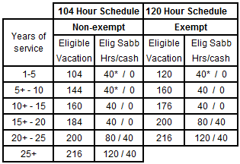
*Must have accumulated 520 hours of sick leave by the end of the October B pay period to be eligible for this category.

State Patrol Troopers and Inspectors “Grandfathered”
Per contract, the eligibility for BU 63 is based on a combination of seniority and sick leave accumulation. Once an employee has reached the criteria for a higher level (years of service and sick leave accumulation) their “Grandfathered” Sick Balance shown (in HCM on the Results by Calendar Group screen, WI SABBSICK BAL field) will not be reduced to a lower level even if they drop below the sick leave hour requirement for that level.
The number of hours available for use in the following categories shall be prorated at the pertinent annual leave rate or
rates for employees who are in pay status less than 2080 hours during the calendar year.
520 Hr. Sick Leave AccuMulation
This includes all employees on the leave accounting system who had in the previous year or have a balance of 520 hours of sick leave accrued at the end of the October B pay period.
- These employees are eligible to put a maximum of 40 hours into their sabbatical account.
144 HR. VACATION RATE - Dependent on Sick Leave Accumulation
They earn vacation on the 104 Hour Schedule and have 5+ years of service. Their eligibility is tied to the number of hours they have accumulated of sick leave as of the October B pay period each year.
- These employees are not eligible for term/sabbatical until they have a minimum of 520 hours of sick leave as of the October “B” pay period when sabbatical eligibility is determined.
- These employees with at least 520 hours of sick leave are eligible to put a maximum of 40 hours in their sabbatical account or split the 40 hours between sabbatical and cash payment with cash being a maximum of 40 hours.
160 HR VACATION RATE – Dependent on Sick Leave Accumulation
They earn vacation on the 104 Hour Schedule and have 10+ years of service. Their eligibility is tied to the number of hours they have accumulated of sick leave as of the October B pay period each year.
- These employees are not eligible for sabbatical until they have a minimum of 520 hours of sick leave as of the October “B” pay period when sabbatical eligibility is determined.
- These employees with at least 520 but less than 728 hours of sick leave are eligible to put a maximum of 40 hours in their sabbatical account or split the 40 hours between sabbatical and cash payment with cash being a maximum of 40 hours.
- These employees with at least 728 hours of sick leave are eligible to put a maximum of 60 hours in their sabbatical account or split the 60 hours between sabbatical and cash payment with cash being a maximum of 40 hours.
184 HR VACATION RATE – Dependent on Sick Leave Accumulation
They earn vacation on the 104 Hour Schedule and have 15+ years of service. Their eligibility is tied to the number of hours they have accumulated of sick leave as of the October B pay period each year.
- These employees are not eligible for sabbatical until they have a minimum of 520 hours of sick leave as of the October “B” pay period when sabbatical eligibility is determined.
- These employees with at least 520 but less than 728 hours of sick leave are eligible to put a maximum of 40 hours in their sabbatical account or split the 40 hours between sabbatical and cash payment with cash being a maximum of 40 hours.
- These employees with at least 728 but less than 1040 hours of sick leave are eligible to put a maximum of 60 hours in their sabbatical account or split the 60 hours between sabbatical and cash payment with cash being a maximum of 40 hours.
- These employees with at least 1040 hours of sick leave are eligible to put a maximum of 80 hours in their sabbatical account or split the 80 hours between sabbatical and cash payment with cash being a maximum of 40 hours.

200 HR VACATION RATE – Dependent on Sick Leave Accumulation
They earn vacation on the 104 Hour Schedule and have 20+ years of service. Their eligibility at this vacation rate is no longer dependent on sick leave hours.
- These employees are eligible to put a maximum of 80 hours in their sabbatical account or split the 80 hours between sabbatical and cash payment with cash being a maximum of 40 hours.
216 HR VACATION RATE – Dependent on Sick Leave Accumulation
They earn vacation on the 104 Hour Schedule and have 25+ years of service. Their eligibility at this vacation rate is no longer dependent on sick leave hours.
- These employees are eligible to put a maximum of 120 hours in their sabbatical account or split the 120 hours between sabbatical and cash payment with cash being a maximum of 40 hours.
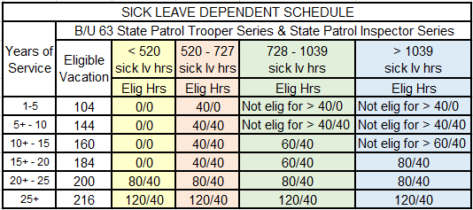
References: Comp Plan Section K 3.01 230.35 (1p) ER 18.02(5)

QUERIES
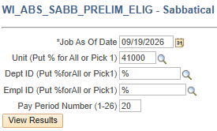
- This query is updated after each payroll confirm and run PP3-Oct B. Job As Of Date is the last end date of the pay period that has been confirmed.
- With the new fields of Actual Hours and Estimated Hours, we have added a new prompt: Pay Period Number. Put in the Pay Period that most recently confirmed.
- This is an example if you are running it after PP2026B20 has confirmed use the Date 9/19/2026 and PP # 20.
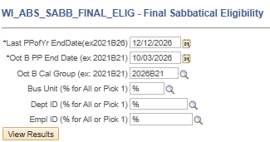
- You do not want to run the Prelim_Elig query after Oct B. Once the Sabb Eligibility process is finalized in Oct B, we will not run the Sabbatical Eligibility process again until PP03 of the following calendar year.
- This query is updated and finalized after the October B pay period is confirmed each year.
- The 2026 Sabbatical Eligibility Report will be finalized as of 10/12/2026. Use the dates indicated above.
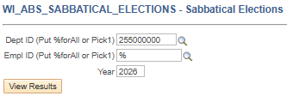
- This query is showing all employees that have made an election. You may look by department, or you may enter a wildcard (I.e., 255%) in the Dept ID criteria field and see your entire agency.

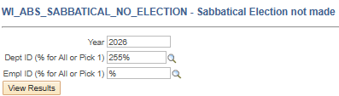
- This query is showing all eligible employees that have NOT made an election. You may look by department, or you may enter a wildcard in the Dept ID criteria field and see your entire agency.

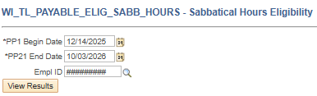

- See page 17 – 19 for detail. Payable Time to Calculate Eligible Sabbatical hours.

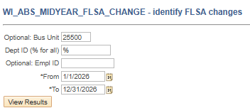
- This query is showing all mid-year FLSA changes. Agencies need to review these employees.
- Instructions and examples are included on the Sabbatical Eligibility Change Request worksheet.

