
Death of an Employee Job Aid
Version 1.4
Version History
Version | Date | Editor | Description
1.0 | 03/07/24 | Matt Olsen | Initial release
1.1 | 12/20/24 | Matt Olsen | Various updates for new process
1.2 | 02/14/25 | Matt Olsen | Updates to term and absence sections
1.3 | 12/04/25 | Matt Olsen | Updates to documentation request section
1.4 | 10/01/26 | Matt Olsen | Updates to review benefits and documentation request sections

Role: Agency Payroll Specialist
Contents
OVERVIEW 2
INITIAL CONTACT – BENEFICIARY/NEXT OF KIN AND ETF 2
NOTIFY WORKER’S COMPENSATION COORDINATOR (IF APPLICABLE) 3
NOTIFY HR TO ENTER TERM IN JOB DATA 3
UPDATE FEDERAL AND STATE TAX DATA 4
INACTIVATE DIRECT DEPOSIT 5
UPDATE PAYCHECK NAME 5
REVIEW BENEFITS 6
ENTER FINAL ABSENCE TRANSACTIONS 8
Process Payout/Collection 8
Zero Out Absence Balances 8
Certify Sick Leave 9
REQUEST DOCUMENTATION FROM BENEFICIARY/ESTATE 9
UPDATE ADDRESS FOR ANNUAL MAILINGS 10
ADDITIONAL RESOURCES 11
STAR HCM Resources 11
ETF Resources 11
Estate/FEIN Resources 11

OVERVIEW
Agency Payroll should use the Death of an Employee Checklist to ensure all steps are completed and send documentation to Central Payroll for release of paychecks issued after death.
When Agency Payroll is notified of the death of an employee, the steps outlined in each of the following sections should be taken as soon as possible to ensure state and federal compliance and correct processing of the employee’s payroll and benefits.

INITIAL CONTACT – BENEFICIARY/NEXT OF KIN AND ETF
NOTE: If you do not know who to contact, then Emergency Contacts, Benefit Enrollments, Wisconsin Court Records, and/or the obituary may be useful to find the appropriate person.
- Contact the beneficiary/next of kin to discuss the following items.
  - They will need documentation for release of paychecks after death (see Request Documentation section). If they are the spouse, domestic partner, child, parent, or sibling of the employee, let them know which documents are needed for payment to the beneficiary as those will usually be available much sooner than estate documentation.
  - They will need to provide a certified copy of the death certificate that lists cause of death to ETF. Copies can be obtained from these locations or similar agencies in the applicable state if the employee resided outside of WI:
    - The funeral home or cremation organization – this is usually the easiest method as they prepare and file the death certificate.
    - Any WI County Register of Deeds Office.
    - The Vital Records Office.
  - They may also need to contact the following organizations:
    - The Social Security Administration.
    - The Wisconsin Deferred Compensation Program at (877) 457-9327 if the employee had a deferred compensation account.
    - The companies for any other health, life, or disability coverage the employee may have had, unrelated to state employment.
    - Any other investment plans or financial institutions in which the employee had assets, unrelated to state employment.
- Contact ETF within 24 hours of notification of the employee’s death at (608) 266-3285 or email ETF SMB Employer WRS to report the following employee information. ETF will assign a counselor and send a death benefits packet to the beneficiary/next of kin 4-6 weeks after notification of the death.
  - Name.
  - ETF Member ID.
  - Date of Death.
  - Date of Birth.
  - Beneficiary/next of kin’s relationship to employee, address, and contact information.

NOTIFY WORKER’S COMPENSATION COORDINATOR (IF APPLICABLE)
If the employee’s death was due to a work-related injury, notify your agency’s Worker’s Compensation Coordinator immediately because paperwork must be submitted to the Department of Workforce Development within 24 hours of the fatality.

NOTIFY HR TO ENTER TERM IN JOB DATA
Notify Agency HR of the employee and the date of death so they can key the termination in Job Data using Action Termination and Action Reason Death effective dated the day after the employee’s death.
If the date of death is unknown at the time of notification, contact Central Payroll immediately and skip to the next section. Enter the termination as soon as date of death is determined.
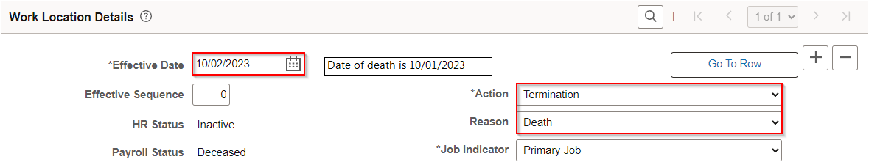
NOTE: If the employee is to receive one or more paychecks in the year after the date of death (e.g. death on 12/27/2023 and final check on 1/11/2024), no FICA taxes should be taken. Central Payroll will update the employee’s FICA Status and paycheck(s) when necessary.

UPDATE FEDERAL AND STATE TAX DATA
Paychecks dated after the date of death should not have federal or state taxable gross and withholding applied. Enter the updates below as soon as you are notified of the death to ensure future checks are taxed correctly.
NOTE: If notified of the death after the current payroll has confirmed but before the check date, allow the ACH to process as normal unless the beneficiary/next of kin has requested the paycheck be stopped and reissued to the estate.
- Navigate to Update Employee Tax Data page.
  - Navigation: Workforce Administrator Homepage > Payroll Dashboard > Payroll Processing Tile > Pay Data Folder > Update Employee Tax Data.
  - Enter at least one search criteria and click Search.
- Click on Plus Sign (+) on Federal Tax Data tab to add a new effective dated row.
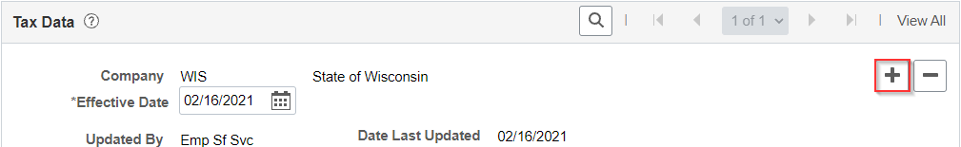
- Effective Date defaults to today’s date. Select date for the new entry using the first day of the pay period or the next available day in the pay period if needed.
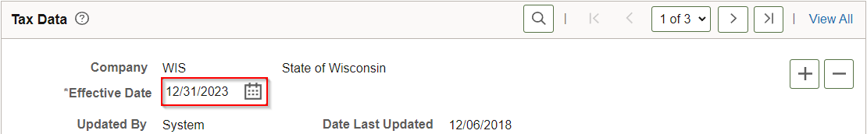
- Select a Special Withholding Tax Status of No taxable gross; no tax taken from the dropdown. It is not necessary to change the Tax Status.
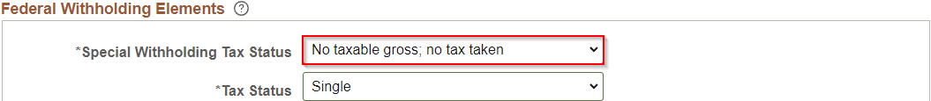
- Click on State Tax Data tab (skip steps 5 and 6 if employee was working in the state of CO, DC, GA, IA, MD, MO, NC, NJ, or SC and has a matching Tax Residence state).
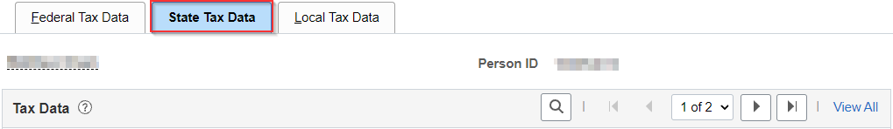
- Select a Special Withholding Tax Status of No taxable gross; no tax taken from the dropdown in the row with the Tax Residence box checked. It is not necessary to change the Tax Status.
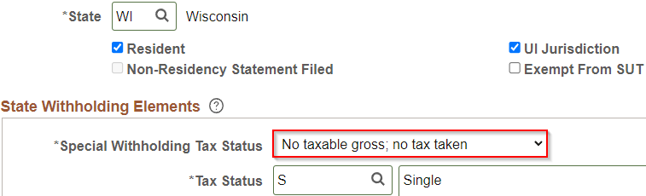
- When both Federal and State Withholding Elements are updated, click Save.

INACTIVATE DIRECT DEPOSIT
Paychecks dated after the date of death should be processed as paper checks if possible. Make sure to key the inactivation of direct deposit as soon as your agency is notified of the death.
NOTE: If notified of the death after the current payroll has confirmed but before the check date, allow the ACH to process as normal unless the beneficiary/next of kin has requested the paycheck be stopped and reissued to the estate.
- Navigate to Request Direct Deposit page.
  - Navigation: Workforce Administrator Homepage > Payroll Dashboard > Payroll Processing Tile > Pay Data Folder > Request Direct Deposit.
  - Enter at least one search criteria and click Search.
- Click on Plus Sign (+) in Deposit Information to add a new effective dated row.
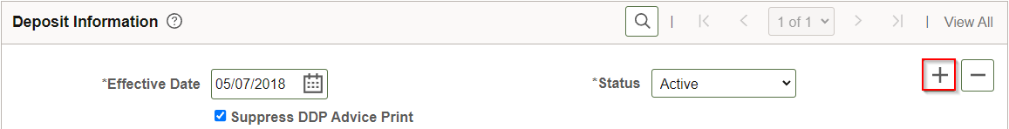
- Use the default Effective Date of today’s date and change the Status to Inactive.
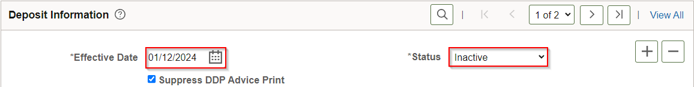
- Click Save.

UPDATE PAYCHECK NAME
Paychecks dated after the date of death should be issued to the employee’s estate initially. The Update Payroll Options page allows for the name to be overridden. Do not change the employee’s actual name on the Modify a Person page.
- Navigate to Update Payroll Options page.
  - Navigation: Workforce Administrator Homepage > Payroll Dashboard > Payroll Processing Tile > Pay Data Folder > Update Payroll Options.
  - Enter at least one search criteria and click Search.
- Click on Payroll Options 2 tab.

- Update Paycheck Name to “Estate of Employee’s Name”.
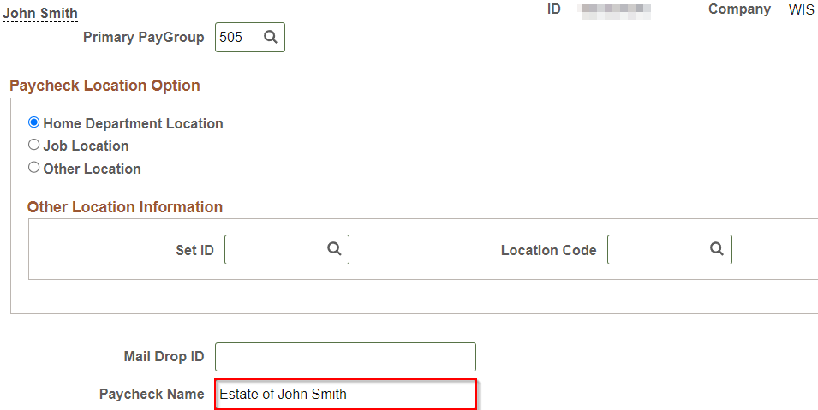
- Click Save.

REVIEW BENEFITS
The effective date of the termination row should be the day after the employee dies.
- Verify employee’s insurance enrollments by navigating to Benefits Summary page.
  - Navigation: Workforce Administrator Homepage > Benefits Administration Dashboard > Benefit Enrollments Tile > Review Employee Benefits Folder > Benefits Summary.
  - Enter at least one search criteria and click Search.
  - Click on the arrow next to employee’s name to bring up summary.
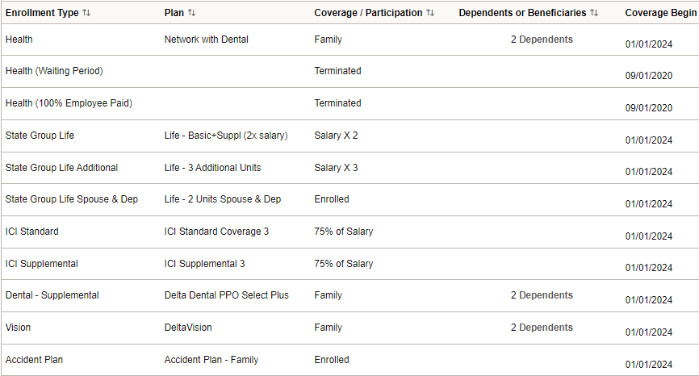
- Review retro benefit deductions to ensure correct refunds are scheduled to process from the next paycheck by navigating to Update Retro Ded Calc Results page.
  - Navigation: Workforce Administrator Homepage > Benefits Administration Dashboard > Benefit Deductions Tile > Retro Arrears Folder > Update Retro Ded Calc Results.
  - Enter at least one search criteria and click Search.
  - Select the calculated row(s) to review.
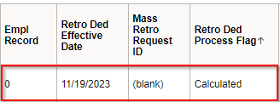
  - Click on the arrows to cycle through each row calculated by the system.
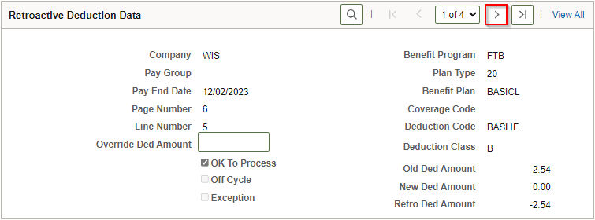
- Complete and mail continuation forms to the beneficiary/next of kin for employee’s insurances that are family coverage.
- Complete and send to Securian Life Insurance Company the Notice of Death Form if employee was enrolled in life insurance.
Insurance | Coverage End Date - Single |  | Coverage End Date - Family | Continuation Form
State Group Health | End of month of death | End of month through which premiums paid |  | COBRA Continuation-Conversion Notice (employee not retirement age)
State Group Life | End of month of death | N/A |  | N/A
Income Continuation | Date of death | N/A |  | N/A
Delta Dental Preventive & Supplemental | End of month of death | End of month through which premiums paid |  | Retiree/Continuant Change Form
MetLife Vision | End of month of death | End of month through which premiums paid |  | Retiree/Continuant Change Form
Securian Accident Plan | End of month of death | End of month through which premiums paid |  | Survivor must contact Securian in 30 days:  (866) 295-8690 or (888) 658-0193 for accidental death, madisonbranch@securian.com

ENTER FINAL ABSENCE TRANSACTIONS

Process Payout/Collection
Use the Term Payout Worksheet in the P&B WorkCenter to calculate the final payout or collection of leave.
- Enter a POTT using earnings code LAN for a payout or earnings code LSR for a leave collection (see POTT job aid).
- If the deceased employee was in the first six months of state employment, treat personal holiday as an involuntary termination for purposes of current year proration and collection.
- Per policy determination by DPM, Bureau of Class & Comp, and Central Payroll on December 6, 2023, after collecting all possible overdrawn leave via payroll, do not bill the employee’s estate for any remaining amount owed.

Zero Out Absence Balances
Refer to the Absence Adjustments Job Aid for complete instructions on zeroing out absence balances for terminated employees.
- Once absence has been confirmed for the employee’s final pay period in pay status, review Results by Calendar Group for balances that need to be zeroed out.
- Key absence adjustments using the Calendar ID that coincides with the pay period of death for positive balances of sick leave, legal holiday, personal holiday, vacation, and sabbatical.

Certify Sick Leave
Certify sick leave credits through the Accumulated Sick Leave System within 30 days of death. For complete instructions, refer to Chapter 4 of Sick Leave Conversion Program Employer Manual.

REQUEST DOCUMENTATION FROM BENEFICIARY/ESTATE
Paychecks issued after the date of death are processed but held by Central Payroll until the necessary documentation is received. Any vital records used to substantiate death and/or relationship to the deceased employee must be certified copies.
If there is no estate or payment is demanded by the beneficiary prior to the filing for estate administration, then the following documentation is needed for the check(s) to be sent to the beneficiary:
- Death certificate to substantiate death.
- Document or record to substantiate one of the required relationships:
  - Spouse – marriage certificate, tax return with spouse listed, or active benefit enrollment at time of death in My Insurance Benefits with spouse listed.
  - Domestic partner – official declaration of domestic partnership.
  - Child – birth certificate of child, tax return with child listed, or active benefit enrollment in My Insurance Benefits with child listed.
  - Parent – death certificate (with parent listed in box 21 or 22). If estate is filed prior to documentation being received, then they must submit estate documentation.
  - Sibling – birth certificate of sibling. If estate is filed prior to documentation being received, then they must submit estate documentation.
- W-9 for reporting of 1099 income with the beneficiary’s name in box 1, “Individual/sole proprietor or single-member LLC” checked in box 3, address in boxes 5-6, SSN in Part 1, and signature plus date in Part 2 (Sample – Beneficiary W-9).
If the payment is to be made to the estate, then the following documentation is needed for the check(s) to be sent to the estate:
- Domiciliary Letters (or comparable court-acknowledged documentation) to substantiate death and estate administration.
- W-9 for reporting of 1099 income with estate’s name in box 1, “Trust/estate” checked in box 3, address in boxes 5-6, Employer Identification Number (EIN) in Part 1, and executor’s signature plus date in Part 2 (Sample – Estate W-9).
Provide documentation to Central Payroll using one of the following methods:
- Fax to (608) 266-7734.
- Send secure, encrypted email to Central Payroll.
- Mail in sealed confidential envelope:
State of Wisconsin – Department of Administration
Attention: Central Payroll
101 E. Wilson St. 5th Floor
Madison, WI 53703
If no earnings were paid after the date of death and/or they were included in an ACH that processed normally with federal and state taxes, the documentation above is not required.
You may direct the beneficiary/next of kin to review IRS Publication 559, Get an Employer Identification Number, and/or consult with a legal representative for further questions on estate administration and taxation. There are many scam websites that charge a fee for an EIN, but the actual IRS application is free. If they are applying for an EIN, direct them to use the link above or a valid IRS.gov website.
- Send a copy of Form W-9 with the Initial Documentation Request Template in certified mail to the beneficiary/next of kin as soon as possible. You may incorporate this template into an agency-specific letter if desired.
- If documentation is not received within 30 days of the first mailing date, send a second request using the Second Documentation Request Template with Form W-9 to the beneficiary/next of kin.
- If documentation is not received after the second request, send all request documentation to Central Payroll.
- If documentation is received, send copies of each item to Central Payroll so they can mail paychecks after death to the estate or beneficiary, and process the 1099-MISC at year-end.
NOTE: If there is no beneficiary or estate administrator for the deceased employee, contact Central Payroll for assistance.

UPDATE ADDRESS FOR ANNUAL MAILINGS
Annual mailings (W-2 and 1095-C) will default to the employee’s name and home/mailing address in STAR HCM. You should update the employee’s address in Modify a Person to include the beneficiary/estate administrator and address listed on the W-9.
Use in care of (c/o) in address line 1 with the estate administrator’s or beneficiary’s name to direct mail to that person and check the Override Address Verification box.
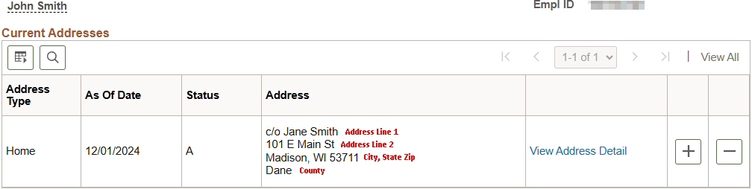

ADDITIONAL RESOURCES

STAR HCM Resources
- Death of an Employee Checklist
- Action/Action Reason Job Aid
- Update Pay Data Job Aid
- Absence Adjustments Job Aid

ETF Resources
- Report the Death of a WRS Member
- Termination Checklist Due to Employee Death
- Death Benefits

Estate/FEIN Resources
- Publication 559 - Survivors, Executors and Administrators
- Publication 1635 - Understanding Your EIN
- Get an Employer Identification Number
- Form W-9

