
Employee Time Reporting Setup Job Aid
Version 1.2
Version History
Version | Date | Editor | Description
1.0 | 04/04/24 | Central Payroll | Initial release
1.1 | 11/18/25 | Central Payroll | Revisions to Work Schedule section
1.2 | 09/18/26 | Matt Olsen | Revision to Time Reporter Data sections
Role: Agency HR, Payroll and Time & Labor Specialists
Contents
TIME REPORTER DATA OVERVIEW 2
Compensation Rules 2
TIME REPORTER DATA ENTRIES 2
Create Time Reporter Data 2
Maintain Time Reporter Data 4
Time Reporter Data Fields 4
Time Reporter Data Errors, Tickets, & Late Entries 10
WORK SCHEDULE SETUP 10
Helpful Information 10
Assign a Predefined Work Schedule 11
Assign a Personal Work Schedule 12
Exception Time Reporter Work Schedules 14
ADDITIONAL RESOURCES 15

TIME REPORTER DATA OVERVIEW
Time Reporter Data (TRD) is an essential component for employees and contractors who will be reporting their hours in the Time & Labor module. It determines an employee’s timesheet setup, compensation rules being applied, and salary expense funding sent to the STAR Finance system.
The information contained in this document provides a framework for most situations, but it should be recognized that there are exceptions that may be excluded from this document.

Compensation Rules
Below are some of the common compensation rules that apply to various groups of employees in the system. Some rules are hardcoded into the system and are not visible or set up anywhere in Job Data, TRD, or Add’l Pay. This is not a comprehensive list.
Rule Type | Notes
FLSA non-exempt employees | Defaults hours worked over 40 to premium overtime.
FLSA exempt employees | Defaults hours over FTE to unpaid time. Able to override to straight rate or time and a half rate overtime/comp time on timesheet using specific TRCs if approved.
Differential Pay | Add-on pay for qualifying night, weekend, and holiday shifts.
Critical Vacancy and Security Add-on Pay | Multiple add-ons based on classification and location for all hours in pay status.
Weekend Classifications | Weekend add-on pay based on classification for all hours worked. These are employees in Abs Eligibility Group WIWKNDNEX (FLSA non-exempt) and WIWKNDNRS (FLSA exempt).
NOTE: For a complete description of compensation rules, refer to the Compensation Plan.

TIME REPORTER DATA ENTRIES
TRD should be created at the time of new hire entry in Job Data and updated when there are changes to an employee’s record or status by Agency Payroll and/or HR.
You may need to consult with management, HR and/or Finance, to determine the appropriate entries in relation to agency-specific policies. Run public query WI_TL_TRD_TIME_REPORTER_DATA to review current TRD entries for active employees at your agency if necessary.

Create Time Reporter Data
This page is used to create the first row of TRD for a new hire or person who is new to recording time in the T&L module. TRD creation should be completed at the time of hire or shortly thereafter to ensure employee’s timesheet is available for entry. Backdated active rows must be entered within 16 days of the effective date or a T&L STAR Ticket will be necessary to make the update.

Option 1 (Agency HR Specialist):
- While in the person’s Job Data record from any tab, click on Employment Data and the link to Time Reporter Data.
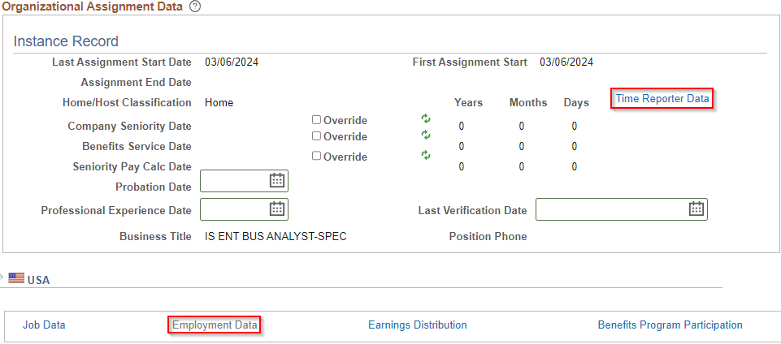
- A popup box will appear with the person’s information at the top and TRD elements for entry below. Leave the Payable Time Start Date blank and enter applicable fields based on instructions in Time Reporter Data Fields section.
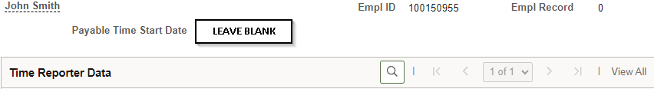
Option 2 (Agency T&L Specialist):
After a person’s Job Data record is saved, navigate to the Create Time Reporter Data page.
- Navigation: Workforce Administrator Homepage > Payroll Dashboard > Time & Labor Tile > Time Reporters Folder > Create Time Reporter Data.
- Enter at least one search criteria and click Search.
- Leave the Payable Time Start Date blank and enter applicable fields based on instructions in Time Reporter Data Fields section.

Maintain Time Reporter Data
This page is used to add a new row to the person’s existing TRD. In most cases, TRD modifications are a result of an employment change that requires updates to one or more fields (e.g. FLSA change, transfer, term/rehire, termination). Backdated active rows must be entered within 16 days of the effective date or a T&L STAR Ticket will be necessary to make the update.
**This process brings forward all information from the previous row. Please be sure to review all fields for updating based on the new/current employment situation**
- Navigation: Workforce Administrator Homepage > Payroll Dashboard > Time & Labor Tile > Time Reporters Folder > Maintain Time Reporter Data.
- Enter at least one search criteria and click Search.
- Click the Plus Sign (+) in the upper right to add a new row and enter applicable fields based on instructions in Time Reporter Data Fields section. 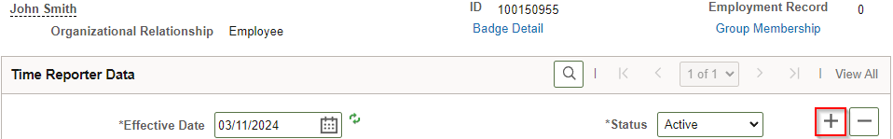

Time Reporter Data Fields
TRD fields are essential to ensure an employee’s timesheet and payable time process correctly. Fields outlined in red are required for each TRD row. Additional information about each field is included in the next section.
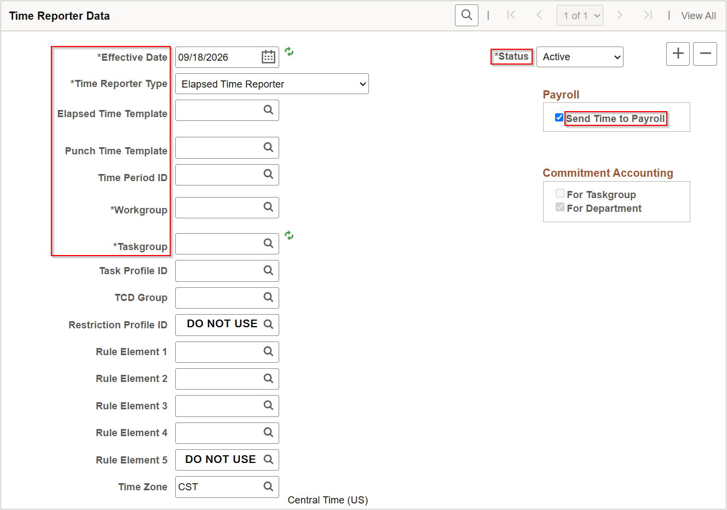
Effective Date
Adding an Active row:
- If a rehire in the system (not necessarily “rehire” in Job Data HR action) with existing Time Reporter Data for that Employment Record, you must use the first day of the pay period as the effective date.
- If brand new in the system for that Employment Record, you must use hire date used in Job Data.
ERRORS: An incorrect effective date can result in one or more days of the timesheet being greyed out for the pay period in which the effective date is entered. You must create a T&L STAR Ticket to request correction to the current TRD row.
Adding an Inactive row:
- Use the effective date of the term row in Job Data which should match the day after the last reported/payable time entry in most cases.
- If there is approved payable time (either positive or negative hours) after the term date, the inactivation date needs to be after the last day with payable time. The system will generate the error message below if an invalid date is used.
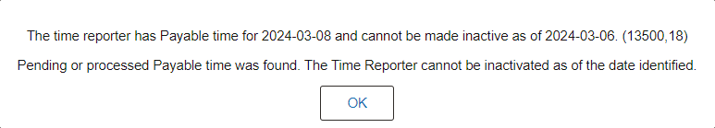
- Don’t add a TRD Inactive row when an employee is on “Exhaust leave” Action/Reason in Job Data. TRD needs to remain active until termination for entering time or resubmitting the timesheet.
- If employee is an exception time reporter and Agency Payroll is notified timely, follow the steps below to ensure correct payable time in the final pay period:
  - Before the system adds exception hours to payable time for the pay period (Thursday night of payroll week), change them to a Workgroup of “WISPOEXM” effective the beginning of their final pay period in pay status.
  - The Workgroup can be changed to “WISPOEXM” prior to the final pay period if they are exhausting accrued leave due to termination because exception hours will not be inserted when there is a full day of absence.
- If employee is an exception time reporter and Agency Payroll is notified after payable time has populated for the final pay period, make sure Job Data termination is entered and use the last day of the pay period as the TRD inactivation date.
ERRORS: If there was approved payable time (either positive or negative hours) after the term date, the inactivation date needs to be after the last date with hours in Payable Time. If the timesheet cannot be completely entered based on the incorrect inactivation date, create a STAR Ticket to request correction to the current TRD and/or Job Data row.
Status
- Active – See Adding an Active row above.
- Inactive – See Adding an Inactive row above.
Send Time to Payroll
- Checked – This box should be checked for all employees.
- Unchecked – This box should be unchecked for all contractors who need TRD set up to record work times in STAR for task reporting.
ERRORS: If the box was checked in error, enter a new row with the correction effective dated to the beginning of the next pay period to prevent project costing issues. If the box was unchecked in error, submit a T&L STAR Ticket for appropriate corrections and manual payment of approved hours.
Time Reporter Type
Time Reporter Type should match the type of Time Template chosen. This determines whether the timesheet shows In/Out boxes for punch times or boxes for entering quantities of hours.
- Punch – Use when you want your FLSA non-exempt or exempt employee to enter actual work times into their timesheet or they qualify to earn differentials.
- Elapsed – Should only be used for FLSA exempt employees who do not need to record actual work times (either positive exempt or exception time reporters).
ERRORS: If the Time Reporter Type is incorrect, it is recommended to change prospectively if completed within 16 days of the effective date. If retroactive correction is necessary, you will need to manually remove all timesheet entries and rekey them once TRD is updated. You may either enter the retroactive row if the effective date is after the current TRD row or submit a T&L STAR Ticket to request a retroactive row prior to the current TRD row.
Elapsed/Punch Time Templates
Used to determine what level of task reporting the employee is supposed to enter on the timesheet.
- Elapsed Time Templates:
  - WIS_ELAPS1 – For employees that are non-task time reporters.
  - WIS_ELAPS(2-5) – For employees that are task time reporters (e.g. Task Profile, Taskgroup, Speed Type, Combo Code, User Field 5).
  - WI_ELPS1C –– For contractors that are not associated with the Knowledge Services interface and do not report tasks.
  - WI_ELPS2C– For contractors that report User Field 3 for the Knowledge Services interface and/or report tasks.
- Punch Time Templates:
  - WIS_PUNCH1 – For employees that are non-task time reporters.
  - WIS_PUNCH(2-5) – For employees that are task time reporters (e.g. Task Profile, Taskgroup, Speed Type, Combo Code, User Field 5).
  - WIS_PNCH1C – For contractors that are not associated with the Knowledge Services interface and do not report tasks.
  - WIS_PNCH3C – For contractors that report User Field 3 for the Knowledge Services interface and/or report tasks.
Time Period ID
Do not use a Time Period ID other than PSDAY or WISBIWEEK.
- PSDAY (day time period) – Used for all punch and positive exempt time reporters.
- WISBIWEEK (biweekly time period) – Used for all exception time reporters.
Workgroup
- CONTRACTOR – For contractors.
- FIRE_EXEMP – For Fire/Crash Rescue FLSA exempt classifications.
- FIRE_RESCU – For Fire/Crash Rescue FLSA non-exempt classifications.
- PATIENTCAR – For Patient Care-specific classifications.
- SFP_1.5XOT – For State Fair Park-specific classifications.
- WIS_EXCEPT – For employees not required to enter hours worked on the timesheet. Hours load biweekly and must be approved by the supervisor.
- WIS_EXCEPT1 – For employees not required to enter hours worked on the timesheet. Hours load biweekly and do not require approval.
- WISEXMPTPT – For LTE’s that are FLSA exempt to ensure hours entered are paid as an override of the FTE percentage. If your agency desires, this can also be used for part-time FLSA exempt employees who are allowed to work over their FTE (not to exceed 80 hours per pay period) without additional/ad-hoc approval.
- WISPOEXM* – For FLSA exempt employees that have hours over FTE in a pay period default to unpaid. Do not use this for LTE’s.
- WISPONEX* – For FLSA non-exempt employees that have hours over 40 in a week paid as overtime or earned as comp time depending on Rule Element 1 setup.
- WI_MINOR – For employees under the age of 18.
*In most instances, if the employee is FLSA non-exempt, you should select one of the non-exempt Workgroup options, and if the employee is FLSA exempt, you should select one of the exempt Workgroup options.
NOTE: If there is a reclass with a FLSA status change, the Workgroup update should be effective the first pay period after the reclass was approved. It is not retroactively applied back to the reclass date.
Taskgroup
Used to designate the appropriate Taskgroup if time is charged to project or default funding. PSNONCATSK is the standard Taskgroup for non-task time reporters.
Task Profile ID
Used to designate a Task Profile ID so that time is charged to specific funding instead of default funding in Position Data. This field is blank for non-task time reporters.
TCD Group
Do not use unless your agency uses a separate T&L system interface with STAR HCM as this will restrict employee from entering time.
Restriction Profile ID
Do not use.
Rule Element 1
Default Overtime indicator for non-exempt time reporters that can be overridden on the timesheet.
- Cash – Hours over 40 in a week are converted to time and a half overtime.
- Combo – Hours over 40 in a week are converted to straight pay overtime and additional half-time to comp time earned.
- Comp – Hours over 40 in a week are converted to time and a half comp time earned.
Rule Element 2
System rules default FLSA non-exempt, permanent staff to receive night and weekend differential. FLSA exempt and all LTE’s do not receive differential automatically (see “D” below).
- C – Shift Differential Critical Vacancy – This is only to be used if you have a corresponding DPM Critical Vacancy Memo and it includes those specific classifications. It creates an addition to what the normal “D” option would provide.
- D – Shift Differential – Used to turn on night/weekend differentials for any FLSA exempt employees or any LTE’s.
- X – Ineligible for Nights and Weekend Shift Differential – Shuts off night/weekend differentials for employees with voluntary work schedules. Hours worked at the request of the employee for flexible schedule do not qualify for differentials per Section A. 4.05 (2)(a) and 4.06 (2)(a) of the Compensation Plan.
Rule Element 3
Supplemental Pay for specific classifications (e.g. Nurses):
- T – Creates RSPNS (Responsibility Pay for Nurses) TRC for night shift hours as a special differential.
- P – Creates PRMPM (Permanent PM Class & Schedules) TRC for night shift hours as a special differential in addition to the RSPNS differential above.
Rule Element 4
Holiday Overtime indicator:
- Cash – Additional half-time for hours worked on a holiday are paid as holiday premium time.
- Combo - Additional half-time for hours worked on a holiday are earned as holiday premium comp time.
Rule Element 5
Do not use.
Time Zone
- Keep as CST (Central Time) even if working in another time zone.
- Since punch employees manually key their work times based on hours worked in their local time zone, choosing a different time zone should not have any impact in the system.

Time Reporter Data Errors, Tickets, & Late Entries
- Keying Errors – Do not add a row to correct a keying error, always create a STAR ticket.
- High Exception Error – Timesheet BU not equal Job BU. This usually happens when an employee changes agencies and enters time before TRD is updated:
- Take note of the timesheet entries, then delete all rows and submit a blank timesheet to clear funding behind the scenes.
- Update TRD with the new row.
- Re-enter and resubmit the timesheet.
- Late Entries (≤ 16 days) – The timesheet must be resubmitted to apply changes. If you backdate an entry, make sure the timesheet gets resubmitted back to the entry date to process the changes.
- Late Entries (> 16 days) – Agency Payroll are limited to a 16-day historical window when adding a new, active row. If not entered in this timeframe, create a STAR ticket.

WORK SCHEDULE SETUP
The earliest an employee can be assigned a schedule is the day after the Job Data start date and the TRD are effective, and the nightly batch process was run. Work schedules should be entered for all permanent and project employees with a TRD no later than Tuesday of processing week for the pay period it is effective dated.
If you go to the Assign Work Schedule page and are not making a change, click on Return to Search, instead of Save. Clicking Save will make the system think you made a schedule change when you did not.
If you enter and save an incorrect schedule and/or effective date, you must create a T&L STAR Ticket to request the corrections. If it is the only row on the screen, we will not be able to delete it. Instead provide the correct Effective Date, Schedule Group, and Schedule ID.

Helpful Information
- Work Schedules assigned in Time and Labor are for the purpose of limiting absence hours so total time (absence hours + work hours) for the day does not exceed scheduled hours for entries made in ESS or MSS. The employee or supervisor (on behalf of an employee) will not be able to enter absences outside of the default schedule (8 hours, Mon-Fri) until assigned a work schedule.
- Agency Payroll can enter absence hours above the scheduled hours on the Create and Maintain Absence page. Under the Forecast tab, you will see the Forecast Value as Ineligible. As long as there is sufficient absence type balance, the absence take will process through to payable time.
- Do not enter schedules for LTE’s unless they need to use worker’s comp or FMLA.
- Do not use the WI-DEFAULT schedule because it does not meet scheduling requirements.
- Do not add a retroactive schedule for a pay period that has been fully processed unless you believe the employee was paid incorrectly due to this work schedule and is less than two pay periods from the current date. If you are a requesting a retroactive schedule further back than two pay periods, you must create a T&L STAR Ticket and provide the correct Effective Date, Schedule Group, Schedule ID and the reason you are requesting the retroactive change of more than two pay periods.
- For a valid retroactive schedule change, you must review the Create and Maintain Absences page to make sure that no absence entries will need to be adjusted due to this schedule change. The schedule change can alter any full day absence (absence not entered with Partial Days indicator) from a “full day” hours under the original schedule to a “full day” hours under the newly entered schedule. You need to review the absences that are effective dated on or after the retroactive schedule date (processed absences and future dated absences). If the “full day” hours change in absences already processed and paid, the system is going to reprocess those absences under the new hour amounts. This could cause the employee to be paid incorrectly.
        - E.g., Employee had an 8-hour schedule when they entered a full vacation day. You backdate a schedule change to a 16-hour (or 24 hour) schedule. The absence take will change from an 8-hour vacation take to a 16-hour (or 24 hour) vacation take.
        - E.g., Employee had an 8-hour schedule when they entered a partial day vacation take for 6 hours (or even 8 hours). You backdate a schedule change to a 16-hour (or 24 hour) schedule. The absence take will remain as a 6-hour (or 8 hour) vacation take despite the schedule change.
    - Refer to Exception Time Reporter Work Schedules section for Work Schedule instructions specific to employees in Workgroups WISEXCEPT and WISEXCEPT1.

Assign a Predefined Work Schedule
This method should be used for most employees with a standard schedule that exists in the system.
- Navigation: Workforce Administrator Homepage > Payroll Dashboard > Time & Labor Tile > Time Reporters Folder > Assign Work Schedule.
- Enter at least one search criteria and click Search.
- Enter schedule data:
  - Effective Date - The effective date of the assigned schedule. It should not be older than the current pay period that is being processed. For a new hire/rehire, the effective date must be the date of hire.
  - Assignment Method – Select Predefined Schedule if a schedule exists in the system.
  - Schedule Group – Select WISCONSIN if this is not prepopulated.
  - Schedule ID – Enter the corresponding ID for the employee’s work schedule. Refer to the Work Schedules spreadsheet for a detailed list of active schedules and hours.
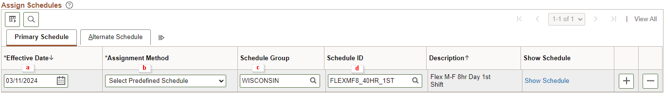
- Click Save.

Assign a Personal Work Schedule
This should only be used if no predefined schedule exists for the employee’s work schedule.
- Navigation: Workforce Administrator Homepage > Payroll Dashboard > Time & Labor Tile > Time Reporters Folder > Assign Work Schedule.
- Enter at least one search criteria and click Search.
- Enter schedule data:
If a schedule is saved as a particular Definition Type (Elapsed, Punch or Flex) on the Definition tab, it cannot be changed to another type. Prior to saving, the Type field can be changed. If the field is changed, any shifts from the Shift Details grid, that does not match the new type, are deleted. Instead, you must enter a new row for the upcoming Pay Period. It should not be older than the current pay period that is being processed.
If the Type is Elapsed, only the elapsed punch types will display on the Shift page. An elapsed shift can contain only one punch entry.
If the Type is Punch, In, Out, Break, Meal, and Transfer punch types can be entered on the Shift page. Punch shifts require an In and Out punch to be saved.
If the Type is Flex, only In and Out punches can be entered.
  - Effective Date - The effective date of the assigned schedule. It should not be older than the current pay period that is being processed. For a new hire/rehire, the effective date must be the date of hire.
  - Assignment Method – Select Create Personal Schedule.
  - Schedule Group – Select WISCONSIN if this is not prepopulated.
  - Schedule ID – This field is prepopulated with a unique number assigned to the schedule.
  - Click on the Create Schedule link.
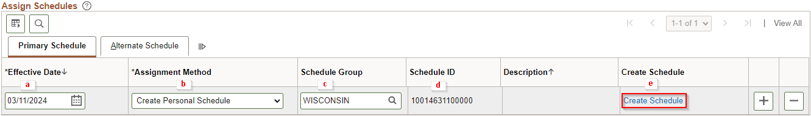
  - Fill in Schedule Details – Definition tab:
- Description – Use Empl ID or employee’s last name.
- Short Description – Defaults to first 10 characters of Description.
- Definition Type – Select Punch for punch time reporters or Elapsed for elapsed time reporters. Flex may be used to allow flexible Shift IDs to be selected.
- Daylight Savings Time – Fixed Time.
- Days in Schedule – Either 7 or 14 (depending on whether the schedule for both weeks in the pay period is the same or different).
- Default Taskgroup – Do not use.
- Time Reporting Template ID – Do not use.
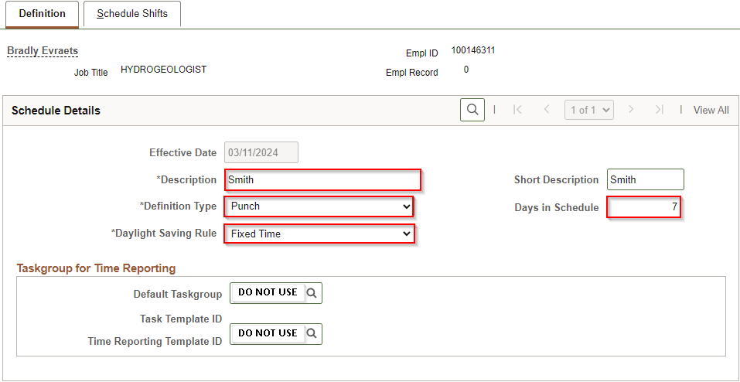
  - Click OK to proceed to Schedule Shifts tab.
  - Fill in Schedule Details – Schedule Shifts tab:
- Day – Prepopulates numbered day based on Days in Schedule (e.g. day 1 = Sunday, day 2 = Monday) when effective dated on Sunday.
- Workday ID – Do not use.
- Shift ID – Select an ID that corresponds with the shift on that day. If none exists to match the desired hours, then you must key punches or quantities instead.
If you enter an incorrect Shift ID or punches, click on the Select box to the left of the row, click on the Clear Shifts function at bottom of screen. The row is cleared and you can re-enter the correct data.
To copy a row, click on the Select box to the left of the row, then click on the Copy function at bottom of screen. Click on the Select box(es) to the left of the row(s) you want to copy too, click on the Paste function at the bottom of the screen.
- Off Shift – Check this box if the day is normally scheduled off.
- First In/Out/In/Last Out – Fill in these boxes with punch times if using a Punch or Flex Definition Type and no Shift ID is selected.
- Time Zone – Do not use.
- Sched Hrs – Auto-fills for Punch and Flex Definition Types. Fill in these boxes with quantities of scheduled hours if using an Elapsed Definition Type and no Shift ID is selected.
- More – Do not use.
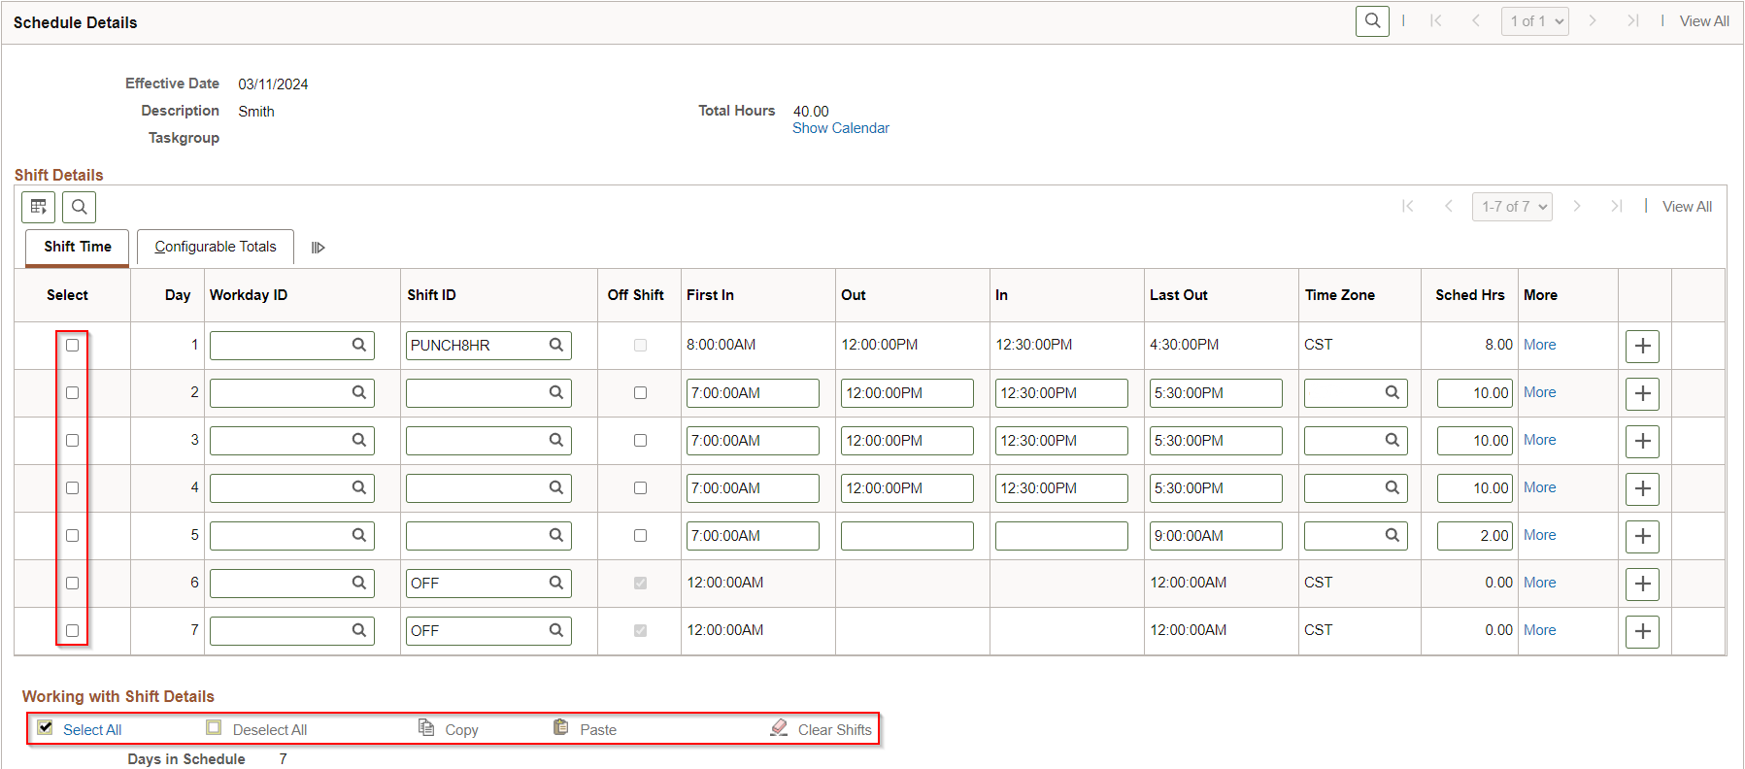
  - Verify total scheduled hours and days match employee’s work schedule then click OK.
- Click Save.

Exception Time Reporter Work Schedules
Exception Time Reporters are not required to enter work hours on the timesheet. The system loads their Work Schedule hours directly to payable time on Thursday night of the first week of each pay period.
It is crucial to set up these employees as described below to ensure payable time loads correctly when there are partial-day absences.
- If they are 100% FTE and working 8 hours Monday – Friday, use Predefined Schedule ID WI_ELAPSED_EXCP.
- If they are less than 100% FTE and/or working an alternate schedule, create a Personal Work Schedule with these additional details:
  - Definition Type – Always select ELAPSED.
  - Shift ID – Select one of the predefined shifts for every day in the schedule.
    - Do not use 24_HRS_ELP
    - Use OFF_ELAPSE for scheduled days off.

  - Create a T&L STAR Ticket to request a new Shift ID if daily hours are different than existing values.
ELAPS4.8HR | ELAPSED5HR
ELAPS8.5HR | ELAPSED6HR
ELAPSED10H | ELAPSED7.5
ELAPSED12H | ELAPSED7HR
ELAPSED1HR | ELAPSED8HR
ELAPSED2HR | ELAPSED9HR
ELAPSED3HR | OFF_ELAPSE (off day)
ELAPSED4HR | WISCOREEX (8 hours)

ADDITIONAL RESOURCES
- Compensation Plan
- Work Schedules
- Task Administration Job Aid
- User Field 5 Administration

