
Manage Delegations Job Aid
Version 1.4
Version History
Version | Date | Editor | Description
1.0 | 10/01/19 | Matt Olsen | Initial release
1.1 | 01/28/22 | Matt Olsen | PUM and post-PUM updates
1.2 | 03/11/22 | Matt Olsen | Process and add delegation section updates
1.3 | 09/04/24 | Matt Olsen | Add delegation section updates
1.4 | 10/02/26 | Matt Olsen | Administer delegation section updates
Role: Agency Time & Labor Specialist

PROCESS
Delegation allows a supervisor to assign their direct reports to someone else in the organization to approve timesheets and enter/review absences on their behalf. Delegation can be established for a duration not to exceed one year.
Agency Payroll staff may enter delegations on behalf of a supervisor if the supervisor cannot in the following scenarios:
- Supervisor is on a vacation.
- Supervisor is out of the office during approval deadlines.
- Supervisor cannot locate the desired delegate from the pre-populated list.
Agency Payroll staff should not enter a delegation in the following scenarios because transactions will automatically route upward to the approver for that supervisor:
- Supervisor is on a leave of absence.
- Supervisor’s position is vacant.
Agency Payroll staff should not enter a delegation for a supervisor who is using accrued leave prior to termination. The Reports to Position Number for the supervisor’s staff should be updated to the person who will be approving on their behalf.

TERMINOLOGY
Delegator
The supervisor who is delegating their Time & Labor and/or Absence transactions to another employee.
Delegate or Proxy
The employee to whom Time & Labor and/or Absence transactions are being delegated.
User ID
The 7–11-character ID associated with an employee. This is also known as the User Profile and IAM.

ADD DELEGATION REQUESTS
- Navigate to Add Delegation Request page:
  - Navigation: Workforce Administrator Homepage > Payroll Dashboard > Time & Labor Tile > Approvals Folder > Add Delegation Request.
  - Enter or paste User ID of the delegator in all capital letters. If User ID is not known:
    - Click the magnifying glass to bring up a list of available employees, click the arrow next to Search Criteria and enter one or more search criteria, then click Search.
      - User ID: 7-11 character ID associated with the employee.
      - Description: Employee last name, first name (Smith, John).
      - Empl ID: 9-digit ID associated with the employee’s record.
      - Email ID: Employee’s business email address.
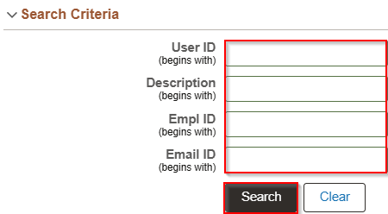
    - Click anywhere on the corresponding row for the delegator being selected.
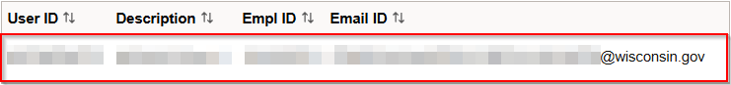
    - Alternatively, you may run WI_SEC_USER_BY_EMPLID to view User ID associated with delegator’s Empl ID and copy into this box.
  - Click on Create Delegation Request.
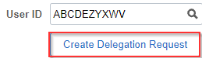
- Start Date defaults to today’s date. If delegation is prospective, select or enter a future date.
- Enter End Date greater than or equal to Start Date, and click Next.
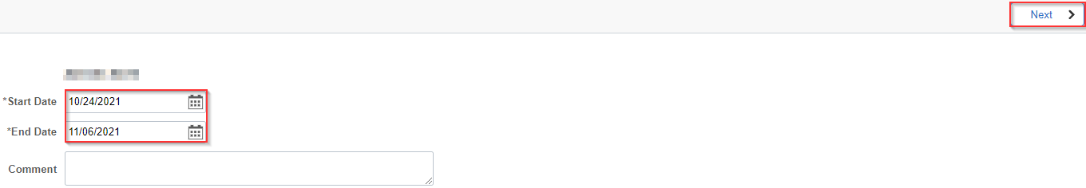NOTE: The End Date is a required field and must be no later than one year past the Start Date. The system will not allow a delegation with a duration greater than one year.
- Click Add Delegate.
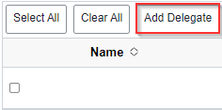
- Repeat Step 1(b) to search for the delegate by User ID, Empl ID, name, or email address. You may only select one delegate so this field will be greyed out after this step.
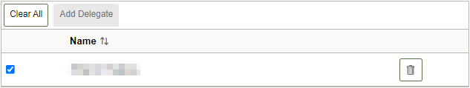
- Click the checkbox next to each transaction being selected or click Select All if all transactions are being delegated to a delegate, then click Next.
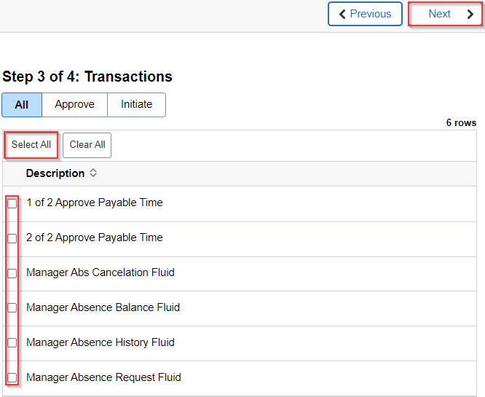
NOTE: Best practice is to delegate all transactions, but if selecting specific rows, make sure to check both Approve Payable Time transactions to reroute payable time correctly.
- If any of the transactions selected have already been assigned, then you will receive the error message below. The dates, delegate, and/or transaction must be corrected to proceed.

- Review Delegation Details for accuracy then click Submit to finalize the delegation.
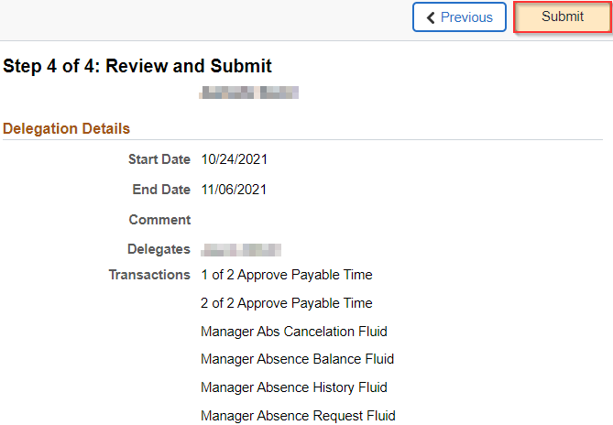
IMPORTANT: The delegate will receive an automated email with a link to accept the delegation. This step is required to make the delegation active. Timesheets may need to be resubmitted or nightly Time Administration processed to reroute existing payable time to the delegate.

ADMINISTER DELEGATION REQUESTS
- Navigate to Administer Delegation page:
  - Navigation: Workforce Administrator Homepage > Payroll Dashboard > Time & Labor Tile > Approvals Folder > Administer Delegation.
- Enter one or more of the following search criteria (all must be exact matches):
  - Start Date and End Date: Specify date range of delegation.
  - Transaction Name: Select a transaction name from the dropdown.
  - Request Status: Select status of requests from the dropdown.
  - Delegation Status: Select status of delegations from the dropdown.
  - Proxy Emplid: Enter Empl ID of delegate.
  - Delegator Emplid: Enter Empl ID of delegator.
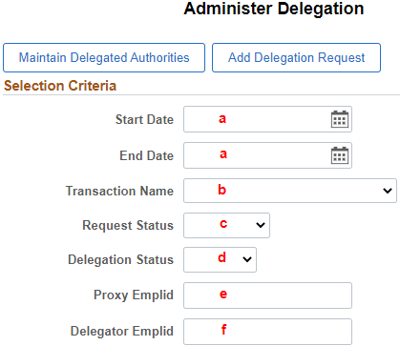
- Once search criteria are entered, click Search.


Review Delegation Request(s)
- Under the search results, transactions names are listed in the Description column. The next columns show various delegation details including the dates and status.
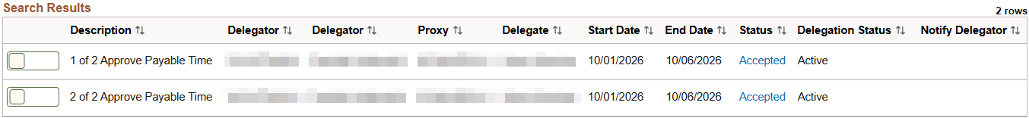

Revoke Delegation Request(s)
- From the search results, select the toggle switch next to each request to be revoked. When the appropriate delegation requests are selected, click Revoke.
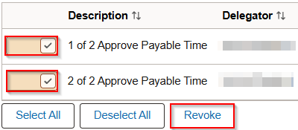
NOTE: The system will send a notification to the delegate affected by the change and automatically reassign all pending transactions back to the delegator.

ADDITIONAL RESOURCES

Transactions
Transaction | Transaction Description
Approve Payable Time (1 and 2) | Reroutes payable time to delegate for approval (always select both rows).
Manager Abs Cancelation Fluid | Allows delegate to cancel absences for delegated staff.
Manager Absence Balance Fluid | Allows delegate to view absence balances for delegated staff.
Manager Absence History Fluid | Allows delegate to view history of absence requests for delegated staff.
Manager Absence Request Fluid | Allows delegate to enter absence requests for delegated staff.

Request and Delegation Statuses
Request Status | Delegation Status | Description
Submitted | Inactive | When a delegator creates a new delegation request the system sets the request status to Submitted and delegation status to Inactive.
Accepted | Active | When a delegate accepts a delegation request, the system sets the request status to Accepted.  The delegation status becomes Active only when the following two conditions occur:  1. The delegate accepts the delegation request.  2. The system date is greater than or equal to the Start Date and less than or equal to the End Date of the delegation period.
Accepted | Inactive | If the delegate accepts the delegation request but the delegation request is future dated, the delegation status remains Inactive until the system date is greater than or equal to the Start Date.
Rejected | Inactive | When a delegate rejects a delegation request, the system sets the request status to Rejected. The delegation status remains Inactive.
Ended | Inactive | When the delegation authority period for the delegate expires, the system sets the request status to Ended and changes the delegation status to Inactive. This change occurs when the system date is greater than the End Date of the delegation authority period.
Revoked | Inactive | When the delegator revokes a delegation request or the delegation administrator revokes the delegation request on behalf of the delegator, the system sets the request status to Revoked and changes the delegation status to Inactive. The system reassigns all pending transactions from the delegate to the delegator.

Delegation Query
To review delegations for active employees, you may run the query: WI_TL_DELEGATION.
- Navigate to Query Viewer page:
  - Navigation: NavBar > Reporting Tools > Query Viewer.
  - Enter WI_TL_DELEGATION into the begins with field.
  - Click Search.
  - Select the desired format for viewing the query.
  - Enter any desired prompts.
  - Click View Results.

