
Manage Quick Fills Job Aid
Version 1.0
Version History
Version | Date | Editor | Description
1.0 | 10/3/24 | Matt Olsen | Initial release
Role: Agency T&L Specialist

OVERVIEW
Employees who report time to tasks (Taskgroup/Task Profile, Combo Code, User Field 5) based on their Time Reporter Data setup have an option to create Quick Fills that automatically populate the additional fields selected from a dropdown on the timesheet.
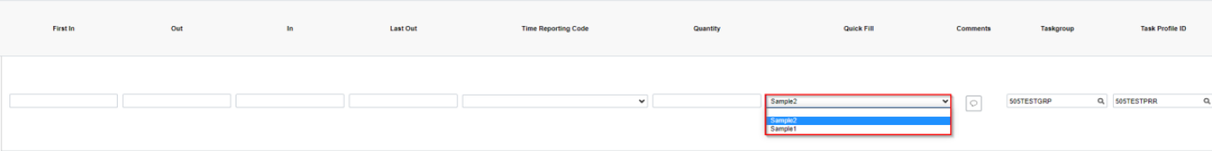
If these Quick Fills have funding tied to the Taskgroup/Task Profile or Combo Code entries, agencies should monitor them to ensure inactive or incorrect Chartfield combinations are deleted when there is an employment change and/or periodic funding change.
When an employee transfers between agencies and reports time to tasks at both agencies, all existing Quick Fills are retained in the new position. The sending agency should delete prior agency Quick Fills as part of their pre-transfer reviews if possible. It is recommended that the receiving agency also review at the time of hire to ensure prior agency Quick Fills are deleted.
NOTE: Only the receiving agency will be able to access the employee’s Quick Fills once the transfer is entered in STAR HCM.

DELETE QUICK FILLS
Agency users with the T&L specialist role can permanently delete one or more Quick Fills that employees should no longer use on the Agency Quick-Fill Delete page.
- Navigation: NavBar → State of Wisconsin (STAR) → Time and Labor → Process → Agency Quick-Fill Delete.
- Enter one or more of the prompts to filter to the desired group that you want to delete, then click Search.
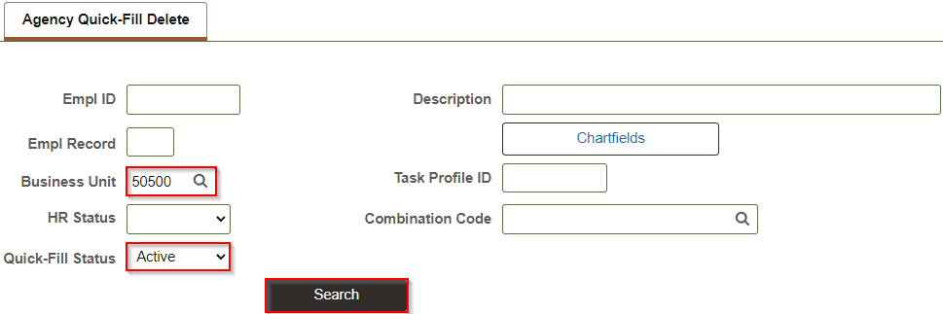
- A list will populate with all Quick Fills based on the selected prompts. Click on any of the column headers to sort by that field if desired.
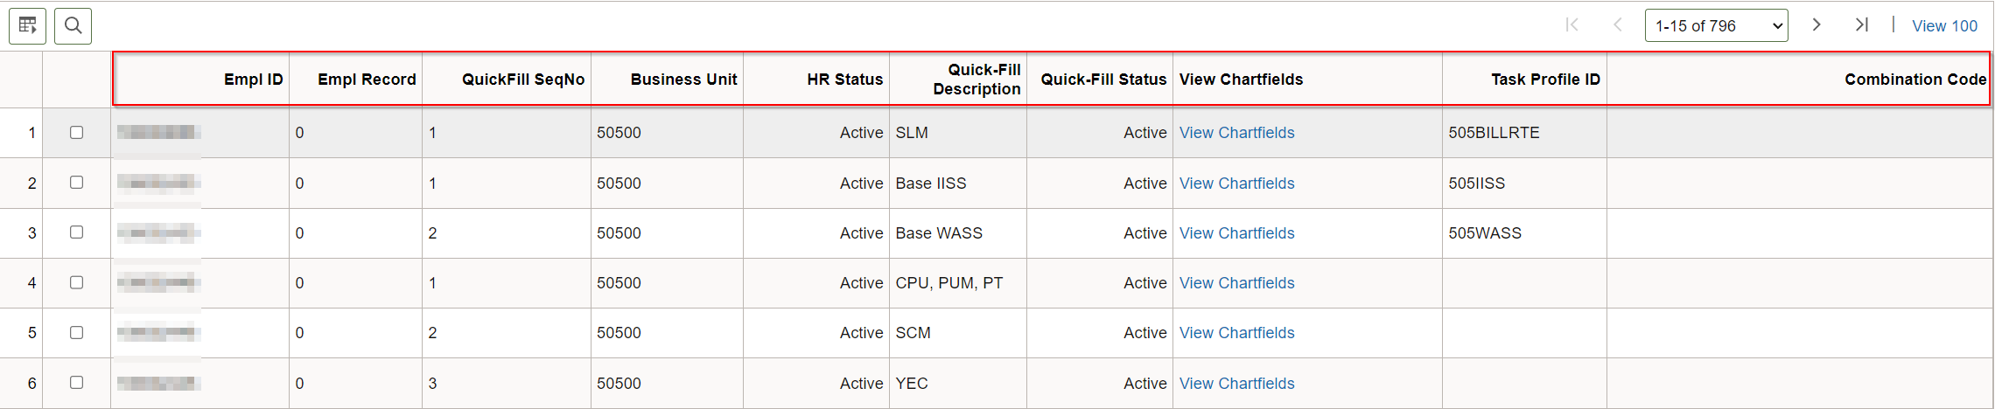
- Select the checkbox next to each individual row that should be deleted or click Select All if every row in the current search parameters should be deleted.
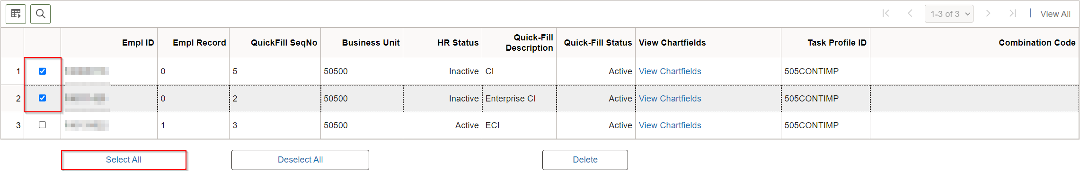
- Once all rows to be deleted are checked, click Delete.
- A pop-up message will appear to confirm the deletion. Click OK.
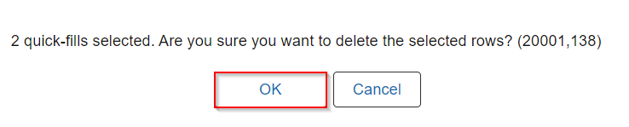
- A second pop-up message will appear indicating how many rows were deleted. They will also be removed from the current list. Click OK.
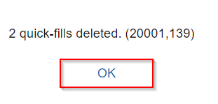
- Deleted Quick Fills already used on the timesheet will display as ‘(Invalid Value)’. If any of these are being used in the current pay period, contact the employees to ensure timesheet rows are changed to the correct Quick Fills or task reporting details are manually entered.
- Repeat steps 2-8 if you have additional Quick Fills to review and/or delete.
NOTE: To review deleted Quick Fill rows, you may run public query: WI_TL_AUDIT_QF_DELETED.

MASS DELETE QUICK FILLS
Agencies may request a mass delete of Quick Fills if there are 100 or more rows to be deleted that are not easily filtered/deleted through the Agency Quick-Fill Delete page. To request a mass deletion of Quick Fills, create a T&L STAR Ticket. A workbook will be provided to select the rows for deletion.

