
Military Leave Accrual Entitlement Job Aid Rev. 4/2026

Version History
Version 1 Date 3/5/2021 Editor Brenda Williams Description Initial Release
Version 2 Date 8/19/2021 Editor Brenda Williams Description WI_MILITARY added Element Name to
Absence Adjustment
Version 3 Date 12/2023 Editor Brenda Williams Description Instructions on Calculating Balances
Version 4 Date 4/2026 Editor Brenda Williams Description Additions recommended by Military Workgroup

Table of Contents
Role, Resource, and Policy Links 2
Military Absence Codes 3
How WI_MILITARY_ENT Works 3
Calculating Accrued Leave Earned While on Military Deployment………………………………………………………………………………..4
Entering A Military Entitlement 5
When there is Military Leave Balance at the end of Calendar Year 6
When the Employee Terminates with a Military Leave Balances 7

Role:
Agency Absence Specialist or Agency FMLA Coordinator

Resources:
Military Leave Benefits Guide
Please refer to the Military Leave Benefits Guide for more information on a Military Leave of Absence.

Policy:
WI HR Ch 720: Military Leave refer to Sec. 720.130.3 Benefits Administration
OSER-0140-CLR/LR/PP: Extension of Military Leave Benefits for an Additional Two Years
OSER-0046-CLR-LR: Implementation of Exec Order #50: Extending Military Leave Benefits
Section IV. Extension of Accrued Leave credits
Note: Accrued leave that may be carried beyond the calendar year, but not more than two years, includes vacation, personal holidays, and Sat./legal holidays (floating).
Example: For example, an employee is activated on July 1, 2003, and returns to work on July 1,2005. At the time of activation, this employee had 40 hours of unused accrued leave time available for use. Upon return to work on July 1, 2005, the employee is granted an additional 216 hours of unused accrued leave time (40 hours of the remainder of 2003, 108 hours for 2004, and 68 hours for the first half of 2005). The appointing authority shall permit this employee to carry over 256 (40 plus 216) hours of accrued leave until December 31, 2007. Any accrued leave time in excess of these 256 hours is time earned after the employee returned to work from military activation and is, therefore, subject to the carryover provisions outlined in the statues or applicable bargaining agreements.
WI_MILITARY_ENT in PeopleSoft/STAR is used for tracking unused accrued annual leave (vacation), legal holiday, and personal holiday leave accrued prior to and during a military deployment/LOA of 31 days or longer. An employee returning to work has the following 2 calendar years to use. If not used by that time, the balance is lost.
Bulletin OSER-0046-CLR/LR does not provide a minimum length of deployment to use the leave accrued prior to deployment and the accrued leave while on deployment. Therefore, any employee who is “activated to serve…other than for training purposes” per s. 230.315, Wis. Stats., (but not if eligible only under the 30-day provision under s. 230.35 (3)(a)), shall be eligible for the extended leave carryover.

If a state observed legal holiday falls within the period the employee is on Military deployment/LOA, enter the military absence code on the timesheet. Only legal holiday accrued prior to being deployed may be used while on deployment, if specifically requested by the employee. Legal holiday accrued while on deployment will remain in the employee’s balance until the employee is re-employed and the unused accrued hours will be added to the WI_MILITARY_ENT.
The employee is eligible to use paid leave accrued prior to the Military deployment/LOA, except sick leave. The employee MAY NOT USE paid leave that is accruing during the deployment. The unused accrued leave should be placed in the WI_MILITARY_ENT/Military Accrual Award upon re-employment. Instructions below.
If you have policy related questions on Military Leave, please email the Bureau of Classification and Compensation at: DOADPMCompEmploymentRelGenInfo@wisconsin.gov
If you have questions about making entries in PeopleSoft/STARS please email: doacentralpayroll@wisconsin.gov.

Military Absence Codes:
While on military leave timesheets must be completed. The Miliary Leave Benefits Guide has detailed instructions on how to properly complete the timesheet.
MILPD (Mil Paid first 30 days)
Use if the employee’s state pay is greater than their military pay and the employee qualifies for the military pay differentials. Allows for the employee to receive the difference between state pay and military pay. Allows for accrual of annual leave, personal holiday, legal holiday and sick.
MIL30 (Mil Paid after first 30 days/240 Hrs)
Use if the employee’s state pay is greater than their military pay and the employee qualifies for military pay differentials. Allows for the employee to receive the difference between state pay and military pay. Allows for accrual of annual leave, personal holiday, legal holiday and sick.
MILNP (Mil Leave Without Pay)
If State pay is less than their military pay the employee does not qualify for pay differential. Allows for accrual of annual leave, personal holiday, legal holiday and sick.
Leave Without Pay (LWOP) - Reason Code Not Eligible for Military Leave
If the employee is not eligible to use the MILNP, MILPD, or MIL30 absence codes for their military leave, the employee will be allowed the time off but will need to enter LWOP - Reason Not Eligible for Military Leave on their timesheet. These hours are covered under USERRA. Does NOT allow for accrual of leave.

How WI_MILITARY_ENT Works
A WI_MILITARY_ENT bucket is created upon re-employment to state service AFTER a Military deployment of 31 days or longer. This bucket stores unused accrued leave hours prior to deployment and while on deployment. An employee returning to work has the following 2 calendar years to use.
The Military entitlement and balance will appear on the Results by Calendar Group (RCG) screen under the Element Name WI_MILITARY_ENT/Military Accrual Award once the Assign Entitlements and Takes screen has been populated. At that point the entitlement will be available for use on the employee’s timesheet.
- Qualified unused annual leave (vacation), legal holiday, and personal holiday leave accrued prior to and while on military deployment is to be converted to WI_Military_Ent at the time of re-employment by calculating the total hours of accrued annual leave, legal holiday, and personal holiday leave over the entire deployment period. Allow the unused accrued leave to be lost at the end of each calendar year in the system while the employee is on the Military deployment/LOA.
- An employee returning from an approved Military deployment/LOA has the following 2 calendar years to use their previously lost leave.
Example:
  - Initial entitlement is keyed 06/06/2021-12/31/2021 for 300 hours.
  - Employee uses 100 hours in 2021 leaving a 200-hour ending balance in 2021.
  - A new entitlement is keyed 01/01/2022-12/31/2022 for 200 hours.
  - Employee uses 100 hours in 2022 leaving a 100-hour ending balance in 2022.
  - A new entitlement is keyed 01/01/2023-12/31/2023 for 100 hours.
  - Any remaining hours at the end of 2023 will be lost.
- At the end of each calendar year, the military entitlement balance will drop off the RCG screen, regardless of the end date keyed on the Assignment Entitlements and Takes screen.
  - If at the start of the second and third year there is a remaining balance, the agency will need to enter new rows on the Assignment Entitlement and Take screen.
  - If it is the end of the third year, any remaining balance is lost.

Calculating Accrued Leave Earned While on Military Deployment
- If the deployment is not crossing a calendar year, when the employee returns from a deployment of 31 or more days and is re-employed, the agency must calculate the total hours of annual leave (vacation) and legal holiday accrued prior to and while on deployment. Add the personal holiday balance to the unused accrued leave to arrive at the TOTAL UNUSED ACCRUED LEAVE HOURS. The sum of these hours is what is entered in the Military Accrual Entitlement.
  - Enter an absence adjustment in the pay period the employee is re-employed decreasing the annual leave (vacation), legal holiday, and personal holiday balances by the TOTAL UNUSED ACCRUED LEAVE HOURS. On the absence adjustment enter in the Description: Balances added to the Military Leave Accrual Entitlement upon employee returning to work from deployment.
  - Enter the Military Entitlement. See instructions below.
- If the deployment is crossing calendar years, only the vacation balance up to 40 hours will automatically carry forward. We do not want this to happen. Instead do the following:
  - When the employee returns from a deployment of 31 or more days and is re-employed, the agency looks at the annual leave (vacation), legal holiday, and personal holiday balances as of 12/31/## on the Results by Calendar Group screen for the prior calendar year(s).
    - Enter an absence adjustment to zero the annual leave (vacation), legal holiday, and personal holiday balances as of 12/31/## in the FINAL pay period of the year. (I.e., for 2023 that would be 2024B02, not 2024B02A). Description: Balances added to the Military Leave Accrual Entitlement upon employee returning to work from deployment.
  - For the current calendar year, calculate the total hours of annual leave (vacation) and legal holiday accrued while on deployment in that year. Add the personal holiday balance to the unused accrued leave to arrive at the total unused accrued leave hours for the current year.
    - Add together previous calendar year(s) leave balance hours and the current year’s unused accrued leave hours to arrive at the TOTAL UNUSED ACCRUED LEAVE HOURS for all years the employee was deployed. The sum of these hours is what is entered in the Military Accrual Entitlement.
    - Enter the absence adjustment in the pay period the employee is re-employed decreasing the annual leave, legal holiday, and personal holiday balances by the unused accrued leave hours for the current year. On the absence adjustment enter in the Description: Balances added to the Military Leave Accrual Entitlement upon employee returning to work from deployment.
    - Enter the Military Entitlement upon re-employment. See instructions below.

Entering A Military Entitlement
Main Menu > Global Payroll & Absence Mgmt > Payee Data > Maintain Absences > Assign Entitlements and Takes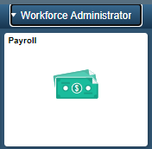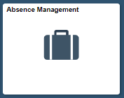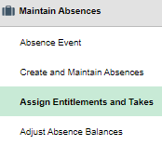
1. Enter the Empl Id under the Find an Existing Value tab.
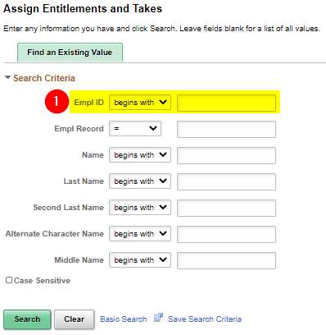
2. Click to expand all available columns.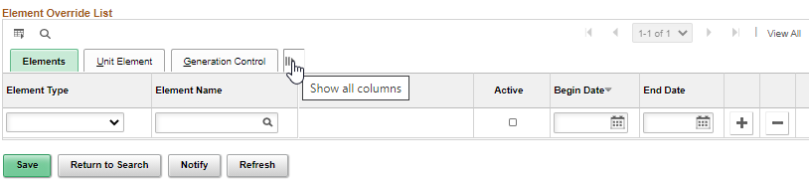
Two rows will need to be added.
3. Element Type: Absence Entitlement with Element Name: WI_MILITARY
4. Element Type: Absence Take with Element Name: WI_MILITARY_LV_TK
  - Make sure the Active box is checked for each line
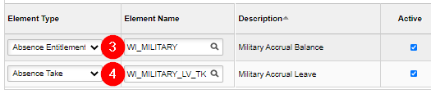
- Begin Date: beginning of the pay period upon re-employment.
- End Date: 12/31/20XX
  - Since entitlements cannot cross calendar years, new rows will need to be added if there is a balance remaining at the end of the first calendar year. See next section for more information.
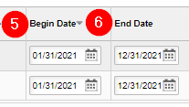
- For Absence Entitlement row
  - Unit Element Type: Numeric
  - Element Name: blank
  - Entitlement Unit: TOTAL UNUSED ACCRUED LEAVE HOURS from calculation above
  - Frequency: Calculate Per Pay Period
  - Frequency ID: blank
  - Generation Control Option: Specified Generation Control
  - Generation Control: WI_MIL_ACCRUAL
When there is Military Leave Balances at the end of Calendar Year 1 and 2
- Since entitlements cannot cross calendar years, two new rows will need to be entered on the Assign Entitlements and Takes screen.
- Review the Results by Calendar Group screen under the Accumulators tab for the last calendar for the year. Determine the remaining WI_Military_Bal/Military Accrual Balance. Use the remaining balance as the Entitlement Unit for the second year and repeat this process for the third year if a balance remains.
- Follow the entry instructions above for the two new rows.
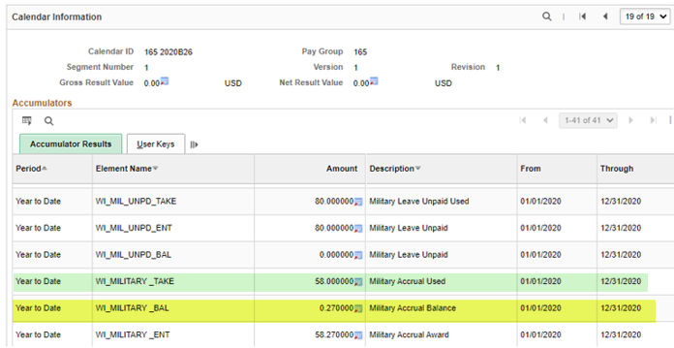
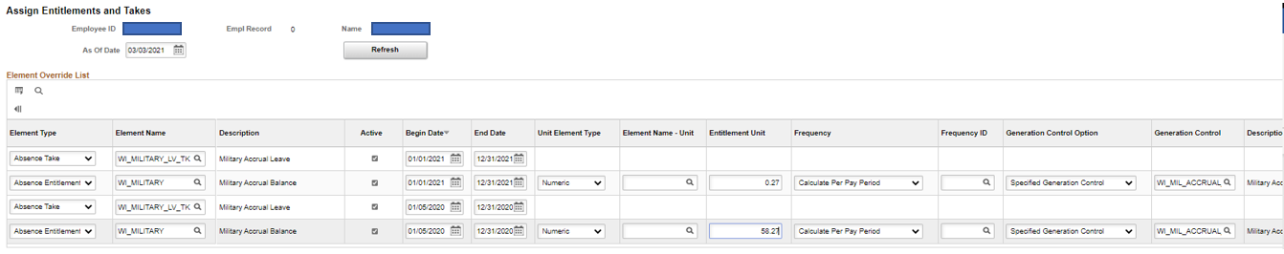
When the Employee Terminates with a Military Leave Balances
If there is a balance remaining in the WI_MILITARY_BAL (Military Accrual Balance) when the employee terminates their employment, include the balance on the Termination Payout calculator. The hours can be added into the Comp Time section or Sabbatical section of the Payout worksheet. The agency should include a comment in the POTT when submitting the LAN/LSR indicating the amount of Military Accrual Leave paid out.
- As of July 2021, the WI_MILITARY element has been added as an absence adjustment selection. When zeroing out balances as part of the termination process, include zeroing out the WI_MILITARY_BAL (Military Accrual Balance). This balance is included in the Results by Calendar Group screen.
- If the employee is transferring to another affiliate and the affiliate are accepting the balances, include the Military Balance on the Personnel Transfer Record form. If the affiliate is not accepting the balances, those hours will have to be included on the Termination Payout calculator.
- Only use the WI_MILITARY element on the absence adjustment screen to decrease the balance. To increase the Military Entitlement, use the Assign Entitlements and Takes as explained above.
