

State of Wisconsin
Department of Administration
Out-of-State Taxes Job Aid

Version 1.7

Version History
Version | Date | Editor | Description
1.0 | 07/13/22 | Matt Olsen | Initial release
1.1 | 07/28/22 | Matt Olsen | Added scenario 5
1.2 | 10/28/22 | Matt Olsen | Updated state setup and additional resources
1.3 | 05/26/23 | Matt Olsen | Added local tax section and updated query instructions
1.4 | 08/04/23 | Matt Olsen | Correction to Tax Validation query references
1.5 | 05/02/24 | Matt Olsen | Added out-of-state remote work section and updated reciprocity state scenarios
1.6 | 01/17/25 | Matt Olsen | Updated multiple sections for new state setup
1.7 | 04/29/26 | Melissa Bartelt | Updated multiple sections for new state setup

Role: Agency Payroll Specialist

Table of Contents
OVERVIEW 2
OUT-OF-STATE REMOTE WORK 2
REVIEW WORK ARRANGEMENT 3
REVIEW HOME ADDRESS 3
REVIEW TAX VALIDATION QUERY 4
UPDATE TAX DATA 5
UPDATE TAX DISTRIBUTION 6
OUT-OF-STATE TAX SCENARIOS 7
REVIEW LOCAL TAXES 18
GLOSSARY 19
ADDITIONAL RESOURCES 20

OVERVIEW
Agency Payroll is responsible for reviewing employees that work and/or live in a state other than WI. Depending on each employee’s situation, Agency Payroll may need to manually update tax fields in STAR HCM to ensure taxable grosses and withholding are applied to the correct state.
This job aid is designed to assist with the review and update process for new hires and current employees with an out-of-state residence and/or work location. If tax updates are not entered timely due to employer error, notify Central Payroll to determine if year-to-date tax corrections are necessary.
Employees may update their own state taxes if submitting a WT-4 for WI tax withholding. All other states require a paper form submitted to Agency Payroll (See Out of State Employee Set Up - Agency Guide).

OUT-OF-STATE REMOTE WORK
If a new hire or current employee requests to work in a state other than WI, confirm with Agency HR that they have approved the out of state telework request. Once the request is verified, follow the next steps in addition to remote work policy and procedures to ensure all documentation and system setup is completed.
Central Payroll recommends best practices that align with the Remote Work Policy documentation, including the DOA-2770, DPM-15902 forms along with the Remote Work Request Tile in ESS, per the guidance below:
- Revised Region 1 - Remote Work Policy
- WI Handbook Chapter 748 Remote Work
- Notify employee to fill out and send a copy of Agency Request to Central Payroll for ​​Non-Wisconsin Employment (DOA-2770)​ to you.
- Obtain the appropriate Agency HR and Appointing Authority signatures, then submit the completed DOA-2770 to Central Payroll for review.
- Central Payroll will notify you if additional steps need to be taken when the employee is working remotely in a state that is not set up in STAR HCM.
- If employee is working remotely in a state that is set up in STAR HCM, follow the steps outlined in the Review Home Address, Update Tax Data, Update Tax Distribution, Out-of-State Tax Scenarios and Review Local Taxes sections.
NOTE: If an employee is in a hybrid remote work agreement with at least 50% of work performed in WI, verify the Tax Residence and Tax Distribution states are set to WI so all taxes are reported to WI.

REVIEW HOME ADDRESS
- Navigate to Modify a Person page.
  - Navigation: Workforce Administrator Homepage > Payroll Dashboard > Payroll Processing Tile > Employee Data Folder > Modify a Person.
  - Enter at least one search criteria and click Search.
- Click on Contact Information tab.
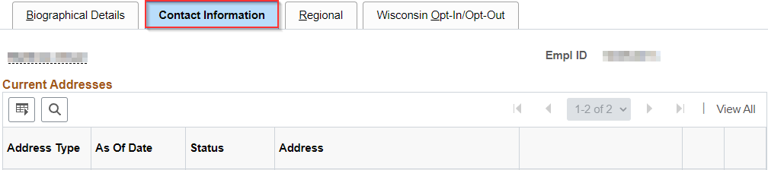
- Review home address to verify employee’s legal residence.
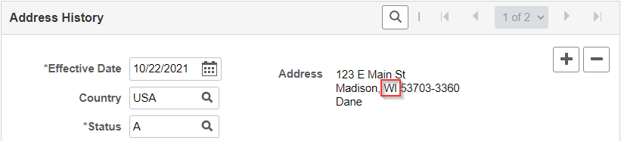
NOTE: If the home address is not up to date, contact employee to update via ESS or HR to update on this page. If the home address is not the legal residence, confirm the legal residence with the employee.

REVIEW TAX VALIDATION QUERY
The tax validation query is designed to be run biweekly by Agency Payroll to review employees with tax, home and/or work data that correspond with a state other than Wisconsin for potential corrections.
- Navigate to Query Viewer page.
  - Navigation: NavBar > Reporting Tools > Query Viewer.
  - Search for the public query: WI_PY_TAX_AUDIT_STATE.
  - Enter any of the optional prompts to narrow down data by Business Unit, Department ID and/or Home Address state.
  - Click View Results.
- Validate warning messages in the Notes column:
  - NO TAX TABLE – Employee’s Home Address state is a state that has no tax table set up in the system. If permanently working in this state, refer to Scenario 10 in the Out-of-state Tax Scenarios section.
  - HOME STATE, TAX RES MISMATCH – Employee’s Home Address state and Tax Resident state do not match. These two should match unless the home address is not the employee’s legal residence, or the employee lives in a reciprocal state and works in WI with no W-220 filed. Refer to the Out-of-state Tax Scenarios section if updates are needed.
  - INVALID UI JURISDICTION – Employee’s UI Jurisdiction state is not WI. This should be WI regardless of the legal residence and work location.
  - LOCAL TAXES MAY APPLY – Employee’s Home Address state is a state that has local tax jurisdictions. Refer to Review Local Taxes section if the employee is working remotely at their home address.
- Contact the employee to verify legal residence, work location and telework arrangement if necessary. Provide appropriate tax form(s) to complete.
- Update Home Address, Tax Resident and/or Tax Distribution if necessary.

UPDATE TAX DATA
- Navigate to Update Employee Tax Data page.
  - Navigation: Workforce Administrator Homepage > Payroll Dashboard > Payroll Processing Tile > Pay Data Folder > Update Employee Tax Data.
  - Enter at least one search criteria and click Search.

- Click on Plus Sign (+) on Federal Tax Data tab to add a new effective dated row.
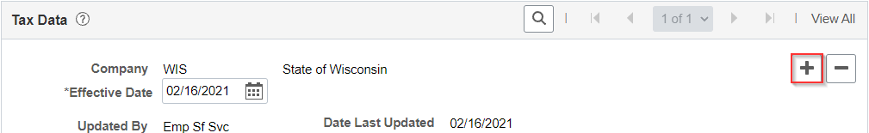
NOTE: A new effective dated row must be added on Federal Tax Data page for a Federal and/or State tax change. If 2019 or Earlier W-4 is the form version in the previous row, Federal Tax Data will default to 2020 or later. Make sure to change back to 2019 or Earlier if only changing State Tax Data.
- Effective Date defaults to today’s date. Select date for the new entry using the first day of the pay period of the change or the next available day in the pay period if needed. Do not use a retroactive date for the effective date.
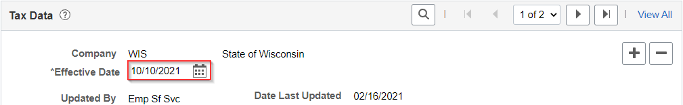
- Click on State Tax Data tab.
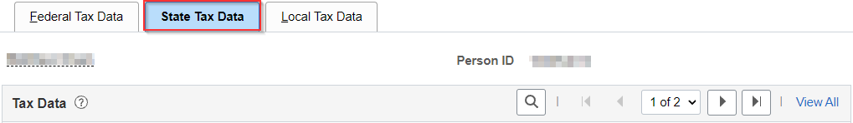
- Update Resident and/or UI Jurisdiction based on the applicable scenario (see Out-of-state Tax Scenarios section). UI Jurisdiction should be WI regardless of the work location.
- When Resident, UI Jurisdiction and State Withholding Elements are updated, click Save.
NOTE: If employee’s tax Resident box is changed and contains a Special Withholding Status other than None, make sure to set to None and default Tax Status/Withholding Allowances to S and 0, respectively.

UPDATE TAX DISTRIBUTION
- Navigate to Update Employee Tax Distribution page.
  - Navigation: Workforce Administrator Homepage > Payroll Dashboard > Payroll Processing Tile > Pay Data Folder > Update Tax Distribution.
  - Enter at least one search criteria and click Search.
- Click on Plus Sign (+) in Tax Distribution section to add a new effective dated row.
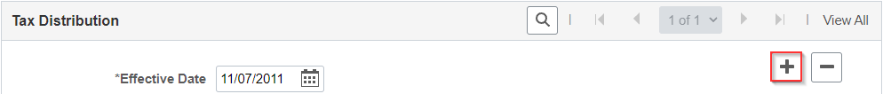
- Effective Date defaults to today’s date. Select date for the new entry using the first day of the pay period of the change. Do not use a retroactive date for the effective date. Create a Payroll STAR Ticket to request correction to an existing row if necessary.
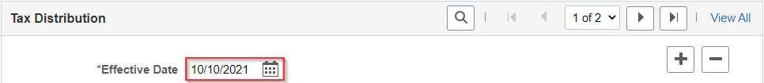
- Enter appropriate state and keep Percent of Distribution as 100.000.
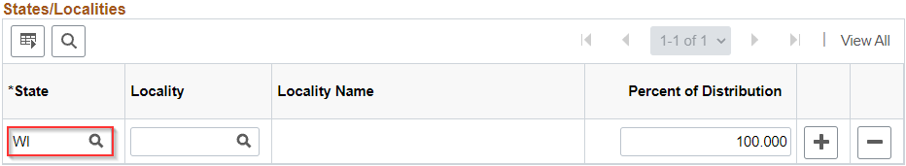
- When State is updated, click Save.

OUT-OF-STATE TAX SCENARIOS
The following examples are designed to cover the most common out-of-state tax scenarios once the employee’s residence and work location are confirmed. Refer to the chart below for reciprocity rules and tax tables for each state. Only states with tax tables in STAR HCM can be selected in Tax Data.
For additional guidance on out-of-state employee tax setup, refer to the Out of State Employee Set Up - Agency Guide.
States | Reciprocity Agreement | Tax Table in STAR HCM
IL, IN, MI, and KY | YES | YES
AZ, CO, CT, DE, FL, GA, IA, KS, MA, MD, MN, MO, NC, NJ, NV, NY, PA, SC, TX, UT, VA, DC | NO | YES
All other states | NO | NO

NOTE: Employees who perform at least 50% of their work in MN qualify for the MN Paid Leave program. Contact Central Payroll or Melissa Bartelt for assistance with payroll deduction setup.

Summary of scenarios:
Scenario | Description
Scenario 1 | Employee’s work location and legal residence are in reciprocal state (e.g. IL, MI).
Scenario 2 | Employee’s work location is in WI and legal residence is in reciprocal state (e.g. IL, MI). Employee submits an optional W-220 and IL-W-4 to have IL taxes withheld.
Scenario 3 | Employee’s work location is in WI and legal residence is in MN.
Scenario 4 | Employee’s work location is in WI and legal residence is in a non-reciprocal state (e.g. IA) other than MN with a tax table.
Scenario 5 | Employee’s work location is in WI and legal residence is in a non-reciprocal state (e.g. TN) with no tax table.
Scenario 6 | Employee’s work location is in reciprocal or non-reciprocal state (e.g. IL, IA) and legal residence is in WI.
Scenario 7 | Employee’s work location and legal residence are in non-reciprocal state (e.g. IA, MO).
Scenario 8 | Current employee moves from reciprocal or non-reciprocal state to WI - taxes are being withheld for the other state (e.g. MI, IA). Their updated work location and legal residence are in WI.
Scenario 9 | New hire or rehired employee has incorrect tax Resident box load to State Tax Data because of a previous home address in Modify a Person. Their updated work location and legal residence are WI.
Scenario 10 | Employee’s permanent work location and legal residence are in reciprocal or non-reciprocal state (e.g. NY, WA) that does not have a tax table set up in STAR HCM.

Scenario 1: Employee’s work location and legal residence are in reciprocal state (e.g. IL, MI).
- Follow Steps 1-3 in Update Tax Data section, then click the Plus Sign (+) on State Information tab to add a new state.
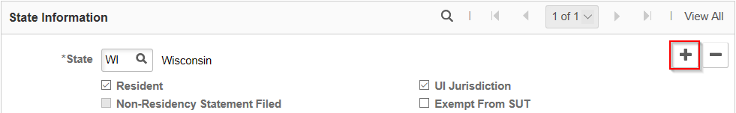

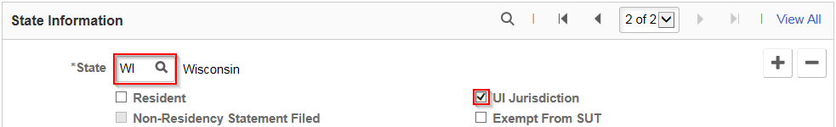
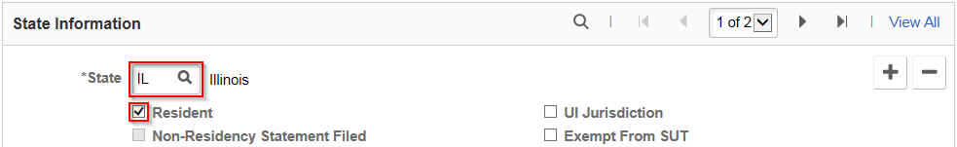
- Update each row to reflect employee’s residence (Resident) and work location (UI Jurisdiction – always WI). Check the respective box under each state.

- Follow Steps 1-3 in Update Tax Distribution section, then update Tax Distribution state to match employee’s work location of IL.
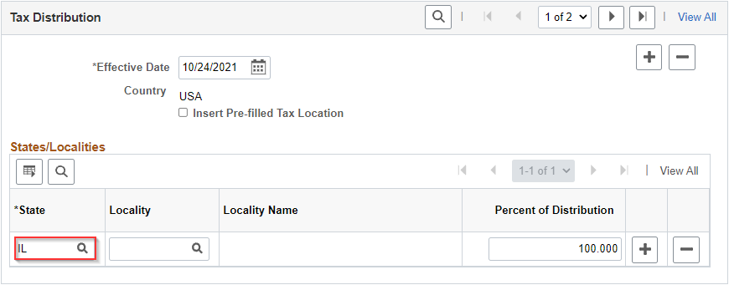
- Provide the employee with the corresponding state’s tax form to complete for entry by Agency Payroll.

Scenario 2: Employee’s work location is in WI and legal residence is in reciprocal state (e.g. IL, MI). Employee submits an optional W-220 and IL-W-4 to have IL taxes withheld.
- Follow Steps 1-4 in Update Tax Data section, then click the Plus Sign (+) on State Information tab to add a new state.
- Update each row to reflect employee’s residence (Resident) and work location (UI Jurisdiction – always WI). Check the respective box under each state. Make sure the WI UI Jurisdiction row is set to default statuses shown below.
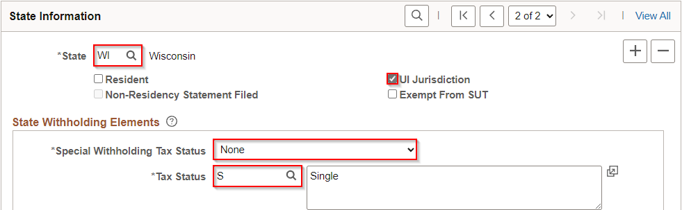
- Verify Tax Distribution state matches work location of WI.
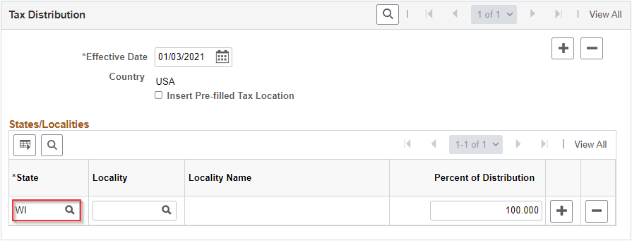

Scenario 3: Employee’s work location is in WI and legal residence is in MN.
- Follow Steps 1-3 in Update Tax Data section, then click the Plus Sign (+) on State Information tab to add a new state.
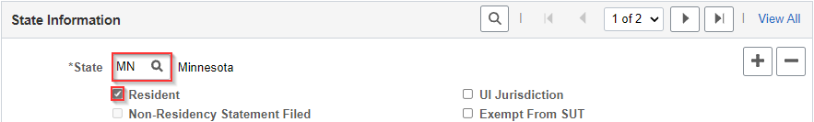
- Update each row to reflect employee’s residence (Resident) and work location (UI Jurisdiction – always WI). Check the respective box under each state.

- Verify Tax Distribution state matches work location of WI.
- Provide the employee with a copy of the Form W-4MN to update their MN marital status and allowances. Notify the employee to submit a WT-4 in ESS to update their WI marital status and allowances.

Scenario 4: Employee’s work location is in WI and legal residence is in a non-reciprocal state (e.g. IA) other than MN with a tax table.
- Follow Steps 1-3 in Update Tax Data section, then click the Plus Sign (+) on State Information tab to add a new state.
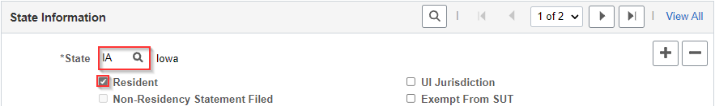
- Update each row to reflect employee’s residence (Resident) and work location (UI Jurisdiction – always WI). Check the respective box under each state.

- Verify Tax Distribution state is set to WI. If not, follow Steps 1-3 in Update Tax Distribution section, then update Tax Distribution state to match employee’s work location of WI.
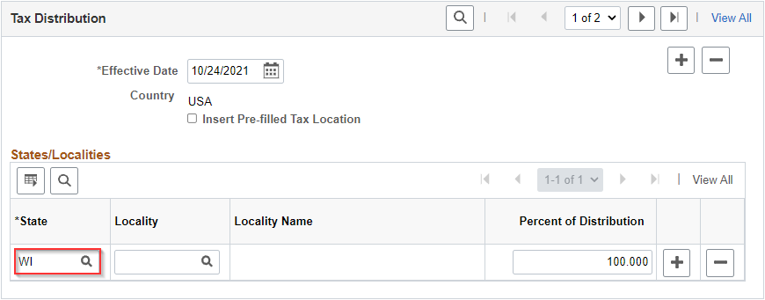
- Notify the employee to submit a WT-4 in ESS to update their marital status and/or allowances.

Scenario 5: Employee’s work location is in WI and legal residence is in a non-reciprocal state (e.g. TN) with no tax table.
- Follow Steps 1-3 in Update Tax Data section, then click Minus Sign (-) on State Information tab to remove the incorrect state.
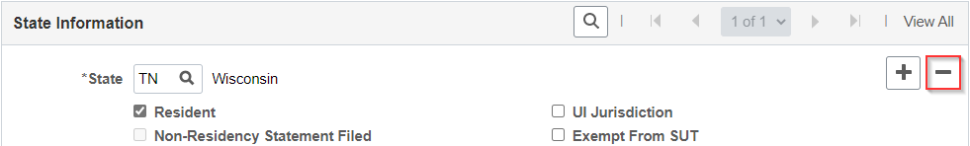
- Update remaining row to reflect employee’s tax residence (Resident) and work location (UI Jurisdiction) for reporting taxes to WI. Check both boxes in the WI row.
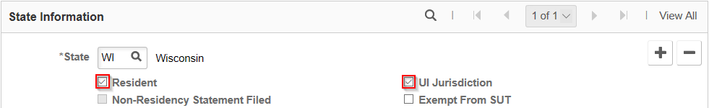
- Verify Tax Distribution state matches work location of WI.
- Notify the employee to submit a WT-4 in ESS to update their marital status and/or allowances.

Scenario 6: Employee’s work location is in reciprocal or non-reciprocal state (e.g. IL, IA) and legal residence is in WI.
- Follow Steps 1-3 in Update Tax Data section, then click the Plus Sign (+) on State Information tab to add a new state.
- Update each row to reflect employee’s work location and residence. The Resident box will not match the employee’s residence in this scenario but is required to withhold taxes correctly.
NOTE: If work location is in a reciprocal state, make sure to set the Special Withholding Tax Status to None and Tax Status to S in the WI UI Jurisdiction row.

- Follow Steps 1-3 in Update Tax Distribution section, then update Tax Distribution state to match employee’s work location of IL.
- Provide the employee with the corresponding state’s tax form to complete for entry by Agency Payroll.

Scenario 7: Employee’s work location and legal residence are in non-reciprocal state (e.g. IA, MO).
- Follow Steps 1-3 in Update Tax Data section, then click the Plus Sign (+) on State Information tab to add a new state.
- Update each row to reflect employee’s residence (Resident) and work location (UI Jurisdiction – always WI). Check the respective box under each state.

- Follow Steps 1-3 in Update Tax Distribution section, then update Tax Distribution state to match employee’s work location of IA.
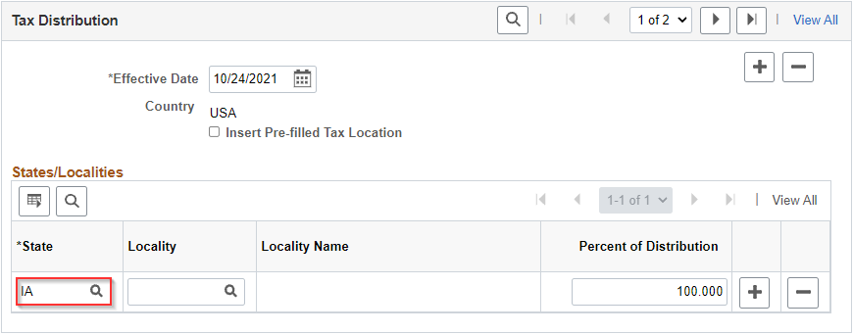
- Provide the employee with the corresponding state’s tax form to complete for entry by Agency Payroll.

Scenario 8: Current employee moves from reciprocal or non-reciprocal state to WI - taxes are being withheld for the other state (e.g. MI, IA). Their updated work location and legal residence are in WI.
- Follow Steps 1-3 in Update Tax Data section, then click Minus Sign (-) on State Information tab to remove the state that is no longer the residence.
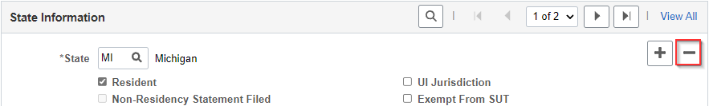
- Update remaining row to reflect employee’s residence (Resident) and work location (UI Jurisdiction). Check both boxes in the WI row.

- Follow Steps 1-3 in Update Tax Distribution section, then update Tax Distribution state to match employee’s work location of WI.
- Notify the employee to submit a WT-4 in ESS to update their marital status and/or allowances.

Scenario 9: New hire or rehired employee has incorrect tax Resident box load to State Tax Data because of a previous home address in Modify a Person. Their updated work location and legal residence are in WI.
- If the home address is not up to date, contact employee to update via ESS or HR to update on Modify a Person.
- Follow Steps 1-3 in Update Tax Data section, then click Minus Sign (-) on State Information tab to remove the incorrect state.
- Update remaining row to reflect employee’s residence (Resident) and work location (UI Jurisdiction). Check both boxes in the WI row.

- Verify Tax Distribution state matches work location of WI.
- Notify the employee to submit a WT-4 in ESS to update their marital status and/or allowances.

Scenario 10: Employee’s permanent work location and legal residence are in reciprocal or non-reciprocal state (e.g. NY, WA) that does not have a tax table set up in STAR HCM.
- Complete the Agency Request to Central Payroll for Non-Wisconsin Employment Form and send to Central Payroll as soon as you are aware of the approved, permanent relocation for out-of-state work to set up the tax table.
- Maintain WI Tax Data and Tax Distribution setup until registration is complete.
- Central Payroll and Finance will research and register with the state for tax withholding and local tax jurisdiction if applicable. You will be notified when this is complete to request appropriate tax withholding forms and detail any other factors applicable to that state.

REVIEW LOCAL TAXES
If an employee performs work in a state and region with local taxes, then additional setup is needed to apply local tax withholding. Use the steps below to enter Local Tax Data for employees working in one of the five locations with a local tax table in STAR HCM.
For additional information on local tax withholding setup, refer to the Out of State Employee Set Up - Agency Guide.
- Follow Steps 1-6 in Update Tax Data section, then click on Local Tax Data.
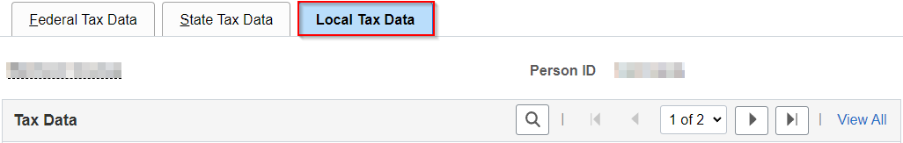
- Enter the Locality and Other Work Locality based on the system settings for the corresponding location. If the employee works in a location with no tax table, refer to Scenario 10 in the Out-of-state Tax Scenarios section.
Local Tax Location | Locality | Other Work Locality | Tax Distribution Locality
Aurora, CO | 04000 | 04000 | 04000
Denver, CO | 20000 | Leave blank | 20000
Tippecanoe County, IN | 157 | Leave blank | Leave blank
Campbell County, KY | 037 | Leave blank | Uses city distribution
Fort Thomas, KY | 28594 | 037 | 28594
Derry Township, PA | 220201  0220125C | O220125C  220201 | O220125C

- Keep the Local Withholding Elements as the default values then click Save.
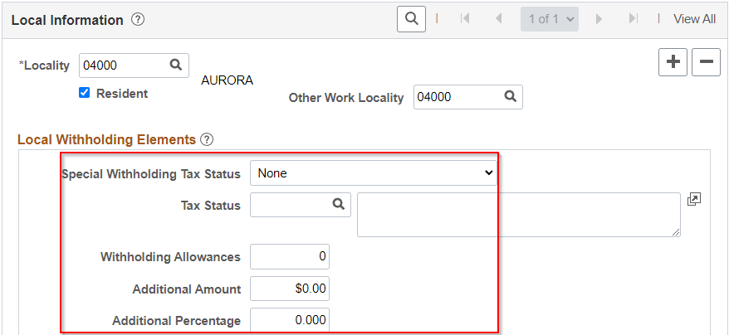
- Follow steps 1-3 in Update Tax Distribution section then enter appropriate state and locality. Keep Percent of Distribution as 100.000.
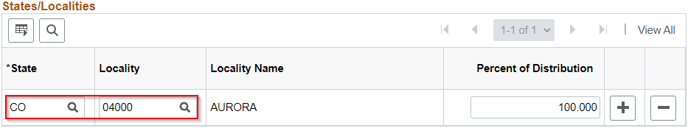
- When State and Locality are updated, click Save.

GLOSSARY
Domicile
A "domicile" is a person's true, fixed, and permanent home where a person intends to remain permanently and indefinitely and to which a person has the intention of returning, whenever absent. It is often referred to as "legal residence."
Legal Resident
A legal resident of Wisconsin is a person who maintains his or her domicile in Wisconsin, whether s/he is physically present in Wisconsin or living outside of the state.
Non-reciprocal State
A state with which Wisconsin does not have a reciprocity agreement so residents of this state working in Wisconsin may be subject to income tax laws of both states.
Reciprocal State
A state with which Wisconsin has a reciprocity agreement so that residents of this state working in Wisconsin will be taxed on income earned as an employee by their home state and not by Wisconsin.
Tax Data
A STAR HCM page used to determine the Federal and State withholding rate applied to earnings, unemployment reporting location, and residency for additional earnings reporting and tax withholding (when applicable).
Tax Distribution
A STAR HCM field that populates the tax state on an employee’s pay lines. The state defaults to WI based on the Tax Location code in Job Data. It should match the employee’s primary work location.
Tax Location Code
A STAR HCM field that defines an employee’s telework arrangement as Headquarter Location, Remote or Mixed.
Tax Reciprocity Agreement
An income tax agreement between two states that prevents the same income from being subject to tax by more than one state.
Tax Resident
A STAR HCM field that determines the application of state tax withholding in conjunction with Tax Distribution. The state defaults to the first home address entered in the system on or prior to the hire date. It should usually match the employee’s home address.
Telework Arrangement
A work flexibility arrangement under which an employee performs the duties and responsibilities of his/her/their position, and other authorized activities as determined by the supervisor, from an approved alternate worksite other than the employee’s primary main office, one or more days per week on a standard and recurring basis.

UI Jurisdiction
A STAR HCM Field that determines the application of employer unemployment tax. The state defaults to WI for all employees. This state should always be Wisconsin regardless of work location.
Work Location
A worksite where employees perform their work duties. This is determined by the STAR HCM Location and/or home address.

ADDITIONAL RESOURCES
- Out of State Employee Set Up - Agency Guide
- Agency Request to Central Payroll for Non-Wisconsin Employment Form
- Update Pay Data Job Aid
- DOR Publication W-166 - Withholding Tax Guide
- DOR Publication 121 - Reciprocity
- DOR Wisconsin-Minnesota Tax Reciprocity Termination

