
Pay One Time Transactions (POTT) Job Aid
Version History
Version | Date | Editor | Description
1.0 | 01/12/16 | Ashley Price | Initial release
1.1 | 10/06/22 | Matt Olsen | Content update
1.2 | 01/23/23 | Matt Olsen | Addition of POTT Changes Overview resource
1.3 | 04/02/24 | Tammy Lenzendorf | Phase I POTT Improvements and deleting POTT update
1.4 | 04/14/26 | Tammy Lenzendorf | Fixed to Accessibility requirements
1.5 | 7/16/26 | Courtney Lenzendorf | Phase 2 POTT Improvements and email notifications update
Role: Agency Payroll Specialist
Contents
OVERVIEW 2
COMMON SCENARIOS 2
EARNINGS BEGIN AND END DATES 3
ENTER EARNINGS POTT 4
ENTER DEDUCTION POTT 7
ERROR RESOLUTION 10
FILE UPLOAD 12
REJECTED POTT 12
CHARTFIELD & FUNDING 13
REVIEW/DELETE/CANCEL POTTS 14
View the status of a POTT: 14
Delete a POTT: 15
Request a Cancelation: 15
ADDITIONAL RESOURCES 16

OVERVIEW
POTTs are a customized feature in STAR HCM to adjust earnings and/or deductions for employees that are not automatically processed in the system.
The normal deadline to submit a POTT is Wednesday at 11 a.m. of processing week for the pay period. Only the current and next pay period are available to select for POTT entry.
For a list of common earnings and deductions codes with instructions on their usage, refer to the POTTs - Earnings & Deduction Codes Guide.
Any questions related to earnings POTTs can be directed to Central Payroll. Any questions related to deduction POTTs can be directed to Central Benefits.

COMMON SCENARIOS
Below is a list of common scenarios when a POTT is necessary to adjust an employee’s paycheck. As a rule of thumb, if the earnings or deductions can be resolved by making corrections to the applicable timesheet, absence, or benefit, Agency Payroll should fix using that method instead of POTT.
Scenario | POTT Entry
Pay out unused leave or collecting overdrawn leave for a terming employee. | Earnings POTT coded to LAN/LAR/LSR.
Pay discretionary merit compensation. | Earnings POTT coded to DMC.
Pay a sign-on bonus. | Earnings POTT coded to SA* (specific to type of bonus).
Collect overdrawn legal holiday for an active employee. | Earnings POTT coded to ODL.
Adjust current year WRS hours and earnings. | Earnings POTT coded to WAA.
Collect insurance deductions for employee going on leave of absence. | Deduction POTT coded to applicable insurance deduction codes as an addition.
Override arrears or retro benefits. | Deduction POTT coded to applicable insurance deduction codes as an override.
General deduction not started or ended timely. | Deduction POTT coded to applicable general deduction code as an addition or refund.

EARNINGS BEGIN AND END DATES
If the dates are left blank, they will default to the dates for the current pay period.
When using different earnings begin and end dates:
- You need to manually key both the begin and end dates - never just one date assuming the other date will default.
- Except in limited circumstances, each row should encompass one week or pay period. If you need the earnings to go against multiple weeks or pay periods, separate rows should be used for each weekly period.
Scenarios for using the Earnings Begin and End Date fields in POTTs. All other POTT entries should use the default current pay period dates:
- Use original pay period begin and end dates: If you are changing old hours or differentials from a prior time sheet instead of correcting the time sheet and changes will NOT affect the FLSA rate for non-exempt overtime from that week.
    - Example 1: Board member per diems
    - Example 2: Timesheet corrections from prior pay periods where Finance has requested specific funding for that change.
    - Example 3: Lump sums necessary because of a change to work time on a prior pay period time sheet where the add-on is normally paid by Add’l Pay.
- Use original weekly begin and end dates: If you are changing old hours or differentials from a prior time sheet instead of correcting the time sheet and the changes will affect the FLSA rate for non-exempt overtime for that week.
    - Example 1: Timesheet corrections from prior pay periods for non-exempt employee with overtime in the affected week.
    - Example 2: Lump sums necessary because of a change to work time on a prior pay period time sheet where add-on is normally paid by Add’l Pay.
When submitting batch (file) uploads for POTTS, you have two options:
- Load with no dates: The columns must be completely empty and there can be no comma between the two empty columns. Those two are the last columns in the file so you just set up the CSV as if those last two columns do not exist.
- Load with dates (if POTT is for applicable scenario above): All rows must have earnings begin and end dates entered or none of the data will load. You do NOT need to use the same earnings dates with all rows.

ENTER EARNINGS POTT
Earnings POTTs are used to increase or decrease earnings for an employee in a specific pay period. As a rule of thumb, LAN/LSR POTTs should be an individual batch per employee. All other types of earning POTTs can be organized into batches by earnings code and/or employee, whichever is preferred.
- Navigate to Enter POTT – By Batch page.
  - Navigation: Workforce Administrator Homepage > Payroll > Payroll Processing Tile > POTT Folder > Enter POTT – By Batch.
  - Click Add a New Value.
  - Enter Company, Pay Group, Pay Period End Date. Verify these for accuracy before starting the batch because they can no longer be changed after batch is added.
  - Do not check the Off Cycle box unless tied to a year-end off-cycle payroll.
  - Select Transaction Type of Earnings from the dropdown menu.
  - Click Add.
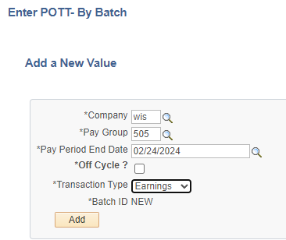
- Enter or update the fields below:
  - Empl ID: Employee ID.
  - Empl Rec: Employee Record (use applicable record).
    - If an Employee Record not tied with the organizational relationship of employees is entered (i.e. Person of Interest), a hard error message will appear and not allow the POTT to proceed until corrected.
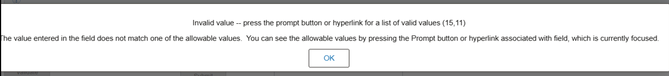
    - If a non-existing Employee Record is entered, a hard error message will appear and not allow the POTT to proceed until corrected.
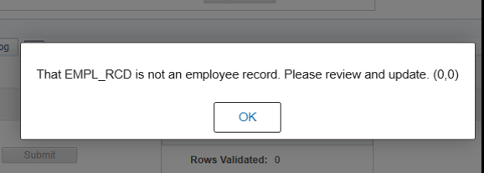
  - Earnings Begin Date: defaults to current pay period, change if need to point to different dates.
  - Earnings End Date: defaults to current pay period, change if need to point to different dates.
  - Erncd: Earnings Code.
  - Oth Hrs: Hours associated with earnings code (negative to collect; positive to pay).
  - Amount: Flat amount associated with earnings code (negative to collect; positive to pay).
  - One Time Cd: Always use Addition for earnings POTTs.
  - Sepchk#: Should be 0 unless earnings need to be on a separate check by using 1.
  - Comments: Notes to clarify the reason for POTT.
    - If you are submitting a POTT, you will only be able to enter a comment in the submitter comment box.
    - If you are reviewing a POTT (central staff only), you will only be able to enter a comment in the reviewer comment box. Reviewer will list the reason a POTT row was rejected for agency correction. Agencies will have read-only access to the Reviewer comments.
- Click the Plus box to add a row(s) if needed and repeat Step 2.
- Click on Attach or View Supporting Documents to add supporting documentation(s).
  - Click Add.
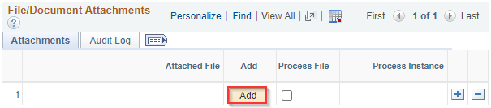
  - Click Choose File. Navigate to and select the supporting document from your PC. Or you can drag a document by placing the curser on the “choose file” and drop.
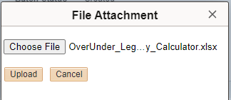
  - Click Upload.
  - Add clarifying information in the Description (optional).
  - Click the Plus box to add another document or Return to continue with the POTT entry.
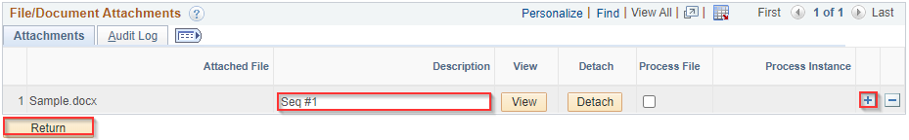
- When all rows are completed and documents attached, click Save. Now the number of supporting documents will appear.
- Click Validate. This will be grayed out until Save is clicked.
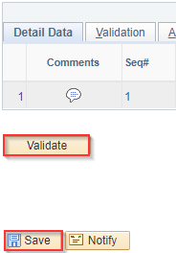
- Verify there are no rows with errors. If there are one or more rows with an error, refer to the Error Resolution section for additional instructions.
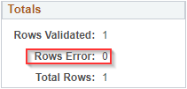
- Click Submit to submit the batch to Central Payroll for review and approval.
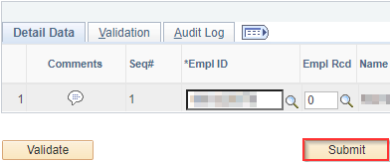
- Pop-up will appear “Are you sure you want to submit this batch for review? Note: Only rows with Validation Status of OK are pushed for Review/Approval. Yes or No” Click appropriate answer.
Once Central Payroll has reviewed the POTT, the agency will receive a system generated email notifying them of the Central Payroll’s decision on the POTT (approval, rejection, or cancellation). If approved, the following system generated message will appear with a link to the POTT:
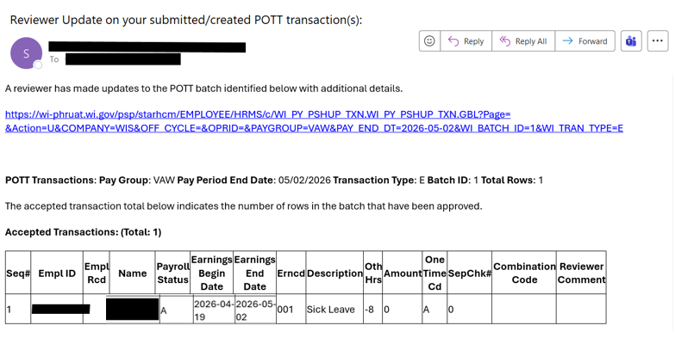If rejected or cancelled, review the Rejected POTT or Delete/Cancel POTT sections.

ENTER DEDUCTION POTT
Deduction POTTs are used to add, refund, or override deductions for an employee in a specific pay period.
- Navigate to Enter POTT – By Batch page.
  - Navigation: Workforce Administrator Homepage > Payroll > Payroll Processing Tile > POTT Folder > Enter POTT – By Batch.
  - Click Add a New Value.
  - Enter Company, Pay Group, Pay Period End Date. Verify these for accuracy before starting the batch because they can no longer be changed after batch is added.
  - Do not check the Off Cycle box unless tied to a year-end off-cycle payroll.
  - Select Transaction Type of Deduction from the dropdown menu.
  - Click Add.
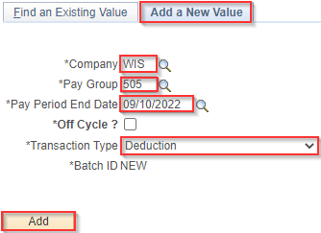
- Enter or update the fields below:
  - Empl ID: Employee ID.
  - Empl Rec: Employee Record (use applicable record).
  - Plan Type: Plan type associated with benefit or general deduction.
  - Benefit Plan: Benefit Plan associated with Plan Type (blank for Plan Type 00).
  - Ded Code: Deduction Code tied to paycheck deduction.
  - Ded Class: Deduction type for tax purposes.
    - After-Tax: Post-tax employee deduction
    - Before-Tax: Pre-tax employee deduction
    - Nontaxable: Non-taxed employer deduction
    - Taxable: Taxable employee deduction
    - PTax Ben: Employer share for retirement deduction
  - Ded Calc: Always use Amount.
  - Amount: Flat amount of the deduction or refund (always positive).
  - One Time Cd: Type of transaction based on desired results.
    - Addition: Adds to current deduction amount or creates this amount if none exists
    - Refund: Refunds deduction amount
    - Override: Replaces existing deduction amount
  - Sepchk#: Should be 0 unless earnings need to be on a separate check by using 1.
  - Comments: Notes to clarify the reason for POTT.
- Click the Plus box to add a row(s) if needed and repeat Step 2.
- Click on Attach or View Supporting Documents to add supporting documentation(s).
  - Click Add.
  - Click Choose File. Navigate to and select the supporting document from your PC. Or you can drag a document by placing the curser on the “choose file” and drop.
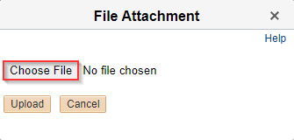
  - Click Upload.
  - Add clarifying information in the Description (optional).
  - Click the Plus box to add another document or Return to continue with the POTT entry.
- When all rows are completed and documents attached, click Save. Now the number of supporting documents will appear.
- Click Validate. This will be grayed out until Save is clicked.
- Verify there are no rows with errors. If there are one or more rows with an error, refer to the Error Resolution section for additional instructions.
- Click Submit to submit the batch to Central Benefits for review and approval.
- Pop-up will appear “Are you sure you want to submit this batch for review? Note: Only rows with Validation Status of OK are pushed for Review/Approval. Yes or No” Click appropriate answer.
Once Central Benefits has reviewed the POTT, the agency will receive a system generated email notifying them of the Central Benefits’ decision on the POTT (approval, rejection, or cancellation). If approved, the following system generated message will appear with a link to the POTT:
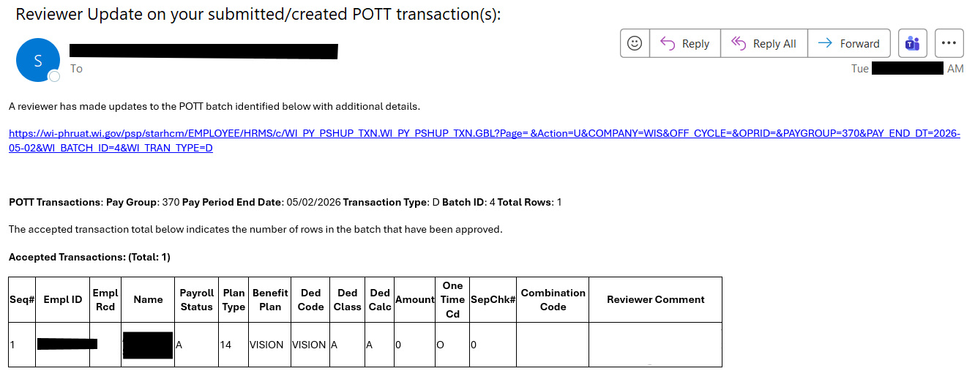
If rejected or cancelled, review the Rejected POTT or Delete/Cancel POTT sections.

ERROR RESOLUTION
Validation errors are generated at the Validate step of the POTT entry. Errors must be resolved for the affected row(s) of the POTT to process before submitting the POTT. Even rows with no errors cannot be submitted for review or approval by Central Payroll.
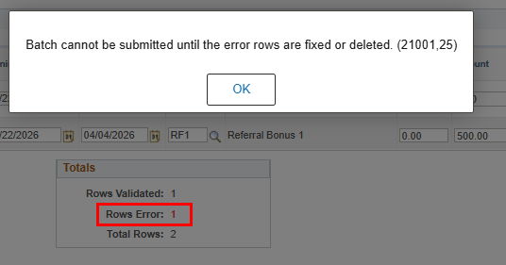
To view the error message, click on Validation tab and the exclamation point:
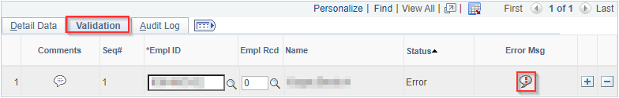
List of common errors:
Message | How to Correct
MESSAGE: Duplicate Entry, matching record found in batch - X | Search for another batch in the pay period with the same data and delete it. If the other batch is already submitted, contact Central Payroll for assistance.
FIELD: X MESSAGE: Field is required | Fill in missing field(s) in the validation message.
FIELD: Amount MESSAGE: Amount cannot be Negative, remove the negative sign and use One-Time Code of REFUND | Change the amount ot a positive number and use one-time code "Refund" if applicable
FIELD: Amount & Oth_Hrs MESSAGE: Amount & Oth Hrs cannot be 0 when One-Time Code is set to ADDITION (or) REFUND | Enter at least one value other than 0.00 in Oth Hrs or Amount field.
FIELD: Plan_TYPE MESSAGE: Invalid value - press the prompt button or hyperlink for a list of valid values | Use the magnifying glass to select a valid Plan Type.
FIELD: Emplid MESSAGE: Invalid value - press the prompt button or hyperlink for a list of valid values | Enter a valid Empl ID for the employee.
FIELD Empl_Rcd MESSAGE: Invalid value - press the prompt button or hyperlink for a list of valid values | Enter a valid Empl Record for the employee.
FIELD: Earning End Date MESSAGE: Earning Begin Date cannot be greater than or equal to Employee Termination Date | Remove the earnings dates, Save, Validate, and Submit
Once the error(s) have been corrected, click Validate and confirm the error row(s) has been resolved in the Totals section:
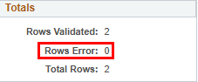

FILE UPLOAD
Agency Payroll may use the file upload feature for batches with many rows to eliminate the need to manually key each individual row. Instructions for this process are in the POTT File Upload Job Aid

REJECTED POTT
During review, Central Payroll and Central Benefits have the option to reject an earnings or deduction POTT for corrections without cancelling the entire POTT. No need for the agency to re-enter the entire POTT batch from the start to make a small correction - saving time for everyone.
- Reject check box (available for central staff only)
  - This will reject the entire batch back to the submitter to make changes.
  - POTT batch status will show “Rejected” until agency corrects and resubmits the POTT. At that point the batch status will return to Submitted.
  - If there are several lines in the batch, only one is rejected back and the rest are accepted, all lines are rejected back to the submitter.
  - The accepted lines are grayed out and unable to be changed by the submitter. Only lines with the open boxes can be edited.
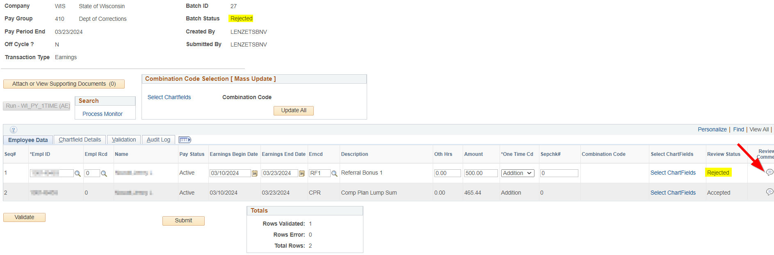
- Notification of a rejected POTT
  - PeopleSoft will generate a rejection email and notify the submitter and creator via email that their POTT was rejected. The Reviewer comment listed within the email will tell the submitter why the POTT was rejected.
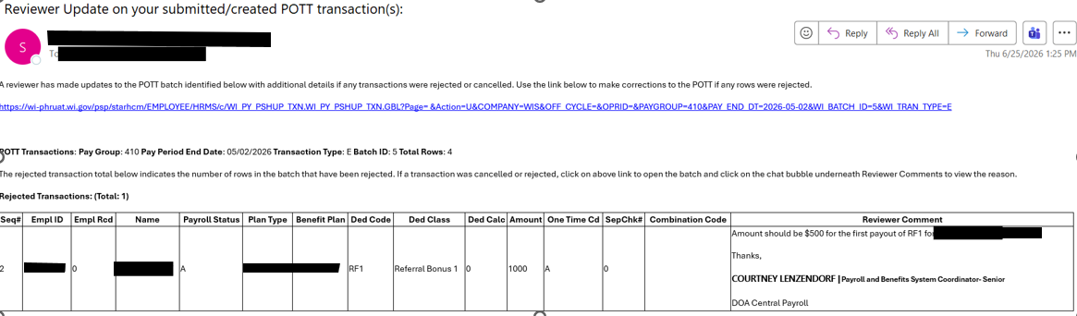
  - Agency submitters and Agency reviewers can find POTTs in “rejected” status by clicking the URL link within the system generated email or going to the POTT entry page and entering pay period end date, select “Rejected” from the batch status drop down options, then click on the Search button.

CHARTFIELD & FUNDING
- If you need to apply funding for a single employee, click on the “Select Chartfields” in the row for that employee.
- If updating for multiple employees as part of an upload, go into the Combo Code Selection (Mass Update) box and “Select Chartfields” from there.
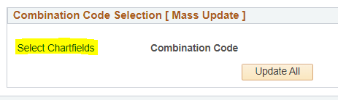
- Chartfield link that opens pop-up to enter various chartfield information.
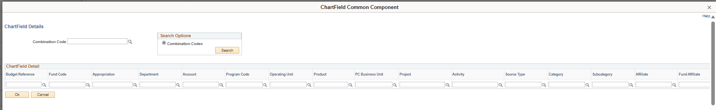
- The chartfields are validated with finance - only validates that they are open/active codes not that they are the appropriate codes.
- Chartfield information must be for the agency where the employee is currently working. Cannot enter chartfield information to allocate to former employers. If this is needed, add notifications in the comments.
- If you process a mass upload of POTT transactions, once they are loaded on the screen you can update or make changes to one or employees to change the chartfields for those transactions using this functionality.
- “Validate” does not validate chartfields – only validates the other data entered.
- The “Detail Data” tab only shows the combo code. Once clicked on details, you will see the detailed chartfields.

REVIEW/DELETE/CANCEL POTTS
The process of deleting or cancel existing POTTs is dependent on the Batch Status of the POTT. Review the status of the POTT and refer to the instructions below for the entry type.
POTT Status | How to Remove Entry
Created | Delete by Agency Payroll
Validated | Delete by Agency Payroll
Submitted | Cancel by Central Payroll
Closed | Shut off pay line by Central Payroll

View the status of a POTT:
- Navigate to Enter POTT – By Employee page.
  - Navigation: Workforce Administrator Homepage > Payroll Dashboard > Payroll Processing Tile > POTT Folder > Enter POTT – By Employee.
  - Enter Pay Period End Date and Batch ID/Empl ID (depending on the situation both may be needed to narrow down to the correct batch) and click Search.
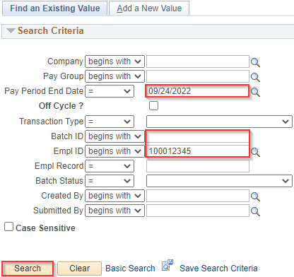
  - If the Submitted By field is blank, then the POTT is in Created or Validated status and can be deleted by the agency. Refer to Delete a POTT section for additional instructions.
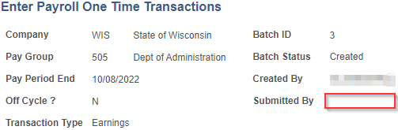
  - If the Submitted By field is completed, then the POTT is in Submitted or Closed status. Click on Return to Search to review the status. Refer to Request a Cancelation section If for additional instructions.

Delete a POTT:
- Return to the batch via the Enter POTT – By Batch.
- Enter Pay Period End Date and Batch ID (depending on the situation both may be needed to narrow down to the correct batch) and click Search.
- Click the Minus box next to each row of POTT data and click Save.
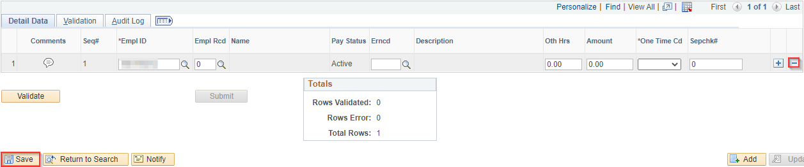
- When Save is clicked and an error appears, double check how you accessed the POTT.
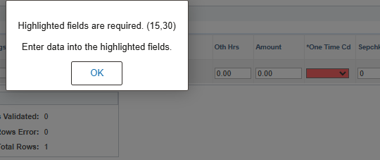
- Make sure you Enter POTT - by Batch. If you go into the Enter POTT – by EE, you are still tied to the employee and the system will not allow the deletion.

Request a Cancelation:
If a Submitted batch or pay line shutoff of a Closed (Approved) batch is needed, send an email to Central Payroll (Earnings POTT) or Central Benefits (Deduction POTT) that includes identifying information or a screenshot of the requested POTT to be removed. This must be done prior to the last pay calc-all on Thursday morning of processing week.
Once Central Payroll or Central Benefits has cancelled the POTT, the agency will receive a system generated email notifying them. The following system generated message will appear with a link to the POTT:
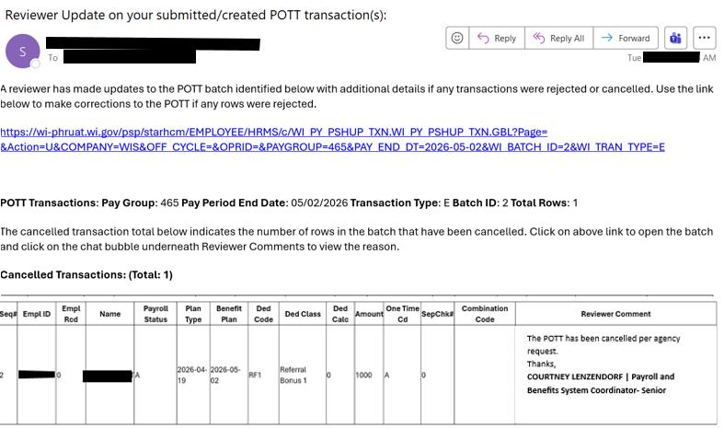
If another POTT is needed, agency staff can re-enter the POTT. For further instructions on entering an earnings or deduction POTT, refer to Enter Earnings POTT or Enter Deduction POTT.

ADDITIONAL RESOURCES
- POTTs - Earnings & Deduction Codes Guide
- POTT File Upload Job Aid
- LAN/LSR Guide Revised 04/14/26

