
POTT File Upload Job Aid
Version 1.2
Version History
Version | Date | Editor | Description
1.0 | 12/09/15 | Ashley Price | Initial release
1.1 | 11/18/19 | Matt Olsen | Fluid and content update
1.2 | 08/14/25 | Matt Olsen | New Overview/Add’l Resources sections and earnings upload revisions
Role: Agency Payroll Specialist

OVERVIEW
The POTT file upload feature allows Agency Payroll to load earnings or deduction data for many employees at once instead of keying each row manually.
Batch validation of row data uses the same logic as manual entries. If the same Empl ID, Empl Record, and Earnings/Deduction data is used in multiple rows, then only one of the rows will load to the batch. To prevent this from occurring, sum the total hours or total amount into one row per combination.
Follow the steps outlined in the next sections to set up your computer for using the correct CSV formatting and uploading the file into STAR HCM.

ADJUST COMPUTER SETTINGS
The instructions below are for Windows 10 users. If you are using a different operating system, locate the comparable settings page that controls list separators.
- Navigate to the Region settings on your computer by typing Region into the search bar and clicking on the Region → Control Bar option.
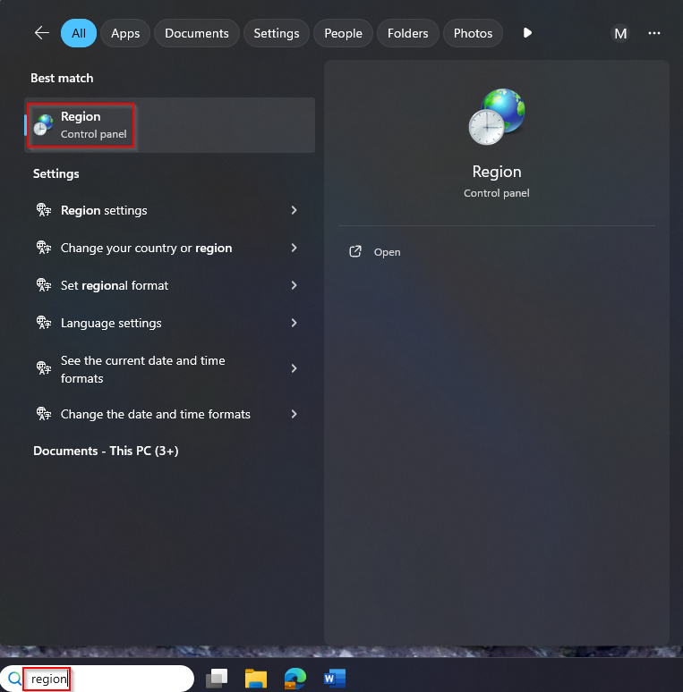
  - Click on Additional Settings.
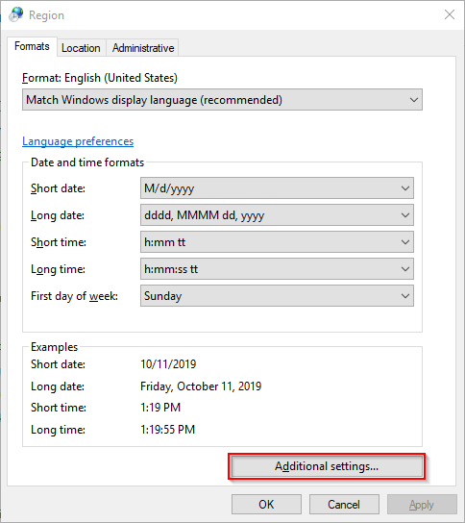
  - Highlight the List Separator field in Customize Format window.
  - Type a Pipe in the keyboard by using Shift + Backslash.
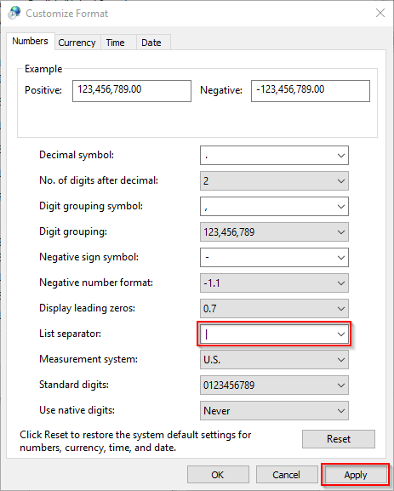
  - Click Apply to save the changes.

FORMAT UPLOAD FILE

Deduction POTT
- Open a new Excel spreadsheet.
- Enter data values in the following column order and format with no headers or footers:
Column Code | Column Name | Additional Instructions
EMPLID | Employee ID
EMPL_RCD | Employee Record Number | Should match primary job
PLAN_TYPE | Deduction Plan Type
BENEFIT_PLAN | Benefit Plan
DEDCD | Deduction Code
DED_CLASS | Deduction Class | A, B, N, or T
DED_CALC | Deduction Calculation | Always is A
PU_AMT | Amount | XXX.XX (positive value only)
ONE_TIME_CD | One Time Code | A, O, or R
SEPCK | Separate Check Number | Always is 0

NOTE: If copying data from an existing spreadsheet, make sure to use Paste Values in the new spreadsheet.
- Enter all rows of data to be included in POTT.
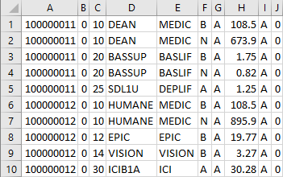

- Click File on the menu bar.
- Click Save As option to display in new window.
- Select location where file will be saved.
- Enter name for file in the File Name Field.
- Select CSV (Comma delimited) in the Save As Type list.
- Click Save.

Earnings POTT
- Open a new Excel spreadsheet.
- Enter data values in the following column order and format with no headers or footers:
Column Code | Column Name | Additional Instructions
EMPLID | Employee ID
EMPL_RCD | Employee Record Number
ERNCD | Earnings Code
OTH_HRS | Hours | XX.XX (negatives allowed; decimals optional)
PU_AMT | Earnings Amount | XXX.XX (negatives allowed; decimals optional)
ONE_TIME_CD | One Time Code | Always is A
SEPCK | Separate Check Number | Always is 0
EARNS_BEGIN_DT | Earnings Begin Date | Optional – use mm/dd/yyyy format
EARNS_END_DT | Earnings End Date | Optional – use mm/dd/yyyy format

NOTE: If copying data from an existing spreadsheet, make sure to use Paste Values in the new spreadsheet.
- Enter all rows of data to be included in POTT. It is recommended to exclude the optional earnings dates unless they need to be different than the current pay period begin and end date (e.g. referral bonuses).
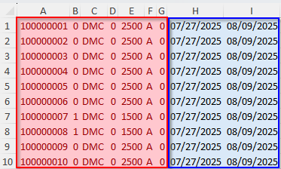
NOTE: Red = Required, Blue = Optional
- Click File on the menu bar.
- Click Save As option to display in new window.
- Select location where file will be saved.
- Enter name for file in the File Name field.
- Select CSV (Comma delimited) in the Save As Type list.
- Click Save.

VERIFY FILE FORMAT
- Locate file to be verified on your PC.
- Right click on file.
- Select Open With menu option.
- Select Notepad option.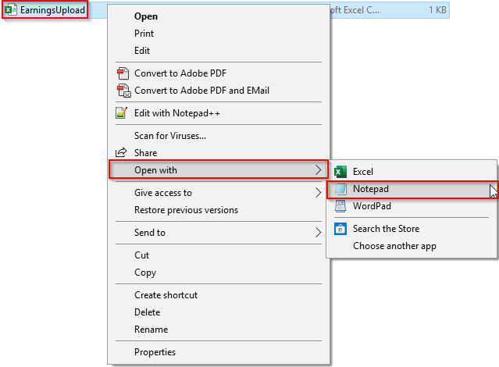
- Verify values are displayed with pipes (|) in between each field and no values are missing
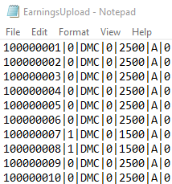
- Save if any changes are made and close file.

ENTER POTT
- Navigate to Enter POTT – By Batch page.
  - Navigation: Workforce Administrator Homepage → Payroll Dashboard → Payroll Processing Tile → POTT Folder → Enter POTT – By Batch.
  - Click Add a New Value.
  - Enter Company, Pay Group, Pay Period End Date.
  - Select Transaction Type.
  - Click Add.
- Click Attach or View Supporting Documents.
- Click Add.
- Select file to be uploaded and click Upload.
- Check the Process File checkbox.
- Click Yes in the popup box to confirm this file.
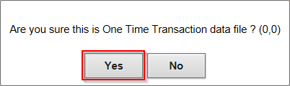
- Click Save.
- Click Run – WI_PY_1TIME (AE).
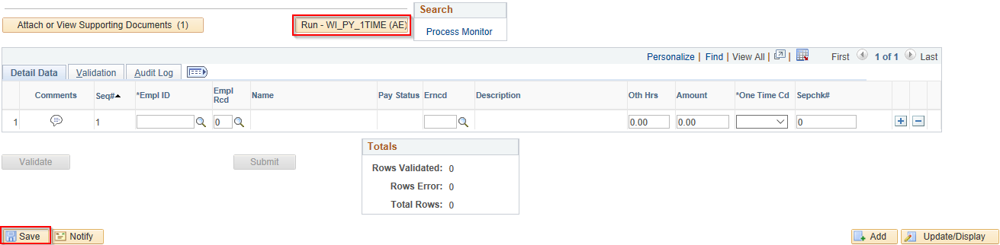
- This process may take several minutes to run depending on the file size and number of rows. When finished, review the rows and data match your CSV file. If the majority or all data did not load correctly, do not Save or Validate the batch. Review and correct any errors on CSV file and return to Step 1 in a new batch.
- After all rows load successfully to the batch, click Validate.
- Fix any rows with validation errors.
- Click Submit.

ADDITIONAL RESOURCES
- Pay One Time Transactions Job Aid
- POTTs - Earnings & Deduction Codes Guide

