
Payable Time Approvals Job Aid
Version 1.1
Version History
Version | Date | Editor | Description
1.0 | 12/28/15 | Ashley Price | Initial release
1.1 | 04/18/24 | Matt Olsen | Fluid and Content update
Role: Agency Time & Labor Specialist

REVIEW UNAPPROVED TIMESHEETS
Payable time should be approved by Tuesday of processing week at 5 p.m. to ensure Wednesday query reviews include all applicable earnings. Search for and review unapproved time using the payable time query.
- Navigate to Query Viewer page.
  - Navigation: NavBar → Reporting Tools.
  - Click on Query Viewer page in the folder navigation.
- Search for WI_TL_PAYABLE_STATUS_BY_TRC.
  - Run to preferred output (HTML or Excel).
  - Enter prompts for Business Unit, dates of current pay period, and Needs Approval status.
  - Click View Results.
  - Verify all time that needs to be approved.
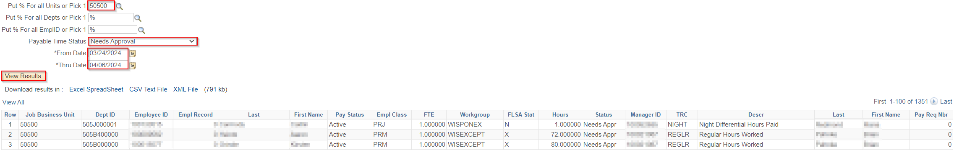

MASS APPROVAL PROCESS
Mass approvals are used to approve all unapproved time for a Pay Group with the option to exclude one or more Empl IDs if necessary. Go to the Batch Approval Process section below if you only want to approve a specific list of employees.
- Navigate to Request Batch Approval Process page.
  - Navigation: Workforce Administrator Homepage → HCM Approvals Tile → Batch Approval Process.
  - Select an existing Run Control ID or create a new Run Control ID.
- Select or enter your Time Reporter Group in the Group ID field. This usually matches the desired Pay Group, but some agencies have additional subgroups set up. You may only select Group ID’s within your row security.
NOTE: If your last Batch Approval run was for specific employees instead of by Group ID, you will need to delete the row(s) with specific employees before the Group ID field will reappear for use.
- Enter From Date and End Date using begin and end date of pay period being processed. You may use a From Date earlier than the current pay period to include prior pay period adjustments, but do not go further back than the current Fiscal Year begin date.
- Accounting Date defaults to the paycheck date for the pay period being processed.
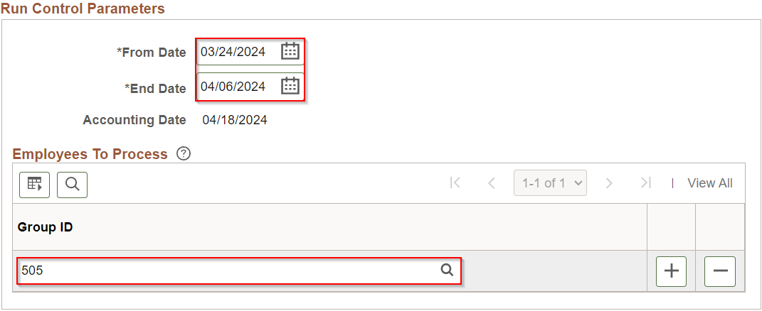
- If an employee needs to be excluded from this approval, click the plus sign to add a new row.
  - Enter Empl ID and Empl Record of employee you wish to exclude from the approval.
  - Select Exclude from the dropdown bar.
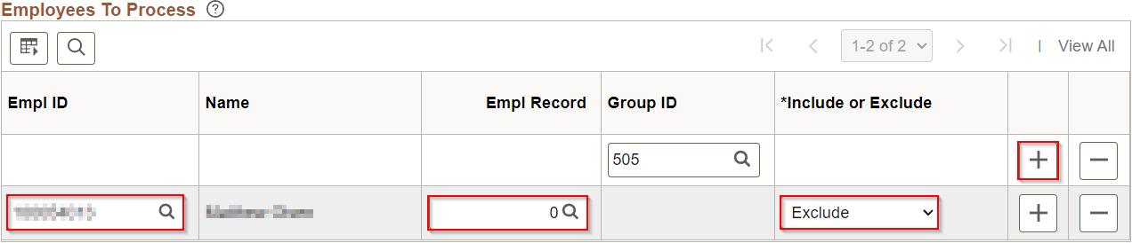
- Click Run.
- Click OK in the Process Scheduler Request.
- Click on Process Monitor to verify approval process runs to success.
- Validate Approved Time.

BATCH APPROVAL PROCESS
Batch approvals are used to select one or more employees to approve by Empl ID and Empl Record.
- Navigate to Request Batch Approval Process page.
  - Navigation: Workforce Administrator Homepage → HCM Approvals Tile → Batch Approval Process.
  - Select an existing Run Control ID or create a new Run Control ID.
- Enter From Date and End Date using begin and end date of desired time period.
- Accounting Date defaults to the paycheck date for the pay period being processed.
- Enter Empl ID and Empl Record of employee to include in batch approval.
- Click the plus box and repeat Step 4 if necessary.
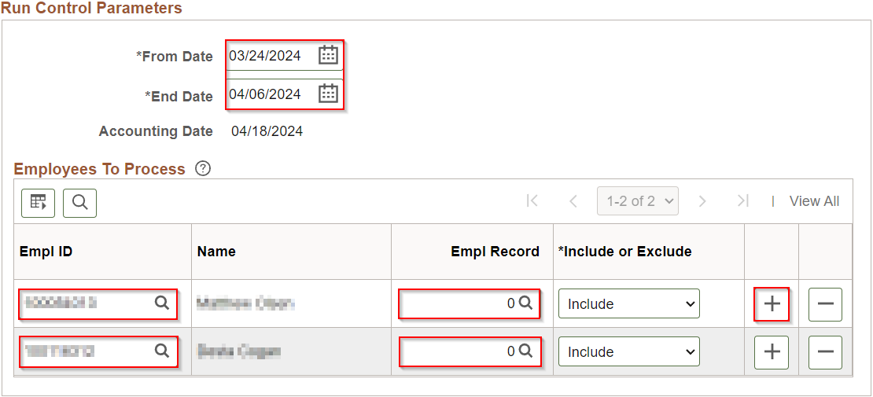
- Click Run.
- Click OK in the Process Scheduler Request.
- Click on Process Monitor to verify approval process runs to success.
- Validate Approved Time.

VALIDATE APPROVED TIME
- Navigate to Query Viewer page.
  - Navigation: NavBar → Reporting Tools.
  - Click on Query Viewer page in the folder navigation.
- Search for WI_TL_PAYABLE_STATUS_BY_TRC.
  - Run to preferred output (HTML or Excel).
  - Enter prompts for Business Unit, dates of current pay period, and Needs Approval status.
  - Click View Results
  - Verify no results for employees previously identified.
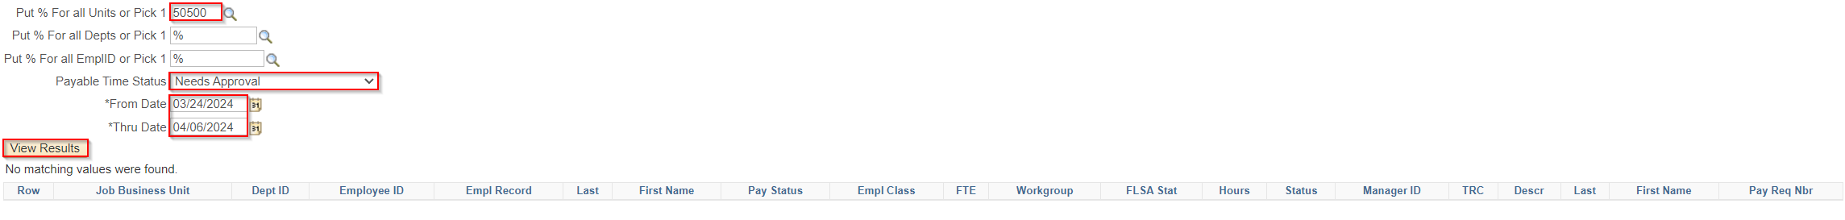

COMMON ISSUES

Issue:
Employee’s payable time still shows on query in Needs Approval status.

Troubleshooting Steps:
- Verify employee’s Business Unit and Pay Group are correct in Job Data for a mass approval.
- Verify correct Empl Record was used for a batch approval.
- Verify correct From Date and End Date were entered for the time period.

Issue:
Mass approval runs to No Success.

Troubleshooting Steps:
Run query WI_TL_PT_INCONSISTENT_AWE with the End Date as the end of the pay period being processed to identify employee with approval error.
- Delete the No Success process(es). All future mass/batch approvals will run to No Success until this is completed.
- Go to Process Monitor (NavBar → Reporting Tools → Process Monitor) and click on Details next to the process named TL_APPRV_AE.
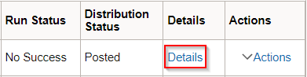
- Select the radial button to Delete Request and click OK.
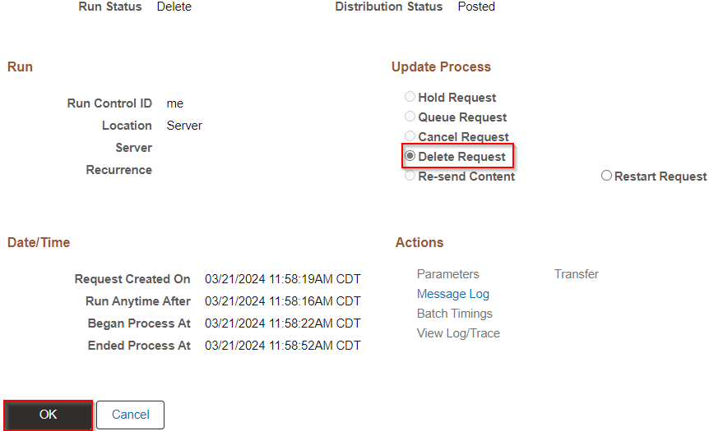
- Run batch approvals for each week of the current pay period.
- When you encounter another No Success mass approval, repeat steps 1-3, note the week, and continue to run mass approvals by day for the week with No Success.
- Run mass approvals by day until you encounter another No Success mass approval and repeat steps 1-3. Note the day and run WI_TL_PAYABLE_STATUS_BY_TRC for Needs Approval hours to view employees that could be causing the error.
- Run batch approvals for small groups of employees using the list obtained in step 6 until you find the employee that is causing the error with a No Success process then repeat steps 1-3.
- Run a mass approval for that day excluding the Empl ID of employee with error.
- Delete the hours for the employee and day with the error, then resubmit with the hours entered and run another batch approval.

