
Update Pay Data Job Aid
Version 2.0
Version History
Version | Date | Editor | Description
1.0 | 12/09/15 | Ashley Price | Initial release
1.1 | 10/01/19 | Matt Olsen | Fluid and content update
1.2 | 12/30/19 | Matt Olsen | Federal taxes update
1.3 | 03/04/22 | Matt Olsen | State Taxes, Out-of-State Taxes, Federal Tax screenshots, State Tax Data Setup update
1.4 | 07/13/22 | Matt Olsen | Out-of-State Taxes, Tax Distribution, State Tax Data Setup update
1.5 | 07/28/22 | Matt Olsen | Add Direct Deposit and Update Direct deposit sections update
1.6 | 02/24/23 | Matt Olsen | Add Add’l Pay and Appendix update
1.7 | 04/04/24 | Matt Olsen | Tax updates and add Inactivate Direct Deposit section
1.8 | 02/07/25 | Matt Olsen | Direct Deposit and Tax section updates
1.9 | 10/21/25 | Matt Olsen | Add’l Pay and Appendix updates
2.0 | 09/21/26 | Matt Olsen | Inactivate Direct Deposit section updates
Role: Agency Payroll Specialist
Contents
ADD DIRECT DEPOSIT 2
UPDATE DIRECT DEPOSIT 4
INACTIVATE DIRECT DEPOSIT 5
VIEW FEDERAL TAXES (2019 OR EARLIER) 6
UPDATE FEDERAL TAXES 7
Enter W-4 (2020 or Later) 8
Enter Lock-In Letter 9
UPDATE STATE TAXES 9
Enter WT-4 10
Enter WT-4A 11
Enter Lock-In Letter 11
Enter Other State W-4 12
UPDATE TAX DISTRIBUTION 12
ADD GENERAL DEDUCTIONS 12
UPDATE GENERAL DEDUCTIONS 13
ADD ADDITIONAL PAY 14
UPDATE ADDITIONAL PAY 16
UPDATE PAYROLL OPTIONS 17
Update Distribution Mail Option 17
Update Primary PayGroup 18
Add Mail Drop ID 18
Add Paycheck Name 19
APPENDIX 19
Effective Dating Guide 19
Commonly Used Earnings and Deduction Codes 20

Reminder: Encourage employees to enter tax and direct deposit changes using self-service when possible.

ADD DIRECT DEPOSIT
- Navigate to Request Direct Deposit page.
  - Navigation: Workforce Administrator Homepage > Payroll Dashboard > Payroll Processing Tile > Pay Data Folder > Request Direct Deposit.
  - Enter at least one search criteria and click Search.
- If rows already exist, click the Plus Sign (+) in the Deposit Information section.
- Effective Date defaults to today’s date. Select appropriate previous or current Effective Date for the entry. Since this page includes ESS entries, future dating should not be used. Refer to Effective Dating Guide for more information.
- Select Active from the Status list.
- Make sure Suppress DDP Advice Print is checked unless employee needs to receive paper advice statements in the mail.
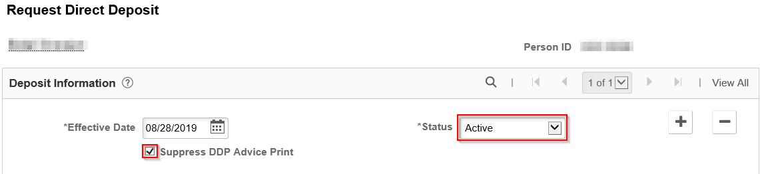
NOTE: The following system rules exist for advice suppression:
- New direct deposits will automatically indicate Suppress DDP Advice Print.
- Changes to direct deposits with Suppress elected will remain as Suppress.
- Changes to direct deposits with NO suppress elected will go to Suppress.
- Enter employee’s bank routing number in the Bank ID.
- Select Prenotification Required to initiate the prenote process.
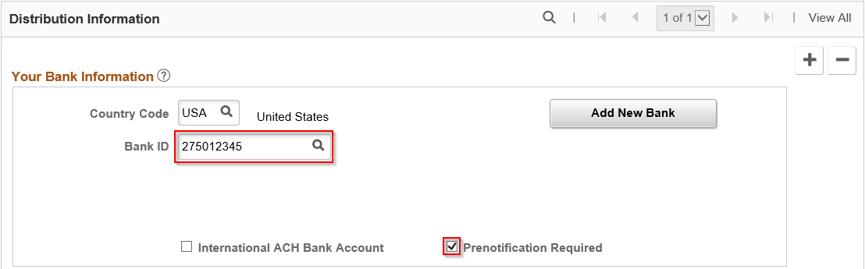
- Select the Account Type.
- Select the Deposit Type.
Deposit Type | Description
Amount | Deposits a fixed dollar amount to this account
Balance of Net Pay | Deposits remaining, non-distributed funds to this account
Percent | Deposits a percentage of net pay to this account
- If Amount or Percent was selected, enter the dollar amount into Net Pay Amount field or percentage into Net Pay Percent, respectively. Leave blank if Balance of Net Pay was selected.
- Enter an appropriate Priority number for the distribution starting with 1 for highest priority. Use 999 if Balance of Net Pay was selected as Deposit Type.
- Enter employee’s Account Number.
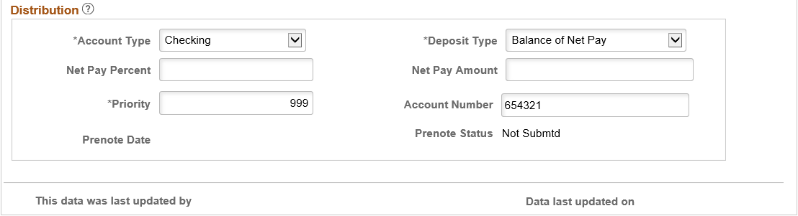
- Add more distribution accounts if needed.
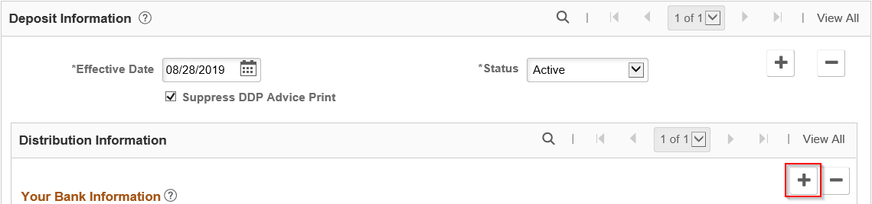
  - Select the Plus Sign (+) in the Distribution Information section.
  - Repeat steps 5 through 12.
- Click Save.

UPDATE DIRECT DEPOSIT
- Navigate to Request Direct Deposit page.
  - Navigation: Workforce Administrator Homepage > Payroll Dashboard > Payroll Processing Tile > Pay Data Folder > Request Direct Deposit.
  - Enter at least one search criteria and click Search.
- Click Plus Sign (+) in the Deposit Information section to add a new effective dated row.
- Effective Date defaults to today’s date. Select appropriate previous or current Effective Date for the entry. Since this page includes ESS entries, future dating should not be used. Refer to Effective Dating Guide for more information.
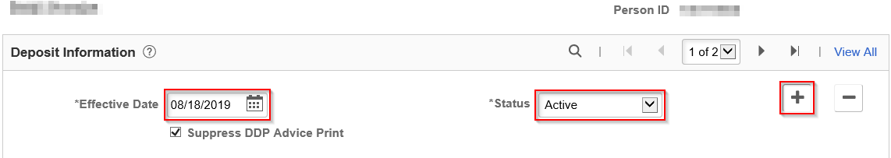
- Select Active from the Status dropdown. Make sure Suppress DDP Advice Print is checked unless employee needs to receive paper advice statements in the mail.
NOTE: The following system rules exist for advice suppression:
- New direct deposits will automatically indicate Suppress DDP Advice Print.
- Changes to direct deposits with Suppress elected will remain as Suppress.
- Changes to direct deposits with NO suppress elected will go to Suppress.
- Select the appropriate row(s) of distribution to be updated by clicking arrows in Distribution Information section.
- Click the Plus Sign (+) or Minus Sign (-) in Distribution Information section to add or remove accounts.
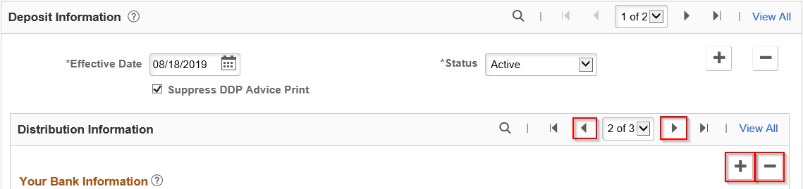
- Update any fields in Your Bank Information and Distribution sections if needed.
- Click Save.

INACTIVATE DIRECT DEPOSIT
Prior to inactivating direct deposit as the result of a terminating employee, verify the employee is not actively employed at another Business Unit. This page inactivates direct deposit for all records of an employee.
- Navigate to Search by National ID page.
  - Navigation: Workforce Administrator Homepage > Payroll Dashboard > Payroll Processing Tile > Employee Data Folder > Search by National ID.
- Enter employee’s SSN in the National ID box and click the arrows to search.
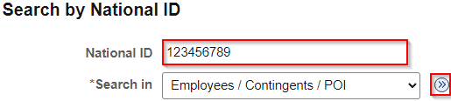
- If an active record exists at another Business Unit, STOP here. Do not inactivate direct deposit.
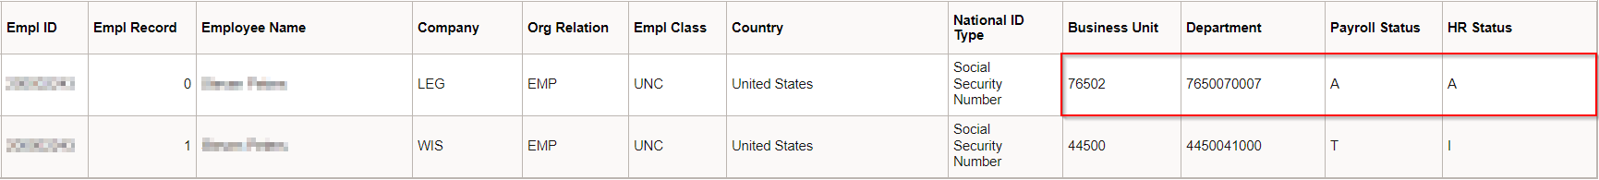
- If no active record exists, proceed with the next steps to inactivate direct deposit.
- Navigate to Request Direct Deposit page.
  - Navigation: Workforce Administrator Homepage > Payroll Dashboard > Payroll Processing Tile > Pay Data Folder > Request Direct Deposit.
  - Enter at least one search criteria and click Search.
- Click Plus Sign (+) in the Deposit Information section to add a new effective dated row.
- Effective Date defaults to today’s date. Select appropriate previous or current Effective Date for the entry. Since this page includes ESS entries, future dating should not be used. Refer to Effective Dating Guide for more information.
- Select Inactive from the Status dropdown.
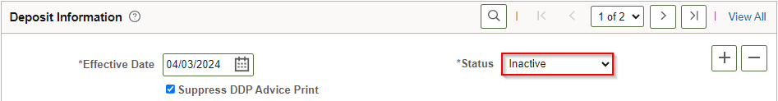
- Click Save.

VIEW FEDERAL TAXES (2019 OR EARLIER)
Employees who last updated their federal tax withholding in 2019 or earlier will continue to have withholding elements and tax calculations based on the previous W-4 rules. Agency Payroll should only view these rows – updates must be entered in the 2020 or later version of the W-4.
- Navigate to Update Employee Tax Data page.
  - Navigation: Workforce Administrator Homepage > Payroll Dashboard > Payroll Processing Tile > Pay Data Folder > Update Employee Tax Data.
  - Enter at least one search criteria.
  - Check the Include History checkbox to view all rows and click Search.
- This page defaults to current row. Click the Next Page arrow in the Tax Data section until row to be viewed is selected.
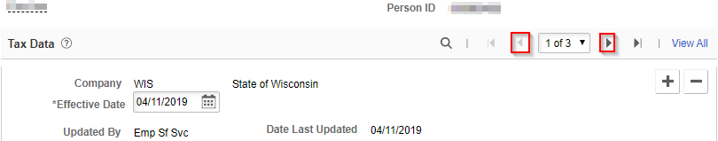
- W-4 Version is 2019 or Earlier. View Tax Marital Status, Withholding Allowances, and Additional Amount from W-4 submitted by employee.
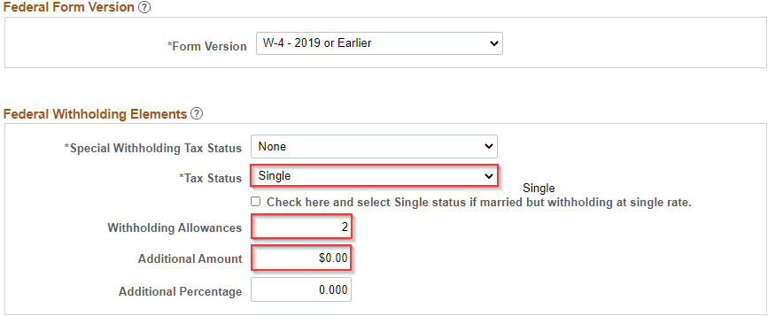NOTE: If employee is claiming exempt from withholding, Maintain Taxable Gross will be selected from Special Withholding Tax Status dropdown.
- View Lock-in Letter Details for IRS limit on Federal Withholding Allowances if applicable.
- Click Return to Search or navigate to another page when completed.

UPDATE FEDERAL TAXES
Employees should be encouraged to submit updates to federal withholding form W-4 in ESS if possible. Instructions below are for Agency Payroll to enter state forms received from an employee or IRS.
New hires and employees who update their federal tax withholding in 2020 or later must use the 2020 or later W-4. Agency Payroll should enter all updates in the 2020 or Later section of Federal Tax Data.
- Navigate to Update Employee Tax Data page.
  - Navigation: Workforce Administrator Homepage > Payroll Dashboard > Payroll Processing Tile > Pay Data Folder > Update Employee Tax Data.
  - Enter at least one search criteria and click Search.
- Click the Plus Sign (+) on Federal Tax Data tab to add a new effective dated row.
- Effective Date defaults to today’s date. Select appropriate previous or current Effective Date for the entry. Since this page includes ESS entries, future dating should not be used. Refer to Effective Dating Guide for more information.
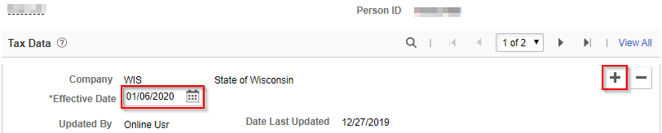
- Select W-4 – 2020 or Later from the dropdown if not already selected.

Enter W-4 (2020 or Later)
- Complete steps 1-4 above then update Federal Withholding Elements fields with Tax Status, Multiple Jobs checkbox, Dependent Amount, Other Income, Deductions, and Extra Withholding based on corresponding step from W-4:
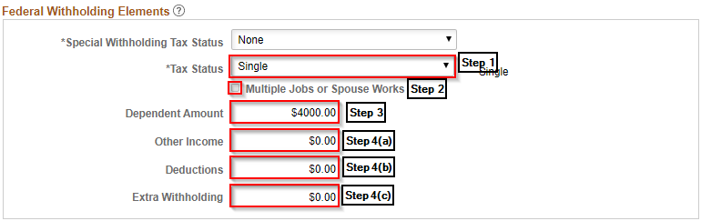
NOTE: If employee is claiming exempt from withholding, select Maintain Taxable Gross from Special Withholding Tax Status dropdown. Do not change remaining fields as they will automatically update when saved.
- Do not adjust any fields or selections in Federal Unemployment Tax, W-4 Processing Status, State Tax Options, or Tax Treaty/Non-Resident Data sections.
- Click Save.

Enter Lock-In Letter
When an original IRS lock-in letter is received, the employee copy will be included on the last four pages. Send that copy to the employee within 10 days of receipt. The employee will have 30 days from the letter date to contact the IRS to ask for a different withholding rate or number of allowances before it takes effect. If the IRS approves a change, they will send a revised letter to the employer.
- Complete steps 1-4 above then click on the Lock-In Letter Details dropdown.
- Check the box for Letter Received and enter the details indicated on the IRS Lock-In Letter.
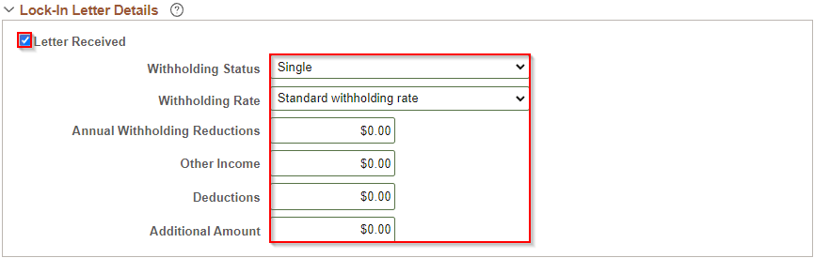
- A warning message will populate that indicates the change to maximum amounts in the corresponding fields. If the Dependent Amount and/or Deductions are higher than the limit, you need to change those values before saving. Click OK.
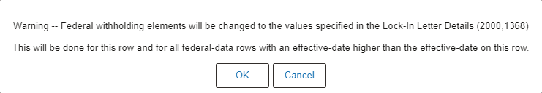
- Do not adjust any fields or selections in Federal Unemployment Tax, W-4 Processing Status, State Tax Options, or Tax Treaty/Non-Resident Data sections.
- Click Save.

UPDATE STATE TAXES
Employees should be encouraged to submit updates to WI withholding form WT-4 in ESS if possible. Instructions below are for Agency Payroll to enter state forms received from an employee or DOR.
- Navigate to Update Employee Tax Data page.
  - Navigation: Workforce Administrator Homepage > Payroll Dashboard > Payroll Processing Tile > Pay Data Folder > Update Employee Tax Data.
  - Enter at least one search criteria and click Search.
NOTE: A new effective dated row must be added on Federal Tax Data page for a Federal and/or State tax change. If 2019 or Earlier W-4 is the form version in the previous row, Federal Tax Data will default to 2020 or Later. Make sure to change back to 2019 or Earlier if only changing State Tax Data.
- Effective Date defaults to today’s date. Select appropriate previous or current Effective Date for the entry. Since this page includes ESS entries, future dating should not be used. Refer to Effective Dating Guide for more information.
- Click on State Tax Data tab.

Enter WT-4
- Complete steps 1-3 above then verify State field is WI for employee working and living in WI and associated Resident and UI Jurisdiction boxes are checked. Make sure Exempt from SUT box is unchecked.
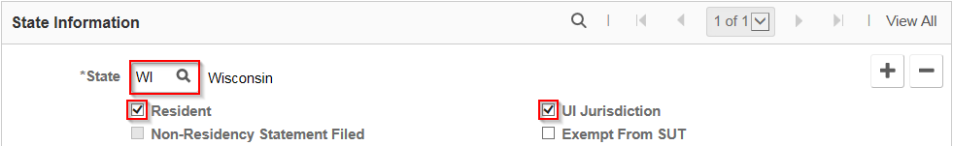
- Update State Withholding Elements fields with Tax Marital Status, Withholding Allowances, and Additional Amount from WT-4.
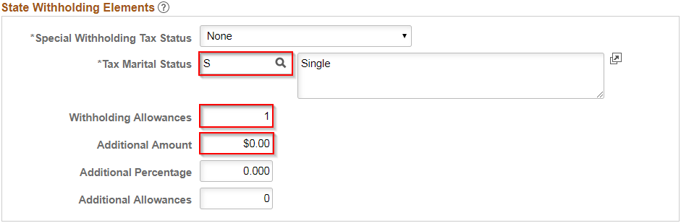
NOTE: If employee is claiming exempt from withholding, select Maintain Taxable Gross from Special Withholding Tax Status dropdown. Do not change remaining fields as they will automatically update when saved.
- Click Save.

Enter WT-4A
- Complete steps 1-3 above then select Maintain Taxable Gross from Special Withholding Tax Status dropdown.
- Check the box next to WI WT-4A Filed and enter the amount to be withheld each payroll period from line 3 of the employee withholding agreement.
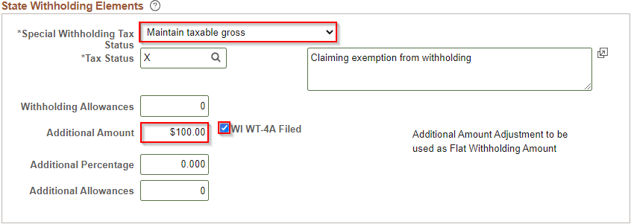
- Click Save.

Enter Lock-In Letter
When a DOR lock-in letter is received, enter the allowance limit indicated in the current pay period.
- Complete steps 1-3 above then click on the Lock-In Letter Details dropdown.
- Check the box for Letter Received and enter the number of allowances indicated as the maximum number of allowances on the DOR Lock-In Letter.
- A warning message will populate that indicates the change to maximum number of allowances. The current State Tax Data row will be updated to match this number if applicable. Click OK.
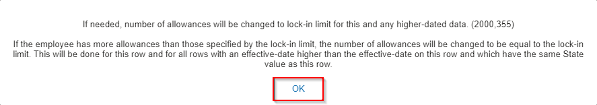
- Click Save.

Enter Other State W-4
Refer to the Out of State Taxes Job Aid for guidance with entries and scenarios for out-of-state employees.
The UI Jurisdiction should always be WI with a Special Withholding Status of None regardless of an employee’s work location.

UPDATE TAX DISTRIBUTION
IMPORTANT: Tax Distribution state should be WI in most cases. Refer to the Out of State Taxes Job Aid for appropriate entries for out-of-state employees.
- Navigate to Update Employee Tax Distribution page.
  - Navigation: Workforce Administrator Homepage > Payroll Dashboard > Payroll Processing Tile > Pay Data Folder > Update Tax Distribution.
  - Enter at least one search criteria and click Search.
- Click the Plus Sign (+) in Tax Distribution section to add a new effective dated row.
- Effective Date defaults to today’s date. Change date to the first day of the current pay period.
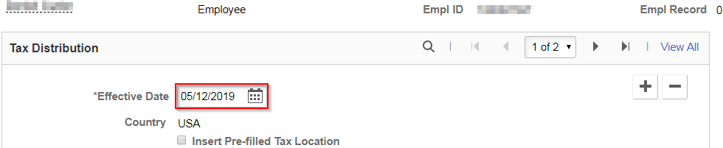
- Enter appropriate State and keep a Percent of Distribution of 100.000.
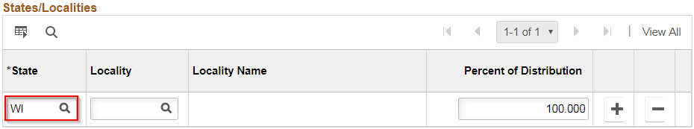
- Click Save.

ADD GENERAL DEDUCTIONS
General deductions are used to collect non-benefit related monies such as biweekly parking, vanpool, or charity. They are also used for miscellaneous, agency-specific or WRS-related deductions.
- Navigate to Create General Deductions page.
  - Navigation: Workforce Administrator Homepage > Payroll Dashboard > Payroll Processing Tile > Pay Data Folder > Create General Deductions.
  - Enter at least one search criteria and click Search.
- If rows already exist, click the Plus Sign (+) in the General Deduction section.
- Enter or select appropriate Deduction Code using the Magnifying Glass.
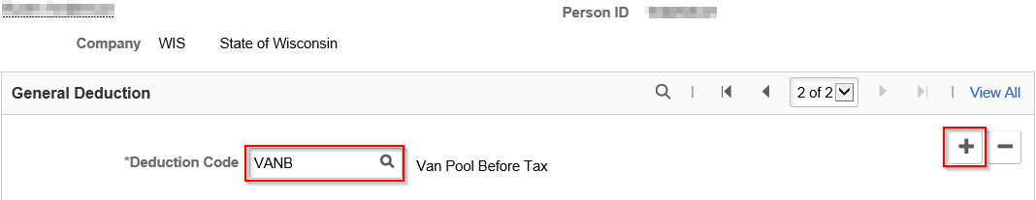
- Effective Date defaults to today’s date. Select appropriate previous or future Effective Date for the new entry. This should be set to first day of pay period in which deduction is to begin. Refer to Effective Dating Guide for more information.
- Select Flat Amount from Calculation Routine list.
- Uncheck the Take on all Paygroups box.
- Enter Deduction End Date if applicable. This should be set to last day of last pay period in which deduction should occur.
- Enter appropriate deduction dollar amount in Flat/Addl Amount field.
- Enter Goal Amount if the deduction should stop after a certain dollar amount has been reached. The Current Goal Balance automatically updates as deductions are taken.
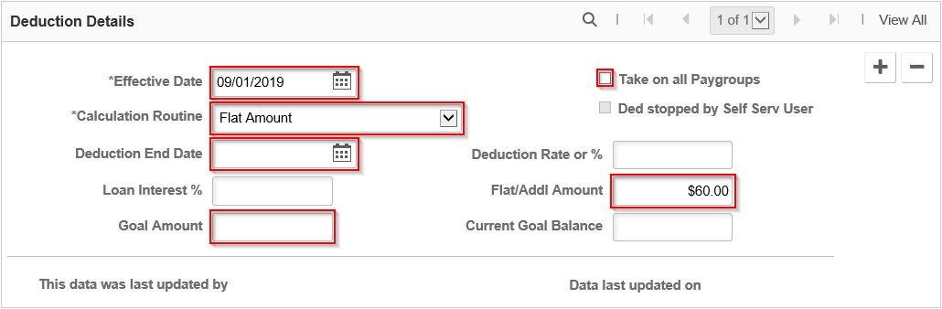
- Click Save.

UPDATE GENERAL DEDUCTIONS
- Navigate to Create General Deductions page.
  - Navigation: Workforce Administrator Homepage > Payroll Dashboard > Payroll Processing Tile > Pay Data Folder > Create General Deductions.
  - Enter at least one search criteria and click Search.
- Click the Next Page arrow in the General Deduction section until deduction to be updated is selected.
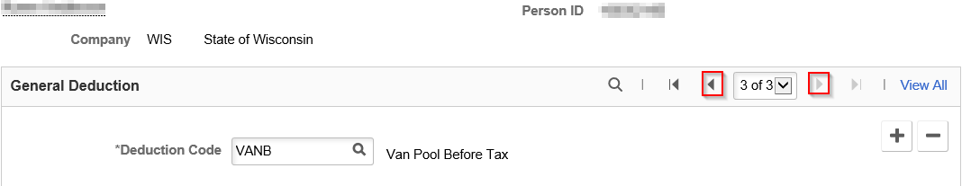
- Click the Plus Sign (+) in the Deduction Details section to add a new effective dated row.
- Effective Date defaults to today’s date. Select appropriate previous or future Effective Date for the new entry. Refer to Effective Dating Guide for more information.
- Update any fields that are being changed as of the Effective Date.
  - Add Deduction End Date to end a deduction.
  - Change Flat/Addl Amount to adjust amount being taken per pay period.
  - Add Goal Amount to set a maximum to be deducted. Current Goal Balance automatically updates as deductions are taken.
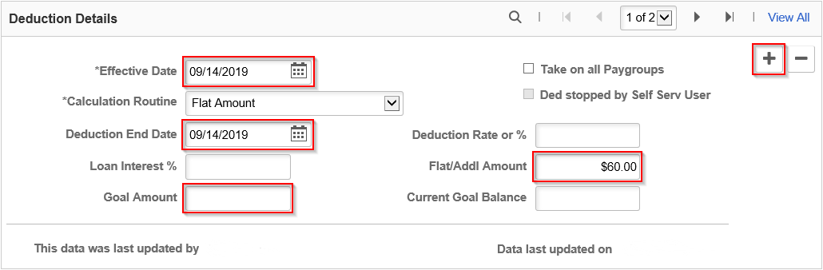
- Click Save.

ADD ADDITIONAL PAY
Additional Pay is used to pay differential earnings tied to work hours for specific classifications. It can also be used to pay miscellaneous earnings codes or as a payment plan to collect back overpaid earnings tied to a specific code. If collecting back overpaid earnings as a payment plan, submit a POTT with the relevant documentation attached for the first payment and then enter Additional Pay for subsequent collections.
Additional Pay is not visible in payable time but rather processes directly to pay lines on the paycheck at the start of payroll processing. It is also tied to Retro Pay so that an effective date prior to the current pay period will calculate and load to pay sheets on a biweekly basis. More information on this process is available in the Retroactive Pay Job Aid.
If an employee with Additional Pay differential paid for hours worked (e.g., Critical Vacancy) has a late timesheet adjustment, no pay adjustment will occur automatically. Agency Payroll should review these late timesheet adjustments for pay adjustments and enter a POTT to add or remove the differential amount.
Additional Pays may be reviewed periodically and/or on an ad-hoc basis by Agency Payroll using the query: WI_PY_ADDL_PAY_HOUR_RATE.
NOTE: Opt-out stipend is managed through the Simple Benefits page and Benefits Administration. No entries should be made in Create Additional Pay using earnings code OOS.
- Navigate to Create Additional Pay page.
  - Navigation: Workforce Administrator Homepage > Payroll Dashboard > Payroll Processing Tile > Pay Data Folder > Create Additional Pay.
  - Enter at least one search criteria and click Search.
- If rows already exist, click the Plus Sign (+) in the Additional Pay section.
- Enter or select appropriate Earnings Code using the Magnifying Glass.
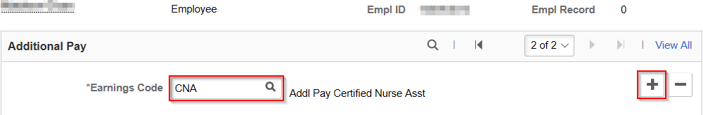
- Effective Date defaults to today’s date. Select appropriate previous (may generate retro-pay) or future Effective Date for the new entry. This should be set to first day of pay period in which earnings are to begin. Refer to Effective Dating Guide for more information.
- Enter 1 in the Addl Seq Nbr field. It should always be 1 regardless of the number of Add’l Pays.
- Enter End Date if applicable. This should be set to the first day of the pay period following final earnings being added or subtracted.
- Enter amount of earnings per pay period in Earnings field. If earnings are tied to work hours on timesheet, leave this field blank.
Hours field should be blank unless Earnings Code is WAA and Hourly Rate field should be blank unless Earnings Code is MDP.
- Enter Goal Amount if the deduction should stop after a certain dollar amount has been reached. The Current Goal Balance automatically updates as earnings are added or subtracted.
- Check the OK to Pay box.
- Verify First, Second, and Third boxes are selected.
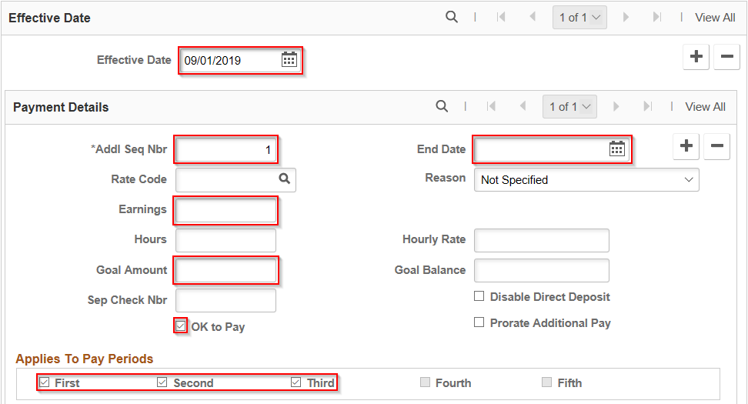
- Do not adjust any fields or selections in Tax Information section. If collecting overpaid earnings on behalf of employee’s previous agency over multiple pay periods, enter the previous position number in the Job Information > Job Data Override section to have the repayment applied to the previous agency.
- Click Save.

UPDATE ADDITIONAL PAY
- Navigate to Create Additional Pay page.
  - Navigation: Workforce Administrator Homepage > Payroll Dashboard > Payroll Processing Tile > Pay Data Folder > Create Additional Pay.
  - Enter at least one search criteria and click Search.
- Click the Next Page arrow in the Additional Pay section until earnings to be updated is selected.
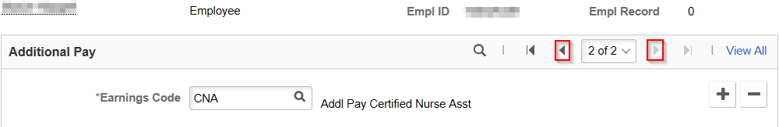
- Click the Plus Sign (+) in the Effective Date section to add a new effective dated row.
- Effective Date defaults to today’s date. Select appropriate previous (may generate retro-pay) or future Effective Date for the new entry. Refer to Effective Dating Guide for more information.
- Update any fields that are being changed as of the Effective Date.
  - Add End Date to end the earnings.
  - Change Earnings to adjust amount being added or subtracted from earnings each pay period.
  - Add Goal Amount to set a maximum to be earned. Current Goal Balance automatically updates as earnings are added or subtracted.
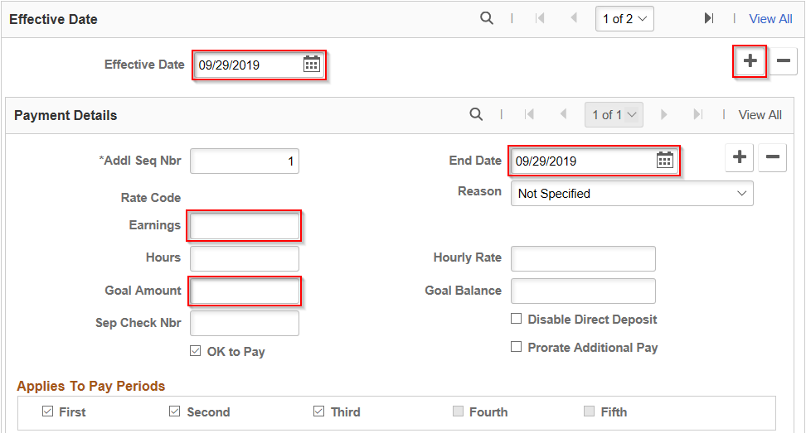NOTE: Do not uncheck OK to Pay box or Applies to Pay Periods boxes even when ending earnings.
- Do not adjust any fields or selections in Job Data or Tax Information sections.
- Click Save.

UPDATE PAYROLL OPTIONS
- Navigate to Update Payroll Options page.
  - Navigation: Workforce Administrator Homepage > Payroll Dashboard > Payroll Processing Tile > Pay Data Folder > Update Payroll Options.
  - Enter at least one search criteria and click Search.
- Make any of the following updates:

Update Distribution Mail Option
This section determines which address employee’s mail will be sent to and should be updated to Mailing Address if multiple addresses are entered in the Modify a Person page.
- Click the radial button next to address to which mail should be sent.
- If using Check Address, click on Update Check Address to add the address and effective date.
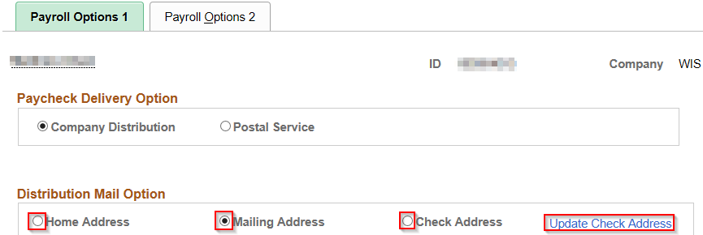
- Click Save.

Update Primary PayGroup
This field may need to be updated if there is a mismatch between the Pay Group in Job Data and this Pay Group to ensure deductions are taken correctly.
- Click on Payroll Options 2 tab.
- Enter or select appropriate Pay Group using the Magnifying Glass.
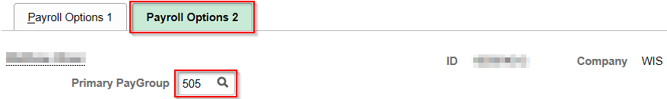
- Click Save.

Add Mail Drop ID
This field allows checks to be sorted by the Print Center prior to distribution to the employee’s agency.
- Click on Payroll Options 2 tab.
- Enter Mail Drop ID corresponding to employee’s location if applicable to your agency/institution.
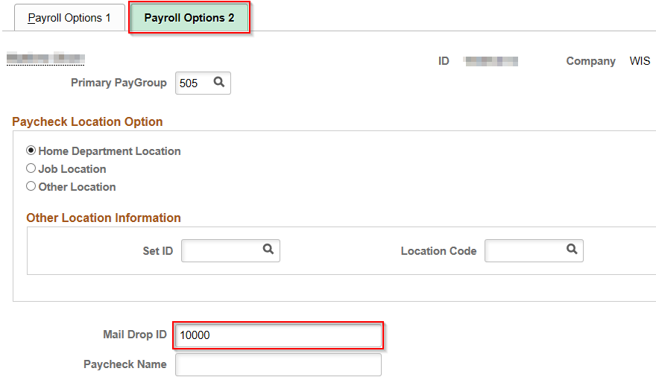
- Click Save.

Add Paycheck Name
This field overrides employee’s name on paychecks. It should only be updated if employee is deceased and mail must be sent to an estate.
- Click on Payroll Options 2 tab.
- Add name for mailing purposes in Paycheck Name field.
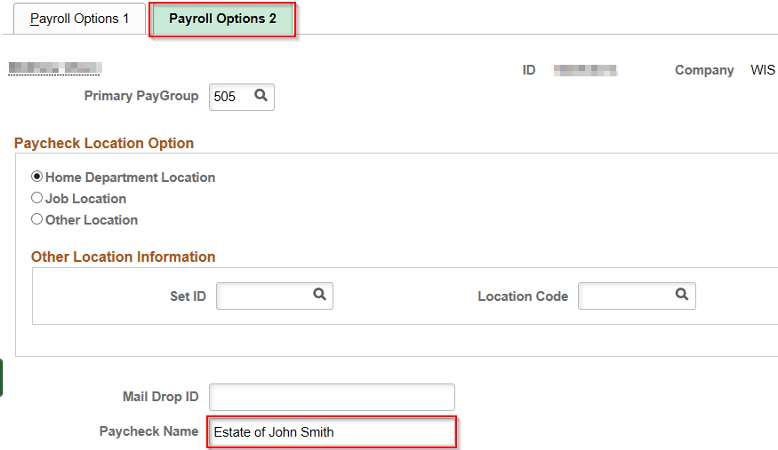
- Click Save.

APPENDIX

Effective Dating Guide
You should use the first day of a pay period to effective date on these pages for start or change entries. A mid-pay period date may be used for a Direct Deposit or Tax Data change and it will process in that pay period as long as it is the last row effective in that pay period and payroll has not been confirmed.
Submit a Payroll STAR Ticket if a correction or “sandwiched” row is needed for Tax Distribution, General Deductions, or Additional Pay.
Page | Start Date | Change Date | End Date
Direct Deposit | First day of current PP | First day of current PP | Current date
Tax Data | Hire Date | First day of current PP | N/A
Tax Distribution | Hire Date | First day of current PP | N/A
General Deductions | First day of current PP | First day of current PP | Last day of current PP (effective date and end date should match)
Additional Pay | First day of effective PP | First day of effective PP | Last day of effective PP (effective date and end date should match)

Commonly Used Earnings and Deduction Codes
Below are some of the frequently used codes in the Create Additional Pay and Create General Deductions pages. For more information on earnings and deductions and when to use them, refer to the Compensation Plan and your agency’s resources.
Earnings Code | Description
CNA | Addl Pay Certified Nurse Asst
CVx | Critical Vacancy (multiple codes exist based on classification/location)
MDP | Medical Officer of Day (Pay)
NR1, NR3 | Nurse Retention $1/hr, $3/hr
OOS | Opt Out Stipend
RPY | Retroactive Pay
Deduction Code | Description
CHARxx | Charity (multiple codes exist based on agency/location)
FSAUNS | FSA Unsubstantiated Card Claim
Mppp | Maintenance (multiple codes exist based on agency/location)
PKLxxB | Parking (multiple codes exist based on agency/location)
UNION | WI Law Enforcement Assoc
WRSADD | Additional WRS Contribution
WpppyyE | Prior Year WRS Contribution (multiple codes exist based on agency/location)

