

Weekend Classifications Job Aid Revised 6/4/2026

Version History
Version 1.0 Date 6/7/24 Editor Brenda Williams Description Initial Release
Version 1.1 Date 11/1/24 Editor Brenda Williams Description Updates to correlate with Policy Bulletin DPM-0630-CC
Version 1.2 Date 6/4/26 Editor Brenda Williams Description Clarify LH and PH entitlement when moving from weekend to non-weekend classification. Made Reader Accessible.
Table of Contents
Policy Links Weekend Classifications: 3
Job Data: 3
FLSA Salary Threshold 4
Benefits 4
Absence types: 4
Transferring into the Weekend Classification: 6
Change in (absence) Eligibility Groups WIWKNDNRS and WIWKNDEX: 10
Transferring out of the Weekend Classification: 10
Terminating Employment While in the Weekend Classification: 10
Maternity Leave / FMLA Leave: 11
APPENDIX A 12
CHECKLIST: Transfer into Weekend Classification 12
Example 1 – Transfer into the Weekend Classification (used LWOP pay period prior to becoming a weekend position) 15
APPENDIX B 17
CHECKLIST: Transfer out of the Weekend Classification 17
Example 1 - Transferring out of the Weekend Classification 18
APPENDIX C 19
CHECKLIST: Termination of Employment from a Weekend Classification Paying Out Accrued Unused Leave 19
Example 1 – Term after Mid-Year move to WKD Classificaiton 20
Example 2 – Term after Full Calendar Year in WKD Classificaiton 20
APPENDIX D 21
CHECKLIST: Termination of Employment from a Weekend Classification – Extending Employment using Accrued Leave 21
APPENDIX E 22
Differentials for Weekend Classification 22

Role: Agency Absence Specialist

Policy Links: Weekend Classifications:
Refer to: 2023-2025 Compensation Plan A – 4.31 Weekend Nurse Program, 4.32 Weekend Certified Nursing Assistant and Weekend LPN Programs, and 4.33 Weekend Security Classifications Program
Refer to: 2023-2025 Compensation Plan Section K – Absences and Continuous Service
Refer to: DPM_0630-CC Treatment of Weekend Classifications for Termination Leave

Job Data:
- Classifications as of 2023-2025 Compensation Plan
*If a different comp plan is in effect at the time of your reviews, please refer to it for updated titles.

Class Title NURSE CLINICIAN 2-WEEKEND Code 38862
Class Title NURSE CLINICIAN 3-WEEKEND Code 38863
Class Title NURSING ASSISTANT 2-WEEKEND Code 38112
Class Title NURSING ASSISTANT 3-WEEKEND Code 38113
Class Title RESIDENT CARE TECH-OBJ-WEEKEND Code 38512
Class Title RESIDENT CARE TECH-ADV-WEEKEND Code 38513
Class Title LICENSED PRACTICAL NURSE – WEEKEND Code 38560
Class Title YOUTH COUNSELOR – WEEKEND Code 53700
Class Title YOUTH COUNSELOR ADVANCE- WEEKEND Code 53763
Class Title CORRECTIONAL OFFICER – WEEKEND Code 66560
Class Title CORRECTIONAL SERGEANT – WEEKEND Code 66563
Class Title PSYCHIATRIC CARE TECHNICIAN – WEEKEND Code 66061
- (Absence) Eligibility Group
  - WIWKNDNRS: Weekend Nurses - Exempt Use this for FLSA exempt weekend NC2 and NC3.
  - WIWKNDNEX: Weekend Nonexempt Employees Available effective 11/5/2023
Use this for all weekend non-exempt classifications and any weekend nurse that is non-exempt due to not meeting the FLSA salary threshold.
- Note: WIWKNDCNA: Weekend CNA no longer available after 11/4/2023.

FLSA Salary Threshold
Fact Sheet #17G: Salary Basis Requirement and the Part 541 Exemptions Under FLSA:
- The US Department of Labor (DOL) finalized new overtime rules increasing the Fair Labor Standards Act salary threshold for a full-time employee effective July 1, 2024, and January 1, 2025. If an injunction is put in place, these new rules could change or be put on hold.
- The FLSA salary threshold is a weekly salary test, and employees must make at least the amount indicated per week to be exempt.
- If a weekend Nurse who would otherwise be exempt does not consistently earn the weekly gross between scheduled work and leave hours, their FLSA status must be changed to non-exempt.
- Use the absence eligibility group of WIWKNDNEX for any nurse that is non-exempt due to not meeting the FLSA salary threshold.

Benefits
- Employees in weekend classifications are entitled to standard benefits such as health insurance, life insurance, retirement, and income continuation as long as they meet ETF’s WRS eligibility requirements.
Exception: An employee hired into a 50% weekend position with no prior WRS does not meet ETF’s requirements for WRS.

Absence Types:
Personal Holiday (See Comp Plan Section K 4.03)
- Classifications listed above are not eligible for personal holidays.
- Unused personal holiday would get paid out upon transferring into a weekend classification via an OTA POTT.
  - If there was a pay change upon entering the weekend classification, you would do the OTA POTT in dollars instead of hours to allow you to pay it out at the old rate of pay.
  - When paying out personal holiday, an Absence Adjustment also needs to be entered to zero out any remaining balance.
- When transferring from the weekend classification, an employee who has not yet received the current year’s personal holiday entitlement will receive it at this time by entering an Absence Adjustment. See Appendix B.
Legal Holiday (See Comp Plan Section K 5.02)
- Classifications listed above are not eligible for legal holidays.
- Employees in a weekend classification will receive pay at a rate of time and one-half for work performed on a legal holiday listed in s. 230.35(4)(a), Wis. Stats.
- Accrued unused legal holiday would get paid out upon transferring into a weekend classification via an OTA POTT.
  - If there was a pay change upon entering the weekend classification, you would do the OTA POTT in dollars instead of hours to allow you to pay it out at the old rate of pay.
  - When paying out legal holiday, an Absence Adjustment also needs to be entered to zero out any remaining legal holiday balance.
- If the employee has used more legal holiday leave than they have accrued, you would collect the overdrawn leave via an ODL POTT.
  - If there was a pay rate change, you would do the ODL POTT in dollars instead of hours to allow you to collect it at the rate of pay the legal holiday was used at.
  - When doing a negative ODL POTT as dollars, be sure to add a row for negative WAH hours.
  - Or if there is ACCRUED unused balance for another leave type, a leave swap can be entered on the Create and Maintain screen to get rid of the negative balance.
- When transferring from the weekend classification, the employee should be given all remaining legal holiday hours for the remainder of the calendar year by entering an Absence Adjustment. See Appendix B.
Sabbatical
- Classifications listed above are allowed to keep the hours that are already in sabbatical, however, they are not eligible to convert additional annual leave to sabbatical/termination leave under s. 230.35(1p), Wis. Stats.
- The Sabbatical leave will sit on account until the employee transfers back to a non-weekend classification or terminates.
- The policy provides agencies with the discretion to permit employees to use Sabbatical leave while in a weekend classification.
  - If the agency permits the use of Sabbatical leave, it should be included in the annual leave / vacation annual USE limit.
  - Typically, the weekend employee allowed to use Sabbatical leave would choose to use their annual leave / vacation first before using their Sabbatical leave.
Annual Leave / Vacation (See Comp Plan Section K 3.04 and 3.05)
See information relating to annual leave under the Transferring into Weekend Classification below.

Transferring into the Weekend Classification: See Appendix A.
- Classifications listed above will receive a cash payment, calculated at their base pay rate, for eligible accumulated annual leave time accrued prior to the date of transfer.
- Accrued unused annual leave prior to entering the weekend classification gets paid out via an OTA POTT. This includes any vacation carryover.
  - When determining the amount Accrued, keep in mind any anniversary dates that affect the leave factor as well as any additional leave accrued for working over their FTE.
  - If there was a pay rate change upon entering the weekend classification, you would do the OTA POTT in dollars instead of hours to allow you to pay it out at the old rate of pay.
  - When paying out annual leave, an Absence Adjustment also needs to be entered to reduce the vacation balance by the amount paid out.
- If the employee has used more leave than they have accrued, no action is needed unless the FTE has decreased and puts their annual leave balance below zero, you would collect the overdrawn leave via an ODL POTT.
  - If there was a pay rate change, you would do the ODL POTT in dollars instead of hours to allow you to collect it at the rate of pay the annual leave was used at.
  - When doing a negative ODL POTT as dollars, be sure to add a row for negative WAH hours.
  - Or if there is ACCRUED unused balance for another leave type, a leave swap can be entered on the Create and Maintain screen to get rid of the negative balance.

96 Hours Annual Leave / Vacation Use Limit
- Weekend employees are not automatically entitled to 96 hours of annual leave in a year. The language is such that they can’t use more than 96 hours in a calendar year. Annual leave eligibility and factors used for calculating the annual leave entitlement are based on the same rules as other employees using their Continuous Service Date, FLSA status and FTE.
  - The policy restricts the USE to 96 hours annually (unless the agency agrees to allow more).
- When an employee enters the weekend classification mid-year, you can approximate or pro-rate how much annual leave they are able to use. Employees falling under the 96-hour USE limit are allowed to use two 24-hour weekends in each of the first and second half of the year. If there is roughly one quarter of the year left, you can figure the employee can use 1 weekend or 24 hours of annual leave.
  - The policy provides agencies with the discretion to permit employees to USE more than 96 hours in a calendar year, by mutual agreement. There is no FTE consideration in the policy documentation. The 96 hours is based on a 60% FTE weekend employee with the expectation of working 24 hours per weekend; or 48 hours per pay period.
    - This allows for 2 weekends at 24 hours each weekend (48 hours) for the first half and 48 hours for the second half of the calendar year.
  - Here is an example of how one agency has elected to calculate the maximum annual leave USE based on the weekend employee’s actual FTE.
This is simply an example, and it is at the discretion of the individual agencies if they want to allow their weekend employees an increased vacation USE limit.
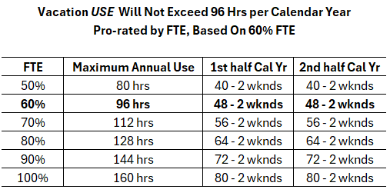

Below is the accessible version for reader technology for the Vacation USE Will Not Exceed 96 Hrs per Calendar Year chart:
- FTE 50%, Maximum Annual Use is 80 hrs, 1st half Cal Yr is 40 – 2 wknds and 2nd half Cal Yr is 40 – 2 wknds
- FTE 60%, Maximum Annual Use is 96 hrs, 1st half Cal Yr is 48 – 2 wknds and 2nd half Cal Yr is 48 - 2 wknds
- FTE 70%, Maximum Annual Use is 112 hrs, 1st half Cal Yr is 56 – 2 wknds and 2nd half Cal Yr is 56 - 2 wknds
- FTE 80%, Maximum Annual Use is 128 hrs, 1st half Cal Yr is 64 – 2 wknds and 2nd half Cal Yr is 64 - 2 wknds
- FTE 90%, Maximum Annual Use is 144 hrs, 1st half Cal Yr is 72 – 2 wknds and 2nd half Cal Yr is 72 - 2 wknds
- FTE 100%, Maximum Annual Use is 160 hrs, 1st half Cal Yr is 80 – 2 wknds and 2nd half Cal Yr is 80 - 2 wknds

- Even if they have already used some of their current year annual leave hours prior to entering the weekend classification, they get a pro-rated amount of their remaining annual leave hours for USE time after they transfer into the weekend classification.
- When weekend employees are also regularly scheduled for non-weekend shifts, they may be permitted to use annual leave for those non-weekend shifts. However, the limit of using annual leave on two weekends during each half of the year still applies.

Annual Leave / Vacation use while in the Weekend Classification:
- Annual leave USE will not exceed 96 hours per calendar year, except by mutual agreement with the employer and employee.
- Employees in the weekend classifications may elect to use annual leave on no more than 2 weekends during each of the time periods January through June and July through December.
  - Whether a full or partial weekend, an employee may only use vacation on two different weekends during each of the time periods. This means that any time off, even if only a few hours, will count as one weekend.
- Employees in weekend classifications are not allowed to carryover annual leave. Instead, annually after December 31 or at the completion of the employee’s first six months of service, whichever is later; accrued unused annual leave must be paid out and annual leave balance zeroed out.
- Employees in weekend classifications are not eligible to convert annual leave to sabbatical/termination leave under s. 230.35(1p), Wis. Stats.

Annual Leave / Vacation Forecasting Issues:
- STAR will not allow employees in the weekend classifications (through ESS) or their supervisors (through MSS) to Forecast and Submit annual leave takes over 96 hours in a calendar year. If an employee attempts to USE more than 96 hours in a calendar year, they will receive the error message:
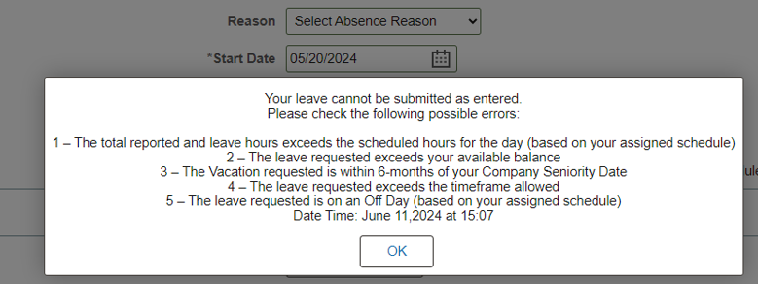
- If an annual leave take is already entered and approved for a future date, and an employee submits an additional annual leave take for a date earlier and the total take now exceeds 96 hours for the calendar year; the future annual leave take will change to Saved status, which does not process or pay.
If an employee in a weekend classification has a Saved annual leave take, you must first look to see if they are eligible for that annual leave take.
  - If they have been a weekend employee for the full year and have used their maximum hours, they would not be eligible unless the agency grants an exception to the 96 hours limit. If an exception is not granted, the vacation take(s) should be removed.
  - If the agency grants an exception to the 96 hours limit, the best practice is to submit a ticket requesting a 96 hours USE limit override.
    - We ask payroll staff to not force through the takes over 96 hours by entering them on the Create and Maintain screen, since the Forecast Value will be Ineligible and the take will be included on the WI_ABS_INELIGIBLE_ABSENCES query.

Annual Leave / Vacation 96 Hours USE Limit Override Request:
- In June 2024 we programmed STAR/HCM to allow an override to the 96 hours USE limit by employee. The override can be set to a specific whole hour amount greater than 96 up to 216 hours. With the override the employee (in ESS) or supervisor (in MSS) will be able to enter in the annual leave takes up to the new USE limit amount. On the Create and Maintain screen the Forecast value will no longer show as Ineligible, thus no longer be included on the WI_ABS_INELIGIBLE_ABSENCES query.

  - Annually during the year end absence procedures DOA Central Payroll will request agencies to submit a list of weekend employees that need an exception entered for the upcoming year with the date range of 1/1/20## to 12/31/20##.
  - If the exception needs to be added or the total annual USE hours increased mid-year, the agency will need to submit a ticket requesting the change. The entry can be set up for the entire calendar year; or we can specify a date range from the beginning of a pay period to the end of a pay period.
    - Subject line for ticket: Vacation Override Request for Weekend Employee – Mickey Mouse 111111111. Indicate number of full hours (I.e., 96 plus additional 20 hours for a request of 116 hours) and the time period of either full year or specified date range.
  - The override is entered by DOA Central Payroll on the Supporting Element screen using Element Type: Variable and Element Name WI VR WKND96 EXCP. Under Values and Numeric Value, we can enter the specific whole hour amount greater than 96 up to 216 hours.
Note: the system will allow us to add the exception to any employee regardless of the (absence) Eligibility Group but will only impact employees with the WIWKNDEX or WIWKNDNRS code. This means if the employee was set up with the exception for the entire calendar year, we do not need to remove the exception on the Supporting Element screen if the employee moves out of the Weekend classification.

Annual Leave / Vacation Payout:
- Annually after December 31 or at the completion of the employee’s first six months of service, whichever is later; accrued unused annual leave must be paid out at the employee’s base pay rate and the annual leave balance zeroed out.
  - If the employee is still within their first 6 months of state service, it gets paid out upon completion of the first 6 months and the annual leave balance reduced at the time of pay out.
  - If processing at year-end, use the employee’s base rate of pay as of 12/31. The OTA POTT can be in hours or dollars unless there has been an intervening pay rate change, then it must be in dollars.
    - In the Comment section indicate “Annual Vacation Payout for Weekend classification”.
  - When paying out annual leave, an Absence Adjustment also needs to be entered in the last pay period of the year (e.g., 2025B02) to zero out the WI_VACATION balance and prevent any carryover into the new calendar year.
    - If the employee is negative at year-end or uses LWOP in the split pay period at year-end, extra review may be needed.
    - If there is an annual leave adjustment due to working over/under their FTE through 12/31 or the employee is taking annual leave on 12/31, you must take this into account when entering the Absence Adjustment.
  - Section 502 of the WRS manual requires that annual leave cash-outs must be routine (at least once a year) and provided to all employees in a category for the cash-outs to be considered WRS earnings.
- If the employee is still within their first 6 months of state service as of 12/31, it gets paid out upon completion of the first 6 months.
  - If the employee is in the first 6 months of state employment, the leave would automatically carryover in STAR (WI_CRR_OVR_6_BAL).
  - Accrued unused annual leave from the prior year will be paid at the employee’s base pay rate (at the time of cash-out) as an OTA POTT during the pay period after completion of the employee’s first 6 months of state service.
    - At the discretion of the agency, the employee could be allowed to use more than 96 hours of annual leave during the year.
    - Enter an Absence Adjustment in the pay period of the pay out to zero out the vacation carryover.
    - If the employee transfers or otherwise moves out of the weekend classification prior to completing the first 6 months of state service, the annual leave would carry into the new position. It would not be cashed out.

Change in (absence) Eligibility Groups WIWKNDNRS and WIWKNDEX:
If the employee is staying in the weekend classification and simply moving between WIWKNDNRS and WIWKNDNEX causing a change in the vacation factor, treat as you do any other employee with a FLSA change.
- You must calculate the new annual leave/vacation accrued/lost from point of change to end of year. Enter an Absence Adjustment to increase/reduce the vacation balance.
- There is no review needed relating to the 96 USE limit.
- The system will automatically increase the vacation entitlement if FTE increases. The automated adjustment for FTE change in the system only works the first time the FTE is changed in the calendar year. If changed more than once in the year, the additional changes have to be entered manually.

Transferring out of the Weekend Classification: See Appendix B.
- Employees transferring out of a weekend classification will receive annual leave in accordance with Comp Plan Section K 3.01 (general employee) for the remainder of the calendar year. Add/Decrease vacation as needed by entering an absence adjustment if there is an FTE change.
- When there is no FTE or FLSA change with movement out of the weekend to non-weekend classification there is no evaluation needed of the annual leave since the vacation accrued while in the weekend classification remains for use in the non-weekend position.
- In 2026 when we updated the programming to calculate personal holiday and legal holiday entitlements upon position changes, we did not include special programming for the Weekend appointments.
  - When transferring out of the weekend classification, an employee who has not yet received the current year’s personal holiday entitlement would receive it at this time by entering an absence adjustment.
  - When transferring out of the weekend classification, the employee should be given all remaining legal holiday hours for the remainder of the calendar year by entering an absence adjustment.

Terminating Employment while in the Weekend Classification: See Appendix C & D.
- Employees terming who were in the weekend classification for the full calendar year should have their leave payout calculation handled in the same manner as other terminating employees.
  - When an employee moves from non-weekend to weekend mid-year; their accrued unused leave at the point of transfer should be paid out. Employees terming who were only in the weekend classification for a partial calendar year should only have the term payout reflect the portion of time that they were in the weekend classification. See Example 1.
  - If the accrued unused leave was not paid out at time of transfer from non-weekend to weekend, due to being overdrawn when they entered the weekend classification, we would want to look at the whole calendar year in processing their leave payout.
- An employee in the weekend classification that is wanting to extend their time on payroll using their accrued leave may need to have their classification changed to an appropriate non-weekend classification. See Checklist in Appendix D.

Maternity Leave / FMLA Leave:
Weekend employees on Maternity Leave are not restricted to 96 hours / 4 weekends of annual leave use.
The employee is able to use available paid leave while on maternity leave, whether that is FMLA or ER 18.14. While the comp plan restricts the use of annual leave, this does not apply to these policies. The FMLA policy allows the use of paid leave and so does ER 18.14. If the employee doesn’t have enough hours to be eligible for FMLA, then they would need to request maternity leave through ER 18.14. This requires form F-00689 to be completed and signed off on by the appointing authority.
- ER 18.14(2)(d) Maternity leave. Upon request of the employee, maternity leaves of absence shall be granted for the period of time requested by the employee, not to exceed 6 consecutive months. Upon request of the employee, the appointing authority may extend or renew a maternity leave of absence for additional periods of time, not to exceed a total of 6 months. Part or all of the original leave, extension or renewal may be covered by sick leave pursuant to s. ER 18.03 (4) (a), leave of absence without pay, accrued annual leave, sabbatical leave, holiday leave, compensatory time off at the employee's discretion, or anticipated annual leave subject to s. ER 18.02 (6).

APPENDIX A - CHECKLIST: Transfer into Weekend Classification
Job Data
- Update the Job Data for the appropriate Weekend Classification Title / Job Code and FTE.
  - For the Nurse Classification verify they meet the FLSA Salary Threshold for exempt status.
- Ensure that the Absence Eligibility Group is updated to WIWKNDNRS or WIWKNDNEX on a separate Data Change / Absence Eligibility Change row in Job Data > Payroll, Eligibility Group.
Leave Payout Upon Movement to the Weekend Classification
- Annual leave / Vacation
  - Use the Term Payout Calculator to determine the number of accrued unused annual leave hours between Jan 1 (or the hire date) and the date in which they enter the weekend classification. Watch for work anniversaries that affect leave or leave adjustments for working over their FTE (WI_ABS_MANUAL_ADJUSTMENTS and WI_ABS_AUTO_ADJUSTMENTS).
  - Pay out any accrued unused leave balance, enter an OTA POTT to pay out ACCRUED unused leave hours at the old rate of pay.
    - If there was a pay change upon entering the weekend classification, you would do the OTA POTT in dollars instead of hours to allow you to pay it out at the old rate of pay.

  - If the employee has used more leave than they have accrued, no action is needed unless the FTE was decreased and creates a negative annual leave balance, in which case the overdrawn leave should be collected by an ODL POTT.
    - If there was a pay rate change, you would do the ODL POTT in dollars instead of hours to allow you to collect it at the rate pay the annual leave was used at.
    - When doing a negative ODL POTT as dollars, be sure to add a row for negative WAH hours.
    - Or if there is ACCRUED unused balance for another leave type, a leave swap can be entered on the Create and Maintain screen to get rid of the negative balance.
- Personal Holiday
  - Pay out any remaining unused personal holiday via an OTA POTT.
    - If there was a pay change upon entering the weekend classification, you would do the OTA POTT in dollars instead of hours to allow you to pay it out at the old rate of pay.
- Legal Holiday
  - Pay out any remaining accrued unused Legal Holiday via an OTA POTT.
    - If there was a pay change upon entering the weekend classification, you would do the OTA POTT in dollars instead of hours to allow you to pay it out at the old rate of pay.
  - If the employee has used more legal holiday leave than they have accrued, you would collect the overdrawn leave via an ODL POTT.
    - If there was a pay rate change, you would do the ODL POTT in dollars instead of hours to allow you to collect it at the rate of pay the legal holiday was used at.
    - When doing a negative ODL POTT as dollars, be sure to add a row for negative WAH hours.
  - Or if there is ACCRUED unused balance for another leave type, a leave swap can be entered on the Create and Maintain screen to get rid of the negative balance.
  - Watch for adjustments for working over their FTE (WI_ABS_MANUAL_ADJUSTMENTS).
Absence Adjustment must be entered upon transfer to the Weekend Classification
- Sabbatical and sick balances will remain.
- Zero out all remaining legal holiday balance using the calendar group prior to the class change.
- Zero out all remaining personal holiday balance using the calendar group prior to the class change.
- If there was a change to the FTE and/or FLSA, enter an Absence Adjustment in the calendar group of the class change for the annual leave balance.
  - Consider the FTE change, any annual leave being paid out and any previously existing automatic system adjustment for the pay period for which you are entering the adjustment.
    - If there is any LWOP in the prior pay period or the employee was a part-time employee that worked above their FTE, be careful as your manual Absence Adjustment will override the automatic adjustment that the system enters. You should increase/decrease your Absence Adjustment accordingly so as to not lose the system calculated adjustment.
Future Leave
- Calculate the amount of future annual leave the employee can USE during the calendar year. When an employee enters the weekend nurse classification mid-year, you can approximate or pro-rate how much annual leave they are able to use. Employees are allowed to use two 24-hour weekends in each of the first and second half of the year (this should be pro-rated based on FTE, so a 1.0 employee could use two 40-hour weekends). If there is roughly one quarter of the year left, you can figure the employee can use 1 weekend or 24 hours of leave.
- Is a 96 Hour Annual Leave / Vacation Use Limit Exception needed? If yes, submit a ticket to DOA Central Payroll.
- After the pay period containing 12/31 processes, review the final annual leave balance for the prior year. In the following pay period, add an OTA POTT to pay out the remaining balance.*
*If the employee is on probation at the end of the year, instead add a reminder to pay out the carryover balance in the pay period after the employee completes probation.
- After entering the OTA POTT, enter a corresponding Absence Adjustment for the final pay period of the prior year (I.e., 2025B02) to remove the vacation balance from WI_VACATION to prevent carryover into the new year.

- *If the employee is still within their first 6 months of state service as of 12/31, it gets paid out upon completion of the first 6 months.
  - Accrued unused annual leave from the prior year will be paid at the employee’s base pay rate (at the time of cash-out) as an OTA POTT during the pay period after completion of the employee’s first 6 months of state service.
    - If the employee is in the first 6 months of state employment, the leave would automatically carry over in STAR.
    - At the discretion of the agency, the employee could be allowed to use more than 96 hours of annual / vacation leave during the year.
    - Enter a manual adjustment in the pay period of the pay out to zero out the annual leave carryover (WI_CRR_OVR_6_BAL).
    - If the employee transfers or otherwise moves out of the weekend classification prior to completing the first 6 months of state service, the annual leave would carry into the new position. It would not be cashed out.
Benefits
- If there was an FTE change, adjust the ICI ABBR

Example 1 APPENDIX A – Transfer into the Weekend Classification (used LWOP pay period prior to becoming a weekend position)
Mickie Mouse was a 1.0 FTE and transferred into a .6 weekend nurse position on 7/22/18 (Calendar Group 2018B17) with the same pay rate. Mickie came from a 100% FTE exempt position and had 3.5 years of service as of the beginning of 2018. In the pay period prior to the class change Mickie lost .12 hours of vacation due to using LWOP.
Annual Leave:
 | Accrued | Used | Balance of  Accrued Leave
Legal Holiday | 36 | 68 | -32
Personal Holiday | 36 | 36 | 0
Vacation | 67 | 57.43 | 9.57
Total |  |  | -22.43
Leave Payout:
An ODL POTT should be entered to recoup the following:
- -22.43 hrs (9.57 vacation accrued, but not used, paid out minus 32 legal holiday hrs overdrawn)
Leave Adjustments:
The following leave adjustments should be entered for Calendar Group 2018B16.
- -4 Legal Holiday (zero out legal holiday as no longer eligible)
- -31.69 Vacation
  - - 9.57 Vacation (amount accrued, but not used, prior to transferring into Weekend Nurse position – this gets paid out)
  - -22 Vacation (120 – 98, manual adjustment due to FTE change)
  - -.12 (as the manual leave adjustment will overwrite the auto, this accounts for leave lost due to LWOP used in PP 16)
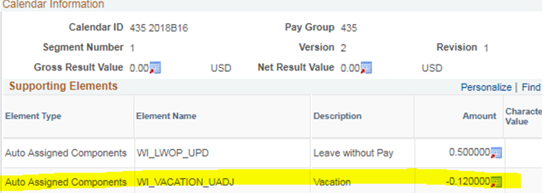
Future Leave:
- If we assume he could use 96 hours in a full year, when we pro-rate it for 7/22 to 12/31 that would mean he could use roughly 42 hours the remainder of the year. As he will only have roughly 31 hours left, the 42-hour limit would not even come into play.

APPENDIX B - CHECKLIST: Transfer out of the Weekend Classification
Job Data
- Change Job Data to the appropriate non-weekend Classification Title / Job Code and FTE.
  - For the Nurse Classification the FLSA status and (Absence) Eligibility Group fields are correct in Job Data based on the FLSA Salary Threshold.
- Ensure that the Absence Eligibility Group was updated to a non-weekend group replacing WIWKNDNRS or WIWKNDNEX on a separate Data Change / Absence Eligibility Change row.
- When there is no FTE or FLSA change with movement out of the weekend to non-weekend classification there is no evaluation needed of the annual leave since the vacation accrued while in the weekend classification remains for use in the non-weekend position.
- A review of the legal holiday and personal holiday balances must be completed and if needed enter an absence adjustment.
Leave Adjustment
We did not program the system to automatically give legal holiday and personal holiday entitlements when moving from a weekend classification to a non-weekend classification.
- Manually adjust by increasing the legal holiday balance based on the employee’s FTE on the non-weekend classification and the remaining number of legal holidays for the calendar year. Use the pay period of the class change.
- If the employee has not yet received their current calendar year allotment of personal holiday hours, manually adjust the personal holiday balance based on the employee’s FTE on the non-weekend classification to give it to them. Use the pay period of the class change. An employee may not receive more than 36 hours of personal holiday hours in a calendar year. If the employee moved into the Weekend Classification in the current calendar year, verify if the personal holidays were already paid out.
- If there was a change to the FTE and/or FLSA, enter an absence adjustment in the calendar group of the class change for the annual leave balance.
  - If there is any LWOP in the pay period, or the employee is now a part-time employee that works above their FTE, be careful as your manual absence adjustment will override the automatic adjustment that the system. You should increase/decrease your Absence Adjustment accordingly so as to not lose the system calculated adjustment.
Future Leave
- The employee should now be under normal leave guidelines and is free to use any remaining leave without restriction.
Benefits
- If there was an FTE change, adjust the ICI ABBR

Example 1 APPENDIX B - Transferring out of the Weekend Classification
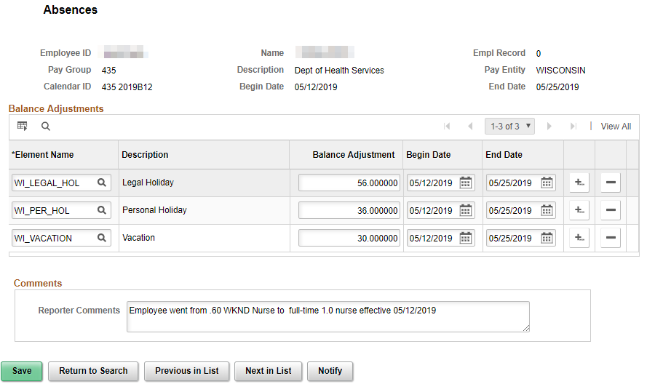

APPENDIX C - CHECKLIST: Termination of Employment from a Weekend Classification – Paying Out Earned Unused Leave (Not Extending Employment using Accrued Leave.)
Job Data
- Enter Termination row in Job Data. Make sure the Effective Date is the day after the last day of employment.
Timesheet and Absence Take Entries
- Verify the employee has made all entries on the timesheet and any absence take entries.
Calculate Accrued Leave and Prepare POTT LAN / LSR
- Complete a Termination Payout worksheet.
- If necessary, enter the POTT for any overused leave (LSR) or payout (LAN) for accrued unused leave. Attach Term Payout worksheet to POTT.
Leave Adjustment
- If necessary, enter the Absence Adjustment in the Pay Period of termination to zero out balances.
- If retirement-eligible and eligible for the Sick Leave Credit (even if not immediately starting their annuity), submit the Sick Leave Certification with ETF and zero out the sick leave balance as well.
- If transferring to another affiliate not using the STAR system, provide the new employer with a completed Personnel Transaction Record and zero out the sick leave balance as well.

Example 1 APPENDIX C – Term after Mid-Year move to WKD Classification
Mickie Mouse was a 1.0 FTE RCT and transferred into a .80 weekend RCT position on 08/29/2021 (Calendar Group 2021B19). He then termed on 11/20/21.
At the time Mickie moved into the weekend classification, he was paid out 8 hours of vacation, 2 hours of personal holiday and was overdrawn by 1 hour of legal holiday. The OTA POTT was submitted for 9 hours and leave adjustments were made for the leave paid out as well as the FTE change.
When Mickie terms on 11/20/21, we can ignore everything prior to 8/29/2021 as this leave has already been dealt with. The term payout spreadsheet is created assuming a hire date of 8/29/21 and a term date of 11/20/21. Had Mickie technically been overdrawn when he entered the weekend position, we would want to look at the whole year.
- There is no personal or legal holiday, so we leave those blank
- As of PP 18 he has used 77.47 vacation and as of the end of PP 23 he had used 77.61. This is a difference of .14 hours. This can also be verified with the WI_PY_PAYCHECK_PAYLINES_EMP query using earn code 006.
- Using WI_ABS_AUTO_ADJUSTMENTS I see that he had 3 adjustments for .80 hours vacation each during this time frame. I added them in as adjustments.
- Employee gets paid out 21.26 hours via LAN.
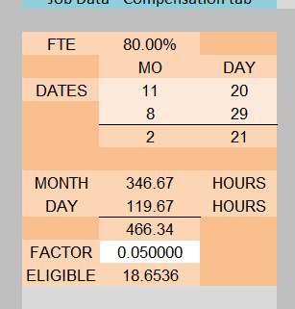 | 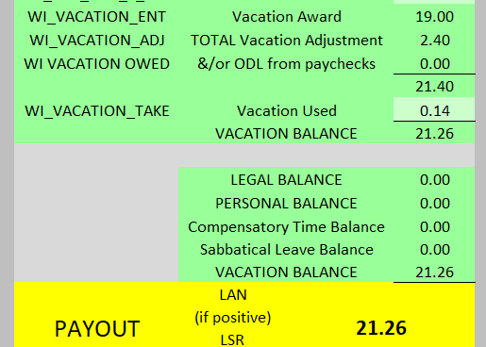

Example 2 APPENDIX C – Term after Full Calendar Year in the WKD Classification
Process the payout calculation in the same manner as any other payout calculation. There will be no Personal Holiday or Legal Holiday entitlements. There could be Sabbatical balance if the employee worked in a non-weekend appointment prior to the current weekend appointment.

APPENDIX D - CHECKLIST: Termination of Employment from a Weekend Classification – Extending Employment using Accrued Leave
Refer to: DPM_0630-CC Treatment of Weekend Classifications for Termination Leave
Job Data
- Change Job Data to transfer the employee to the appropriate non-weekend Classification Title / Job Code and FTE.
  - The transfer with the classification change is effective at the first day of a pay period. When an employee in a Weekend classification resigns and will no longer be assigned any work, the employee shall be transferred to the appropriate non-weekend classification effective the beginning of the pay period following the last day worked. (Clarifying this means last SCHEDULED workday, which could be covered by paid/unpaid leave.)
- Make sure for the Nurse Classification the FLSA status and (Absence) Eligibility Group fields are correct in Job Data based on the FLSA Salary Threshold.
- Ensure that the Absence Eligibility Group was updated to no longer reflect WIWKNDNRS or WIWKNDNEX on a separate Data Change / Absence Eligibility Change row.
- Ensure that the Reason “Exhaust Accrued Leave” is entered on a separate Data Change row.
- If a weekend employee does not have sufficient accrued, unused paid leave to remain in pay status into the next pay period following the employee’s last day of work, no classification change is needed and the employee will terminate employment in the Weekend classification.
- If the accrued annual leave/Sabbatical will be exhausted in the same pay period as final day of scheduled work, then it is not necessary to transfer the employee into the non-weekend Classification in the pay period following.
- Add Termination row in Job Data. Make sure the Effective Date is the day after the last day of employment.
Leave Adjustment
- Enter an Absence Adjustment to increase the legal holiday balance based on the employee’s FTE and the remaining number of legal holidays. Use the pay period of the class change.
- If the employee has not yet received their current calendar year allotment of personal holiday hours, enter an Absence Adjustment giving them the personal holiday balance based on the employee’s FTE. (The annual entitlement cannot exceed 36 hours.) Use the pay period of the class change.
- An adjustment to the annual leave balance is not needed.
Absence Take Entries
- Once the Job Data and leave balances have been updated, enter the absence takes on the Create and Maintain screen. (The changes to Job Data and absence balances will occur after the employee is no longer working.)
- Once the accrued leave balances are depleted, follow the normal process for terminating employees.

APPENDIX E - Differentials for Weekend Classification
Nurses Program:
- Weekend Nurse Add-On (WPN/WPC): Eligible for $10 an hour ($5 for LPN) differential for all hours worked between 6:00 a.m. Friday and 11:30 p.m. Monday, see Comp Plan Section A 4.31 & A 4.32
  - Hard coded in STAR for all employees in an eligible weekend classification
- Nurse Responsibility (RSP): Eligible for $1.40/hr., see Comp Plan Section A 4.07 (4)(a). LPNs are not eligible.
  - Created in STAR on the Create/Maintain Time Reporter Data page.
  - Rule Element 3 should be “T” (Temp PM Shift Responsibility)
- Permanent PM (PPM): Eligible for $2.50/hr. if committing to a permanent PM or night shift for a minimum of 6 months, see Comp Plan Section A 4.07 (4)(b)(4). LPNs are not eligible.
  - Created in STAR on the Create/Maintain Time Reporter Data page.
  - Rule Element 3 should be “P” (Perm PM Shift Responsibility)
- Night (NTE): Nurses are eligible for night if they are not receiving RSP or PPM differentials.
  - Created in STAR on the Create/Maintain Time Reporter Data page.
  - Rule Element 2 should be “D” (Shift Differential) for nurses. A “C” is used while the temporary weekend critical vacancy is in effect through a DPM Memo.
- Weekend (WKD): LPNs are eligible since non-exempt. Weekend Nurses are not eligible, see Comp Plan Section A 4.06 (1).
  - Created in STAR on the Create/Maintain Time Reporter Data page
  - Rule Element 2 should be “D” which is used for both Shift and Weekend differentials.
- If a nurse is coded to receive the Night differential, the system will automatically know to not give the weekend differential to ineligible employees.
- Critical Vacancy Weekend (CVE): Weekend Nurses are not eligible for this $3 critical weekend add-on that NC2 nurses at eligible locations receive for hours worked on a weekend.
CNA Program:
- Weekend CNA Add-On (WPC): Eligible for $5 an hour differential for all hours worked between 6:00 a.m. Friday and 11:30 p.m. Monday, see Comp Plan Section A 4.32.
  - Hard coded in STAR for all employees in a weekend classification
- Night (NTE): CNA is eligible for night.
  - Non-exempt CNA will receive the night differential automatically; no special coding is needed.
- Weekend (WKD): CNA is eligible for the weekend differential during specified hours.
  - Non-exempt CNA will receive the weekend differential automatically; no special coding is needed.
Security Classification Program:
- Weekend Security Add-On (WPC): Eligible for $5 an hour differential for all hours worked between 6:00 a.m. Friday and 11:30 p.m. Monday, see Comp Plan Section A 4.33
  - Hard coded in STAR for all employees in a weekend classification
- Night (NTE): Security is eligible for night.
  - Non-exempt staff will receive the night differential automatically; no special coding is needed.
- Weekend (WKD): Security is eligible for the weekend differential during specified hours.
  - Non-exempt staff will receive the weekend differential automatically; no special coding is needed.
- Critical Vacancy (CVA/CVN): Eligible for $5 an hour differential for all hours worked for some classifications at select locations with a greater than 40% vacancy rate based on DPM approval and issuance of a DPM memo.
- Security classification first became eligible for this on 1/2/22, depending on location.
  - Created in STAR on the Create Additional Pay Page screen.
- Use CVA for correctional officers and CVN for youth counselors. End date gets left blank.
  - This add-on expires 6 months after DPM determines 40% vacancy rate is no longer exceeded.

