DATE: May 25, 2017 File Ref: 02-17

TO: All Agencies on Central Payroll & Leave Accounting

FROM: Stacie Happel, Leave Accounting Coordinator
DOA-Central Payroll Section

SUBJECT: June 30th Absence Processing Procedures

Please review the Carryover Query (WI_ABS_CRRY_OVR_BAL_RPT) to determine if employees have used their carryover hours. June 30th will be processed during pay period 15-B.

*AUTOMATIC AGENCY CARRYOVER AMOUNT
PeopleSoft has the ability to set an Agency Default Amount for all employees. Please let me know what amount your agency would like as the default annual leave for carry over through December 31, 2017, i.e. 0, 40, 80, 216, etc.

Return your Agency Default Amount via email [stacie.happel@wi.gov] NO LATER than June 9, 2017, 4:00 pm.

All remaining carryover buckets exceeding the Agency Default Amount will be taken to zero.

*INDIVIDUAL CARRYOVER EXCEPTIONS
Individual exceptions to the default selected by your Agency should be entered on the Individual Carryover Exceptions spreadsheet included in the email. All employees given an exception will be allowed to carry over any and all remaining balance in the leave type you have chosen for them. If you wish an employee to be allowed to carry over multiple leave types you will need to list them on your exception spreadsheet multiple times, once for each leave type.
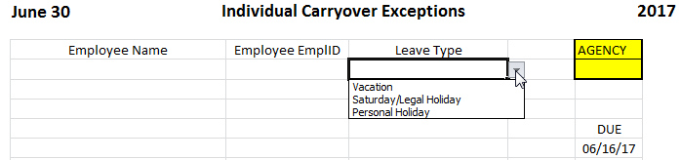

Return your Exception spreadsheet via email [stacie.happel@wi.gov] NO LATER than June 16, 2017, 4:00 pm.

NOTE: Employees completing an original probation period during the first 6 months of the calendar year shall have the remainder of the calendar year in which to use annual leave earned the previous year. This will be applied automatically for these employees, so it is not necessary for agencies to submit an individual exception. These employees have their carryover in the 12 month bucket to help distinguish between them.

*GENERAL INFORMATION
This year pay period 15 calendar will be split like we split pay period 2. You will see one calendar group ID which will contain both 2017B15 (06/25/17-06/30/17) and 2017B15A (07/01/17-07/08/17).

If you need any assistance please call me at (608) 266-8972 or email me at stacie.happel@wi.gov.

