(Version 6.0, Released January, 2024)

Table of Contents
ENTERING A NEW DISCIPLINARY ACTION 2
ADDing a disciplinary document for a discipline record 5
ADDING AN ADDITIONAL DISCIPLINARY ACTION FOR AN EMPLOYEE 9
MAKING CHANGES TO A DISCIPLINARY ACTION 10
UPDATES 10
DELETIONS 11

Overview
Discipline tracking functionality was added to STAR HCM in November 2016. DPM requires all agencies to use the functionality within PeopleSoft to track the disciplines within their agency. Agencies are not required to enter discipline data in STAR for disciplinary actions prior to the release of this tracking functionality.

SECURITY
Users must have the Discipline Security Role to access this functionality. Who the user can see is based on their row-level security (typically their business unit or a subset of their business unit).

A disciplinary action corresponds to a specific employee in STAR. The employee’s disciplinary record will follow them in the system if they transfer to a different agency.

ENTERING A NEW DISCIPLINARY ACTION
Role: Discipline

Use the following steps to enter a disciplinary action. Prior to entering a disciplinary action, it may be helpful to lookup the following information about the employee: Empl ID, Business Unit, and Department ID.

Note: If the employee has an existing disciplinary action, go to page 6: Adding an Additional Disciplinary Action for an Employee

- STEP 1: Navigate to the Record Disciplinary Actions page

- Navigation: Workforce Administrator Homepage > Human Resources tile > Person tile
- Click Grievance & Discipline dropdown and select Discipline
- On the Add a New Value tab, enter or select the Employee ID
  - To search for the employee ID, click the magnifying glass next to the text box
- Click Add
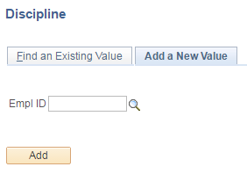

- STEP 2: Enter the disciplinary action data
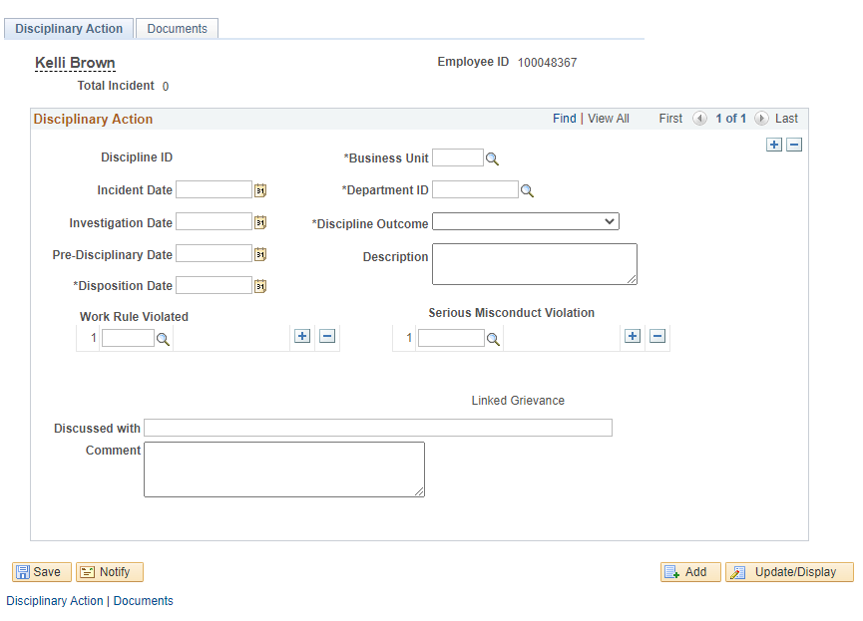
5
14
10
7
3
1
2
4
6
8
9
11
12
13
DEVON
100
- Discipline ID: A unique identifying number for the discipline that will populate after saving the discipline
- Business Unit (required): Enter the employee’s business unit (agency number)
- Incident Date: Enter the date of the incident, if applicable
- Department ID (required): Enter the employee’s department ID (division, section, unit, facility, etc.)
  - This information can be found on the employee’s job data (Main Menu > Workforce Administration > Job Information > Job Data)
- Investigation Date (required): Enter the date of the first investigatory meeting
- Pre-Disciplinary Date (required): Enter the date of the pre-disciplinary meeting
- Disposition Date (required): Enter the date of the discipline letter

- Discipline Outcome (required): Enter the outcome of disciplinary action
  - If “Other” is selected, a description must be entered
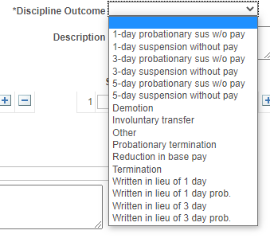
8

- Description: A short description regarding the discipline outcome may be entered in this box
- Work Rule Violated: Select the work rule that was violated using the magnifying glass
  - If more than one work rule was violated, use the + to add a row
  - If a work rule was added in error, use the – to delete the row
  - Up to five work rules may be entered per disciplinary action
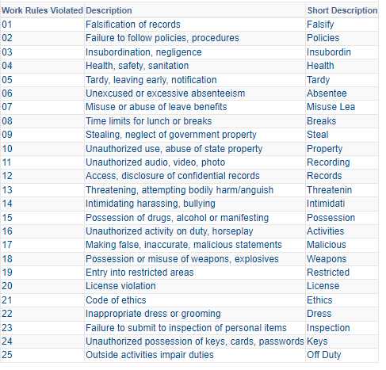
10
- Serious Misconduct Violation: Select the serious misconduct violation using the magnifying glass
  - If more than one serious misconduct violation, use the + to add a row
  - If a serious misconduct violation was added in error, use the – to delete the row
  - Up to three serious misconduct violations may be entered per disciplinary action
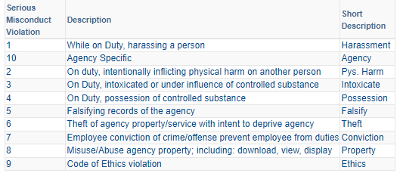
11
Note: The functionality requires that at least one work rule or serious misconduct violation must be selected.
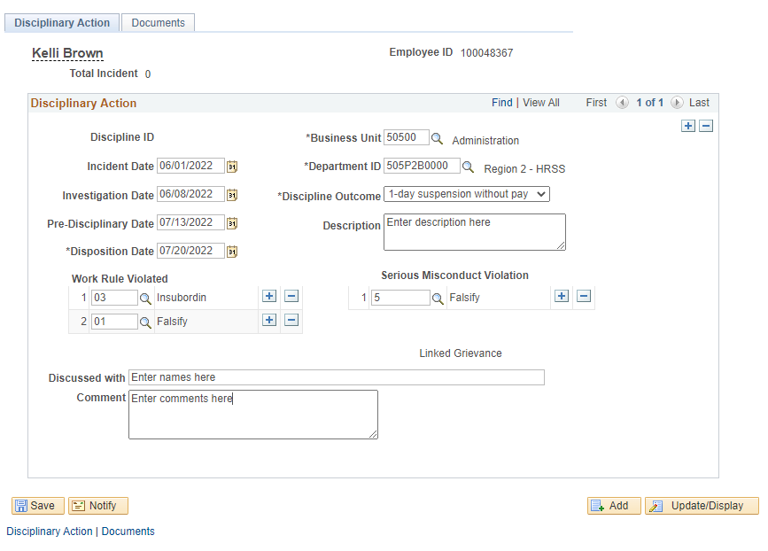
- Linked Grievance: This text will become a hyperlink once a grievance is entered in STAR and is linked to this disciplinary action. See the Grievance Functionality job aid for additional details.
100
DEVON
- Discussed with: Enter the names of those involved in the disciplinary action investigation
- Comment: Enter any additional information in this box

- STEP 3: Click Save
  - The number of Total Incidents has been updated, and the Discipline ID has been populated

ADDing a disciplinary document for a discipline record

- STEP 1: Navigate to the WI Record Disciplinary Actions page

- Navigation: Workforce Administrator Homepage > Human Resources tile > Person tile
- Click Grievance & Discipline dropdown and select Discipline
- On the Find an Existing Value tab, enter the Employee ID, Discipline ID, Name or Last Name
- Click Search

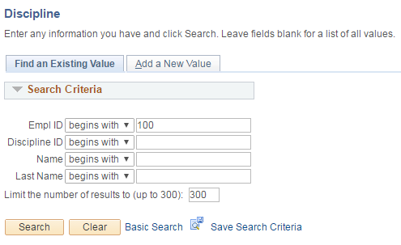

- STEP 2: Click the Documents tab and click Add Document Button

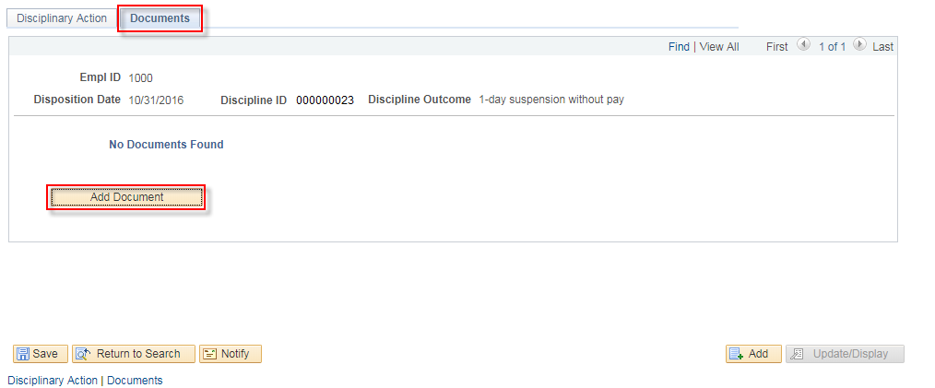

- STEP 3: Enter details about the document being uploaded
- Document effective date: The effective date of the document
- Comments: Enter any comments relating to the document that are needed.
- Business Unit: The business unit will carry forward from the discipline record and cannot be changed.
- Click Upload Document
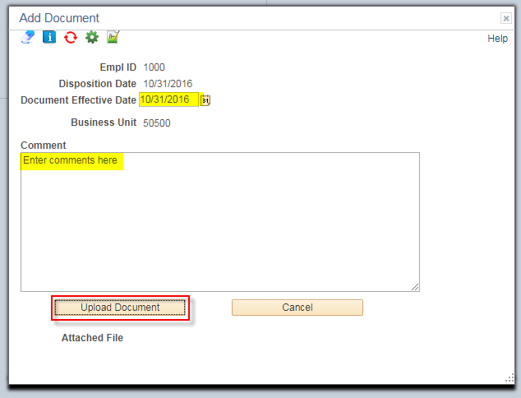
- STEP 5: Select the document to be uploaded.

All discipline documents must follow the below naming conventions

Document Type | Document Name
Letter of discipline: one-day suspension | DISC_1Day_LastFirstNameMI_mmddyy
Letter of discipline: three-day suspension | DISC_3Day_LastFirstNameMI_mmddyy
Letter of discipline: five-day suspension | DISC_5Day_LastFirstNameMI_mmddyy
Letter of discipline: probationary employee | DISC_PROB_LastFirstNameMI_mmddyy
Termination letter | TERM_LastNameFirstNameMI_mmddyy
Termination letter: probationary employee | DISC_TERM_PROB_LastFirstNameMI_mmddyy

- Click Choose File and select the document to upload

- Click Upload

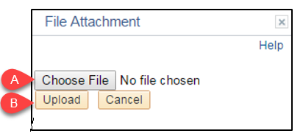

- Click Return
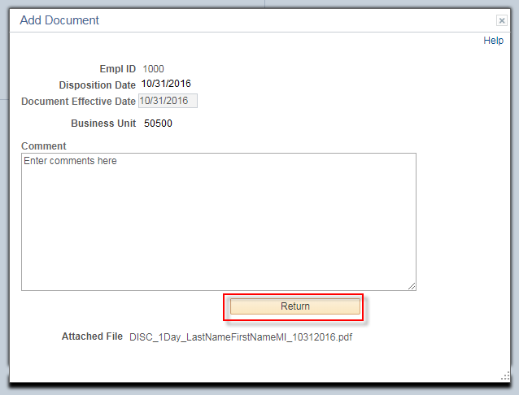

The document is now part of the discipline record:

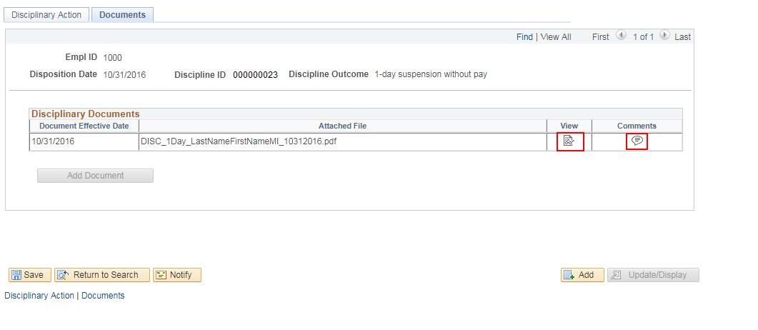

The document and the comments can be viewed directly from this page. The Add Document button is now greyed out as only one document can be attached to a discipline record. The document has also been placed in the employee’s p-file.

ADDING AN ADDITIONAL DISCIPLINARY ACTION FOR AN EMPLOYEE

- STEP 1: Navigate to the WI Record Disciplinary Actions page

- Navigation: Workforce Administrator Homepage > Human Resources tile > Person tile
- Click Grievance & Discipline dropdown and select Discipline
- On the Find an Existing Value tab, enter the Employee ID, Discipline ID, Name or Last Name
- Click Search

- STEP 2: Click the plus (+) button to add a record

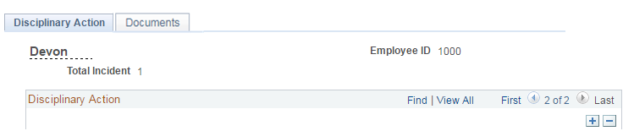

An additional record will be displayed.

- STEP 3: Enter data into the record (see Entering a New Disciplinary Action steps above)

MAKING CHANGES TO A DISCIPLINARY ACTION

UPDATES

- STEP 1: Navigate to the WI Record Disciplinary Actions page

- Navigation: Workforce Administrator Homepage > Human Resources tile > Person tile
- Click Grievance & Discipline dropdown and select Discipline
- On the Find an Existing Value tab, enter the Employee ID, Discipline ID, Name or Last Name
- Click Search

- STEP 2: Navigate to a specific disciplinary record by clicking the arrows at the top of the page

- STEP 3: Update the applicable information.
Click Save

NOTE: Discipline documents can only be deleted through the employee’s P-file. If a discipline document should be updated, work with a P-File User in your agency to submit a deletion request. When a discipline document is deleted from the p-file, it will also be removed from the discipline record. A new document can then be uploaded on the discipline record.

DELETIONS
- STEP 1: Navigate to the WI Record Disciplinary Actions page

- Navigation: Workforce Administrator Homepage > Human Resources tile > Person tile
- Click Grievance & Discipline dropdown and select Discipline
- On the Find an Existing Value tab, enter the Employee ID, Discipline ID, Name or Last Name
- Click Search

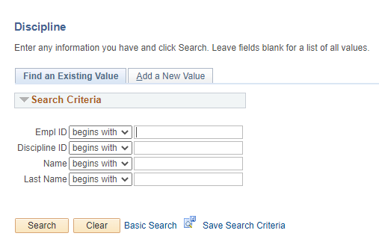

- STEP 2: Navigate to the disciplinary record row to be deleted by clicking the arrows at the top of the page

- STEP 3: Click the minus (-) button to delete the record

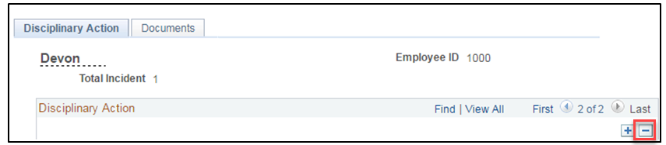

- STEP 4: Confirm the deletion

- Click OK

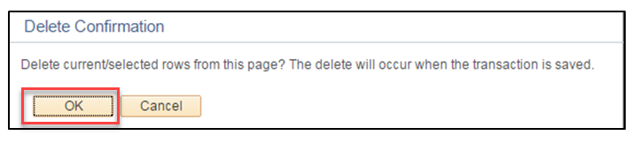

- Click Save

Note: Discipline documents will not be deleted from the employee’s P-file when the corresponding discipline record is deleted in STAR. Discipline documents can only be deleted from the employee’s P-file by submitting a deletion request through the employee’s P-file. If a discipline record has been deleted from STAR and you need to delete the corresponding discipline document from the P-file, work with a P-File User in your agency to submit a deletion request for the document.

Document deletion requests are routed to DPMC for approval.

To submit a request to delete a document from a P-file:

STEP 1: Navigate to the employee’s P-File:
Navigation:
- Workforce Administrator Homepage > Human Resources Dashboard > P-file Administrator Tile > P-file
- Workforce Administrator Homepage > Human Resources Dashboard > Person Tile > Modify a Person
- NavBar > State of Wisconsin (STAR) > Human Resources > Process > Document Management > Employee Personnel File
- NavBar > Workforce Administration > Personal Information > Biographical > Modify a Person To view a restricted employee’s P-file:
- Workforce Administrator Homepage > Human Resources Dashboard > P-file Administrator Tile > Restricted Access Employees
- NavBar: State of Wisconsin (STAR) > Human Resources > Setup > Document Setup > Restricted Access Employees

STEP 2: Click the yellow paper icon next to P-file section where the document is located.

STEP 3: Click the trash can icon next to the document that should be deleted.
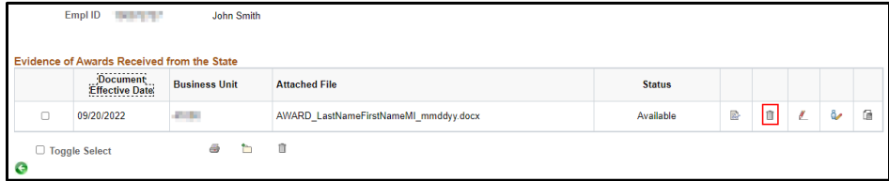
A. Enter the reason for the deletion request.
B. Click Submit.
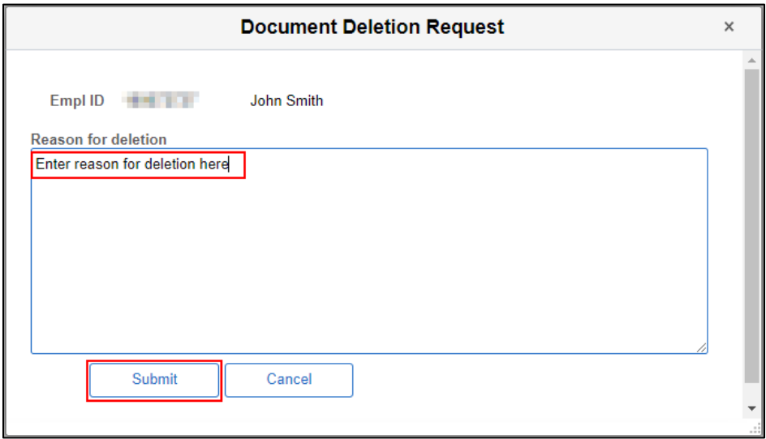
You will receive notification that your document deletion request was sent to DPMC. Additionally, an email will be sent to DPMC notifying them of the deletion request.
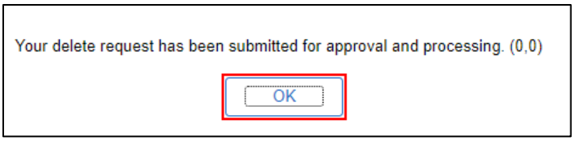
The document status will show as “Pending Deletion" until the deletion request is either approved or denied by DPMC.

NOTE: If there is only one disciplinary record in STAR for the employee, it cannot be deleted by an agency. A JIRA ticket must be submitted to delete the record.

To submit a JIRA Ticket, you must be logged into the JIRA system:
https://all-star.wi.gov/servicedesk/customer/portal/1. You must be an approved user to log into the JIRA system, so please work with someone in your agency who is approved to log into the JIRA system if you are not an approved user.

Once you are logged into the JIRA system, you will be routed to a page that lists several ticket types from which to choose. Select the “Core Human Resources” option and proceed with submitting your ticket request.
Once submitted, your ticket request will be routed to the appropriate DPMC work unit for deletion.

*It is important not to leave the erroneous record in PeopleSoft as it will be attached to an employee throughout their career.
Administrative Information
- This job aid was updated in January 2024 to include naming conventions for disciplinary documents, provide clarification regarding the deletion process and more detailed instructions regarding how to submit a deletion request.

