SCOTT WALKER
GOVERNOR
SCOTT A. NEITZEL
SECRETARY
Division of Executive Budget and Finance
State Controller’s Office
Post Office Box 7932
Madison, WI 53707-7932
Voice (608) 266-1694
Fax (608) 266-7734
www.doa.state.wi.us/debf/

DATE: October 30, 2017 File Ref: 04-17

TO: Agencies on the Central Payroll System

FROM: Stacie Happel, Leave Accounting Coordinator
DOA-Central Payroll Section

SUBJECT: Procedures for Processing Termination/Sabbatical and Cash Payment Options

The Sabbatical Eligibility table lists employees who are eligible to convert unused vacation hours to termination/sabbatical and/or cash payment options. It was finalized after processing pay period 22B (October B).

Refer to the Term/Sabbatical Category Definitions and Term/Sabbatical Eligibility Chart for an explanation of the term/sabbatical leave and cash options available to eligible employees.

All employees can enter their term/sabbatical options directly into PeopleSoft through Employee Self Service. See the Employee Sabbatical Election Job Aid (draft attached) to see what the employee will see when making an election. The enrollment period through ESS will be open 11/1/17-12/1/17.

Manual Term/Sabbatical Adjustments

Employees in multiple part time appointments have leave eligibility in each Empl Record. As a result of this their Term/Sabbatical eligibility is based on the eligibility of each Empl Record. It is the responsibility of the Agency Payroll(s) to determine if each Empl Record eligible is accurate and if not to manually calculate the correct eligibility.

Employees who have been on or are currently on a LWOP in the current calendar year should have their Term/Sabbatical eligibility prorated based on their hours worked through the October B pay period along with their projected work hours through the end of the year. These prorations need to be calculated manually by Agency payroll staff.

The current sabbatical eligibility table is used to forecast an election “Eligible”. Please use the following spreadsheet to request these changes to the eligible amounts on the sabbatical eligibility table:

These change requests should be sent to me as soon as you are aware of them.

NOTE: The table will also need to be updated if an employee swaps leave to make their vacation bucket greater.

520-Hour Sick Leave Option

Employees will be permanently eligible for the termination/sabbatical leave option once they have reached 520 hours of sick leave as long as they remain in a position that is eligible for this provision, even if their sick leave balance drops below the 520 hours. Employees eligible for this option will maintain the minimum 520 sick balance in the Grandfathered Sick Balance field. An employee who accumulates 520 hours of sick leave after the October B pay period this year, but some time before the end of the October B pay period next year will be eligible for this option in 2018, as long as they maintain a minimum balance of 520 hours through the October B payroll in 2018.

There is no proration of hours for employees in less than full-time positions who are eligible for the 520-hour sick leave option. All eligible employees will be able to bank up to 40 hours, if they have that much leave remaining.

For less than full-time employees who reach 200 hours of eligible vacation, there is proration of hours. Refer to OSER bulletin CBB-85, dated January 7, 1999, which explains the eligibility provision for the 520-hour sick leave option and OSER Bulletin 0067-DO-CLR-MRS dated July 8, 2005 which explains the July 1, 2005 changes to Wisconsin Administrative Code rules.

Termination/Sabbatical Category Definitions

Below is a listing of all the categories and their definitions which are used on the Termination/Sabbatical report. Each employee has a corresponding category to show his or her type of eligibility.

Per contract, the eligibility for BU 63 is based on a combination of seniority and sick leave accumulation. Once an employee has reached the criteria for a higher level (years of service and sick leave accumulation) their Grandfathered Sick Balance will not be reduced to a lower level even if they drop below the sick leave hour requirement for that level. NOTE: The Grandfathered Sick Balance is set once a year, after the October B pay period processes. If an employee first meets a new level midyear but drops below that level when the October B pay period processes, they WILL NOT be eligible for the higher level.

Cash Payment Instructions

The cash payment options are based on the employee's status as of the end of pay period 22B.

The cash payments will be processed in Pay Period 26A and will be included on the employee's December 21, 2017 paycheck. Termination/Sabbatical cash payments are not reported as retirement earnings and may be taxed federally up to 25%.

QUERIES
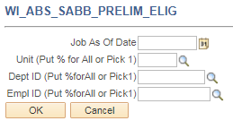
This table is updated after each absence confirm and can be run year-round.

Job As Of Date is always the last date of the last pay period confirmed.

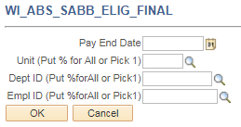
This table is updated and finalized after the October B pay period each year.

Pay End Date is always the last date of pay period 26.

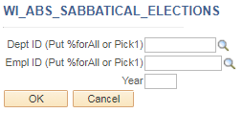
This query shows all employee that have made an election.

HOME PAGE
All employees eligible for a sabbatical election after the October B pay period will automatically receive an announcement on their HCM home page letting them know they are eligible for a sabbatical election.

They will also gain access to the Annual Sabbatical Election pagelets:

Entering Sabbatical Elections on Behalf of the Employee
It is recommended that all elections are entered by the employee through ESS. If an election needs to be changed, delete the original election made by the employee and have the employee make a new election themselves. Only elections entered through ESS will create a Sabbatical Confirmation Statement.

If elections must be changed or entered after the ESS lock-out, please follow these instructions:

Go to “Create and Maintain Absences”

Click on “Personalize” (if you haven’t removed this personalization from last year, this should still exist for you)

Find and select “Config Decimal 1” and “Config Decimal 2” and use the up arrow to move them below “Empl Record”. Scroll to the bottom and click “OK”.

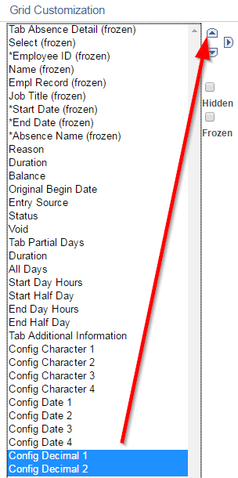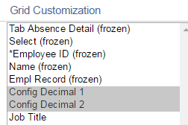

Click on the “+” button to the right to add more rows.

Determine the number of additional rows you would like to add and click “OK”. It is recommended not to exceed 20 rows at a time or forecasting will take a long time.

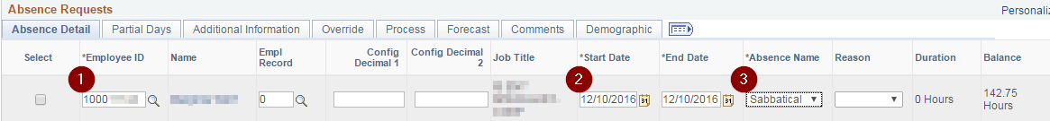
- Enter the employee’s Empl ID. The Name and Job Title will automatically fill in.
- Start Date must be 12/09/2017 (end date of PP26).
- Select “Sabbatical Election” for the Absence Name. The current (vacation) Balance will automatically fill in.

Config Decimal 1 = Total election hours (both sabbatical and cash)
Config Decimal 2 = Cash election hours

Once you have all your elections entered for employees in these newly created rows, click “Select All” at the bottom left of the list:
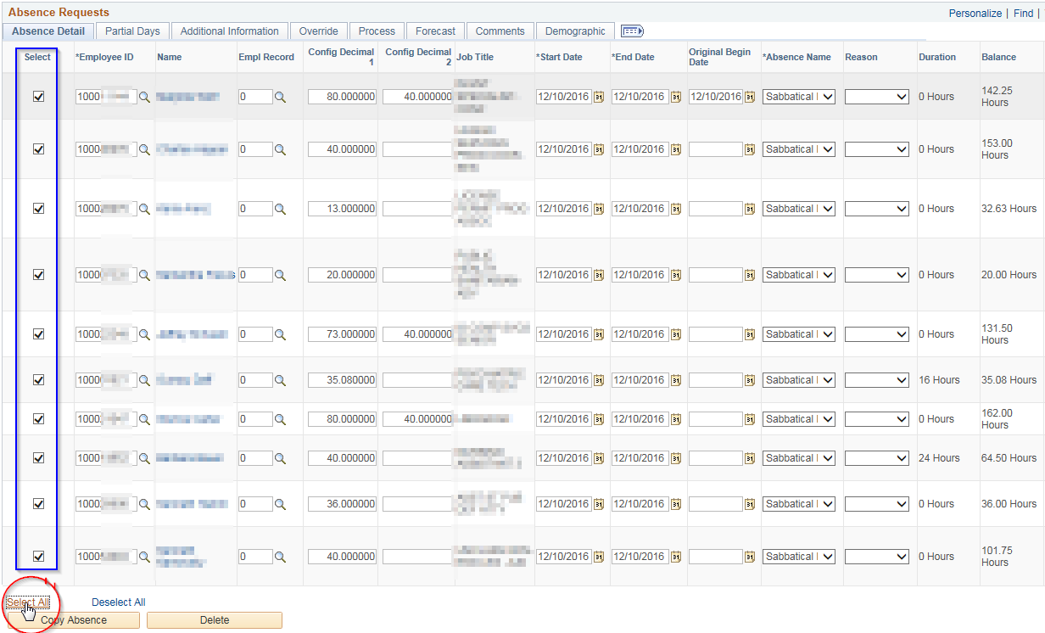
Once all employees have a check in the Select box, click “Forecast” at the bottom of the page.
Click “Yes” on this pop-up
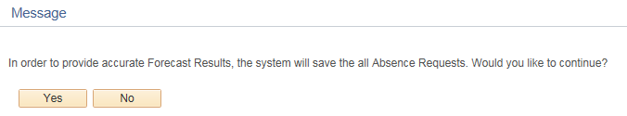

Once forecasting is complete, select the Forecast tab to see the Forecast Values.

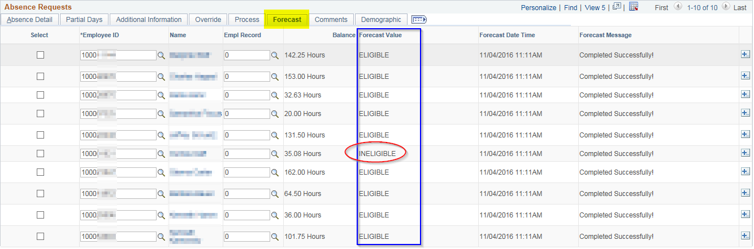

You can review “Ineligible” values individually through the Absence Event page

Go to the Forecast Value tab and Click on the “Forecast Details” link next to the Sabbatical Election line

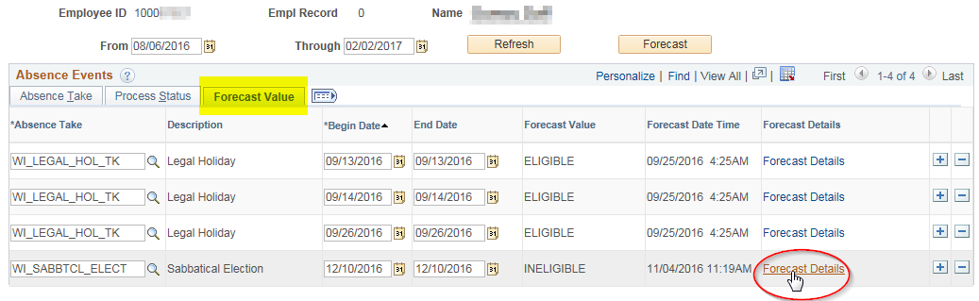

In this example, although this employee’s current vacation balance is 35.08 the report accurately shows 35.00 whole hours and we are forecasting based on the Sabbatical Eligible table hours.
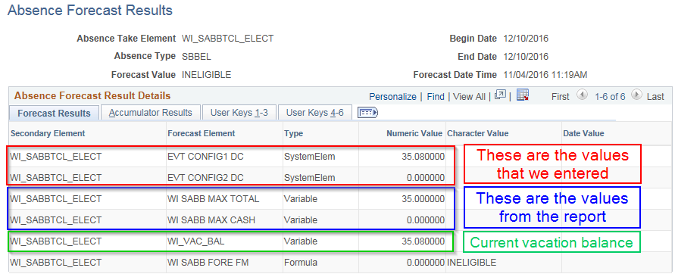
You can go back to the Create and Maintain Absences page to fix the election and re-forecast for the employees that were originally “Ineligible” (just check the select box in front of each of their names before re-forecasting). Once all Forecast Values are “Eligible” then you can “Select All” again and click “Submit” at the bottom of the page. This will flip the status from Saved to Approved.

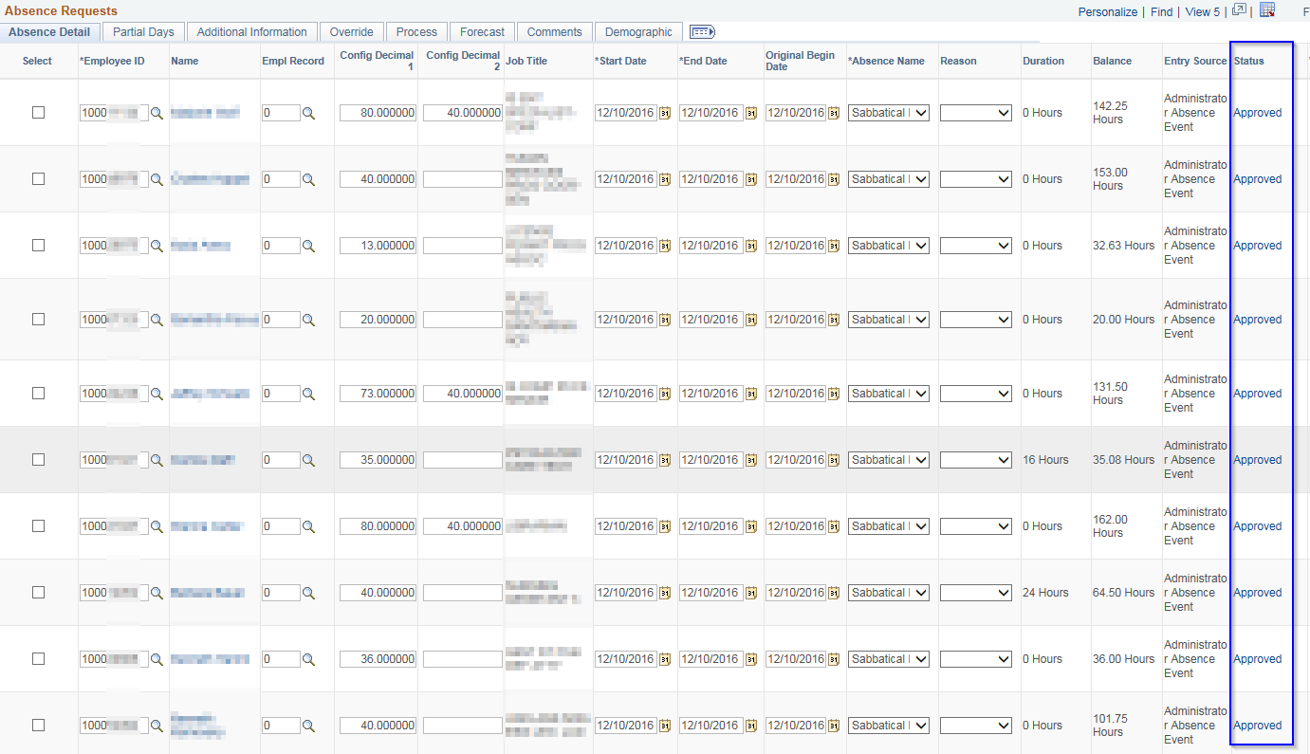

Note that as you are keying the sabbatical/cash elections, you can avoid receiving an ineligible message if you:
- Make sure the elections entered do not exceed the eligibility listed in the Sabbatical Eligible table
- Make sure the total amount elected does not exceed the current vacation balance shown on the page
- Key entries in whole hours
- Use the correct Begin Date
If you find that the status becomes Submitted instead of Approved…delete the entry and start over.

If you get an error about their schedule (and their schedule is correct) enter through the Absence Event page instead. You will find Config Decimal 1 and Config Decimal 2 under the Detail link.
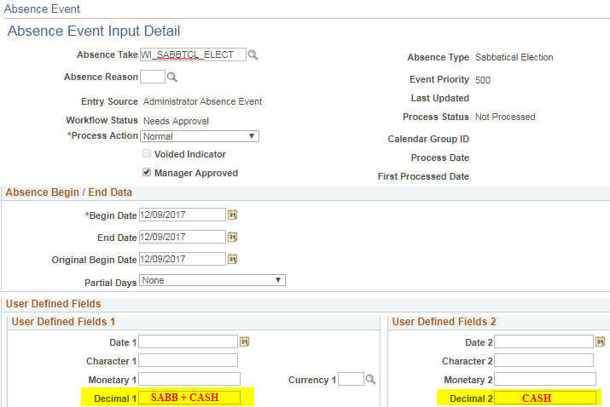

TERMINATION/SABBATICAL CATEGORY DEFINITIONS

200 HR. VACATION RATE –104 Hour Schedule (Excluding State Patrol Trooper & Inspector Series)
These employees are FLSA non-exempt. They earn vacation on the 104 Hour Schedule and have 20+ years of service.

- These employees are eligible to put a maximum of 80 hours in their termination/sabbatical account or split the 80 hours between sabbatical and cash payment with cash being a maximum of 40 hours.

160 HR. VACATION RATE - 104 Hour Schedule (Excluding State Patrol Trooper & Inspector Series)
These employees are FLSA non-exempt. They earn vacation on the 104 Hour Schedule and have 10+ years of service.

- These employees are eligible to put a maximum of 40 hours into their termination/sabbatical account.

160 HR. VACATION RATE – Accelerated/Executive Schedule
These employees earn vacation on the Career Exec Schedule and are FLSA exempt. They have 5+ years of service.

- These employees are eligible to put a maximum of 40 hours into their termination/sabbatical account.

144 HR. VACATION RATE - Dependent on Sick Leave Accumulation
These employees are in State Patrol Trooper & Inspector Series. They earn vacation on the 104 Hour Schedule and have 5+ years of service. Their eligibility is tied to the number of hours they have accumulated of sick leave as of the October B pay period each year.

    - These employees are not eligible for term/sabbatical until they have a minimum of 520 hours of sick leave as of the October “B” pay period when T/S eligibility is determined.
    - These employees with at least 520 hours of sick leave are eligible to put a maximum of 40 hours in their termination/sabbatical account or split the 40 hours between sabbatical and cash payment with cash being a maximum of 40 hours.

176 HR. VACATION RATE – Accelerated/Executive Schedule
These employees earn vacation on the Career Exec Schedule and are FLSA exempt. They have 10+ years of service.

- These employees are eligible to put a maximum of 40 hours into their termination/sabbatical account.

200 HR. VACATION RATE – Accelerated/Executive Schedule
These employees are FLSA exempt. They earn vacation on the Career Exec Schedule and have 15+ years of service.

- These employees are eligible to put a maximum of 80 hours in their termination/sabbatical account or split the 80 hours between sabbatical and cash payment with cash being a maximum of 40 hours.
520 Hr. Sick Leave AccuMulation – Accel/Exec Schedule & 104 Hour Schedule
This includes all employees on the leave accounting system who had in a previous year or have a balance of 520 hours of sick leave accrued at the end of the October B pay period.

    - These employees are eligible to put a maximum of 40 hours into their termination/sabbatical account.

216 HR. VACATION RATE – Accel/Exec Schedule & 104 Hour Schedule
These are FLSA exempt employees who earn vacation on the Accelerated/Executive Schedule. They have 20+ years of service.
These are FLSA nonexempt employees who earn vacation on the 104 Hour Schedule. They have 25+ years of service. (Except State Patrol Trooper & Inspector Series)

    - These employees are eligible to put a maximum of 120 hours in their termination/sabbatical account or split the 120 hours between sabbatical and cash payment with cash being a maximum of 40 hours.

184 HR. VACATION RATE – 104 Hour Schedule
These employees are FLSA non-exempt employees. They earn vacation on the 104 Hour Schedule and have 15+ years of service.

- These employees are eligible to put a maximum of 40 hours into their termination/sabbatical account.

160 HR VACATION RATE – Dependent on Sick Leave Accumulation
These employees are in State Patrol Trooper & Inspector Series. They earn vacation on the 104 Hour Schedule and have 10+ years of service. Their eligibility is tied to the number of hours they have accumulated of sick leave as of the October B pay period each year.

    - These employees are not eligible for term/sabbatical until they have a minimum of 520 hours of sick leave as of the October “B” pay period when T/S eligibility is determined.
    - These employees with at least 520 but less than 728 hours of sick leave are eligible to put a maximum of 40 hours in their termination/sabbatical account or split the 40 hours between sabbatical and cash payment with cash being a maximum of 40 hours.
    - These employees with at least 728 hours of sick leave are eligible to put a maximum of 60 hours in their termination/sabbatical account or split the 60 hours between sabbatical and cash payment with cash being a maximum of 40 hours.

184 HR VACATION RATE – Dependent on Sick Leave Accumulation
These employees are in State Patrol Trooper & Inspector Series. They earn vacation on the 104 Hour Schedule and have 15+ years of service. Their eligibility is tied to the number of hours they have accumulated of sick leave as of the October B pay period each year.

    - These employees are not eligible for term/sabbatical until they have a minimum of 520 hours of sick leave as of the October “B” pay period when T/S eligibility is determined.
    - These employees with at least 520 but less than 728 hours of sick leave are eligible to put a maximum of 40 hours in their termination/sabbatical account or split the 40 hours between sabbatical and cash payment with cash being a maximum of 40 hours.
    - These employees with at least 728 but less than 1040 hours of sick leave are eligible to put a maximum of 60 hours in their termination/sabbatical account or split the 60 hours between sabbatical and cash payment with cash being a maximum of 40 hours.
    - These employees with at least 1040 hours of sick leave are eligible to put a maximum of 80 hours in their termination/sabbatical account or split the 80 hours between sabbatical and cash payment with cash being a maximum of 40 hours.

200 HR VACATION RATE – Dependent on Sick Leave Accumulation
These employees are in State Patrol Trooper & Inspector Series. They earn vacation on the 104 Hour Schedule and have 20+ years of service. Their eligibility at this vacation rate is no longer dependent on sick leave hours.

- These employees are eligible to put a maximum of 80 hours in their termination/sabbatical account or split the 80 hours between sabbatical and cash payment with cash being a maximum of 40 hours.

216 HR VACATION RATE – Dependent on Sick Leave Accumulation
These employees are in State Patrol Trooper & Inspector Series. They earn vacation on the 104 Hour Schedule and have 25+ years of service. Their eligibility at this vacation rate is no longer dependent on sick leave hours.

- These employees are eligible to put a maximum of 120 hours in their termination/sabbatical account or split the 120 hours between sabbatical and cash payment with cash being a maximum of 40 hours.

160 HR VACATION RATE – Grandfathered Eligibility
These employees are in State Patrol Trooper & Inspector Series. They earn vacation on the 104 Hour Schedule and have 10+ years of service. Per MOU dated 3-10-10 their eligibility at this vacation rate is not dependent on sick leave hours.

- These employees are eligible to put a maximum of 60 hours in their termination/sabbatical account or split the 60 hours between sabbatical and cash payment with cash being a maximum of 40 hours.

184 HR VACATION RATE - Grandfathered Eligibility
These employees are in State Patrol Trooper & Inspector Series. They earn vacation on the 104 Hour Schedule and have 15+ years of service. Per MOU dated 3-10-10 their eligibility at this vacation rate is not dependent on sick leave hours.

- These employees are eligible to put a maximum of 80 hours in their termination/sabbatical account or split the 80 hours between sabbatical and cash payment with cash being a maximum of 40 hours.

Term Sabbatical Eligibility Chart

2017

104 Hour Schedule |  |  |  |  |  |  |  |  |  |  |  |  |  |  |  |  |  |  | 120 Hour Schedule
Years of service |  |  | Non-exempt |  |  |  |  |  |  |  |  |  |  |  |  |  |  |  | Exempt
 |  |  | Eligible |  |  |  | Term/Sab Code |  |  |  |  |  |  |  | Elig T/S |  |  |  | Eligible |  |  |  | Term/Sab Code |  |  |  |  |  |  | Elig T/S
 |  |  | Vacation |  |  |  |  |  |  |  |  |  |  |  | Hrs/cash |  |  |  | Vacation |  |  |  |  |  |  |  |  |  |  | Hrs/cash
1-5 |  |  | 104 |  |  |  | 8-520 Sick hrs* |  |  |  |  |  |  |  | 40 / 0 |  |  |  | 120 |  |  |  | 8-520 Sick hrs* |  |  |  |  |  |  | 40 / 0
5-10 |  |  | 144 |  |  |  | 8-520 Sick hrs* |  |  |  |  |  |  |  | 40 / 0 |  |  |  | 160 |  |  |  | 3 |  |  |  |  |  |  | 40 / 0
10-15 |  |  | 160 |  |  |  | 2 |  |  |  |  |  |  |  | 40 / 0 |  |  |  | 176 |  |  |  | 5 |  |  |  |  |  |  | 40 / 0
15-20 |  |  | 184 |  |  |  | A |  |  |  |  |  |  |  | 40 / 0 |  |  |  | 200 |  |  |  | 6 |  |  |  |  |  |  | 80 / 40
20-25 |  |  | 200 |  |  |  | 1 |  |  |  |  |  |  |  | 80 / 40 |  |  |  | 216 |  |  |  | 9 |  |  |  |  |  |  | 120 / 40
25+ |  |  | 216 |  |  |  | 9 |  |  |  |  |  |  |  | 120 / 40
* Must have accumulated the specified hours of sick leave by the end of the Oct. B pay period to be eligible for this category.
 |  | SICK LEAVE DEPENDENT SCHEDULE
 |  | Years of Service |  | B/U 63 State Patrol Trooper Series & State Patrol Inspector Series
 |  |  |  | Eligible Vacation |  |  |  |  | < 520 sick lv hrs |  |  |  |  |  |  |  |  | 520 - 727 sick lv hrs |  |  |  |  |  | 728 - 1039 sick lv hrs |  |  |  |  |  |  |  |  | > 1039 sick lv hrs
 |  |  |  |  |  |  |  |  | FLAG |  | Elig Hrs |  |  |  |  |  |  | FLAG |  | Elig Hrs |  |  |  | FLAG |  |  |  |  | Elig Hrs |  |  |  | FLAG |  |  |  |  | Elig Hrs
 |  | 1-4 |  | 104 |  |  |  |  | blank/M |  | 0/0 |  |  |  |  |  |  | E/X |  | 40/0 |  |  |  | Not elig for > 40/0 |  |  |  |  |  |  |  |  | Not elig for > 40/0
 |  | 5-9 |  | 144 |  |  |  |  | blank/M |  | 0/0 |  |  |  |  |  |  | N/W |  | 40/40 |  |  |  | Not elig for > 40/40 |  |  |  |  |  |  |  |  | Not elig for > 40/40
 |  | 10-14 |  | 160 |  |  |  |  | blank/M |  | 0/0 |  |  |  |  |  |  | N/W |  | 40/40 |  |  |  | O/Y |  |  |  |  | 60/40 |  |  |  | Not elig for > 60/40
 |  | 15-19 |  | 184 |  |  |  |  | blank/M |  | 0/0 |  |  |  |  |  |  | N/W |  | 40/40 |  |  |  | O/Y |  |  |  |  | 60/40 |  |  |  | P/Z |  |  |  |  | 80/40
 |  | 20-24 |  | 200 |  |  |  |  | blank/S |  | 80/40 |  |  |  |  |  |  | N/W |  | 80/40 |  |  |  | O/Y |  |  |  |  | 80/40 |  |  |  | P/Z |  |  |  |  | 80/40
 |  | 25+ |  | 216 |  |  |  |  | blank/S |  | 120/40 |  |  |  |  |  |  | N/W |  | 120/40 |  |  |  | O/Y |  |  |  |  | 120/40 |  |  |  | P/Z |  |  |  |  | 120/40

References: Comp Plan Section K 3.01 230.35 (1p) ER 18.02(5)

