Process to request Aurora HR Training
To review what training classes are available go to the Aurora Training website: https://auroratrainingadvantage.com/.
Search for training by clicking on the training drop down menu:
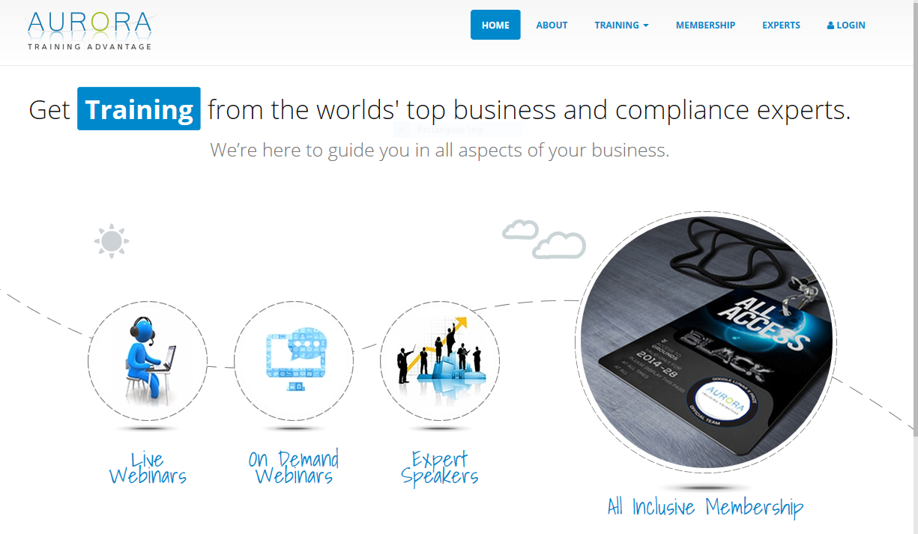

Reviewing training types: Choose the type of training you wish to search for: live webinars or on demand webinars.
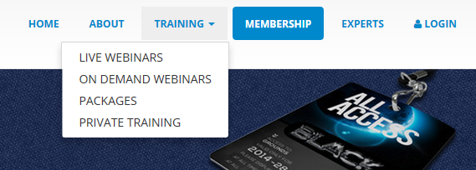

Training Request Form: Once you have determined which course you wish to attend, request attendance using the training request form found here: Aurora Training Request Form

Routing the Training Request Form: The form is automated via Doc-u-sign, when you click on the link it will ask you to provide your information and your supervisors information. Complete the form as instructed, it will then route to your supervisor for review and approval. Once it has been approved by your supervisor, it will route to the DOADPMTraining@wisconsin.gov inbox for review/approval by the training team. Both you and HR will receive a copy of the form that is routed for your records.

Login/Password: When approval is granted, you will be contacted by a member of the training team and will receive the login and password for access to the website. You may participate in On Demand classes by yourself or as a group via Skype. Live webinars will need to be scheduled in advance and there may be a min. participation number required. This will be determined at the agency level. Do not share the login/password. Do not change the login/password.

Attendance/Training Records: Please contact your agency’s training team representative to enter the training record into the learning management system based on your agency’s process and rules. In addition, to receive credit for completing an Aurora training class, you must include class information on your Outlook calendar on the appropriate date (name of the class attended/date/time/and method (Skype in a group) or (individual at your desk

