Background

The Data Request Application serves as a request tool to ensure that data is approved for release by the enterprise business owner before a solution is developed for the requestor. Data requests are categorized by type and are then routed to the appropriate enterprise business owner for approval. After approval, the requests are routed to technical resources to determine next steps. This process will ensure that a standard approval process is followed, so there will be no duplication of effort in terms of requesting data.

This document provides information for users to complete the data request form DOA-1601.

Data Request Process General Workflow

- Requestor enters email into application.
- Requestor receives verification email to continue form.
- Requestor completes request form.
- Form is routed to the respective enterprise business owner (owner) based on data type.
- Owner approves, denies, or forwards the form to leadership or second approver.
- If denied, second approver or leadership provides comments in the form as to why it was denied.
  - Requestor receives automatically generated denied email with comments.
- If approved, copy of the form is automatically sent to STARSupport@wisconsin.gov with a unique form number.
- If a need for a data visualization was indicated on the form, an automatically generated email is sent to groups that may assist in creating the visualization. These groups include the Strategic Management and Planning Team, STAR BI, and Division of Enterprise Technology.

Steps

- Navigate to https://wi.accessgov.com/doa-wi/Forms/Page/doa-wi/data-request-application
- Enter your email address in the email verification field.

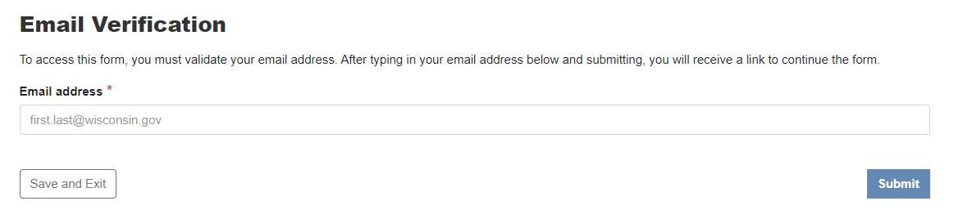
- You will receive an email with a link to continue filling out the data request form. If you did not receive an email, please start the form again. This step is to ensure that users requesting data submit their valid email address.
- When you follow the link in your email, it will take you to the following screen:

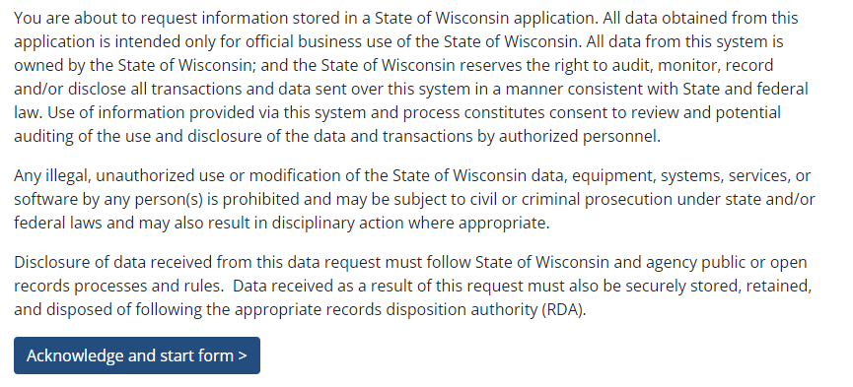

- Read the statement and select ‘Acknowledge and start form’.
- Complete the following form. Fields marked with an * are required.

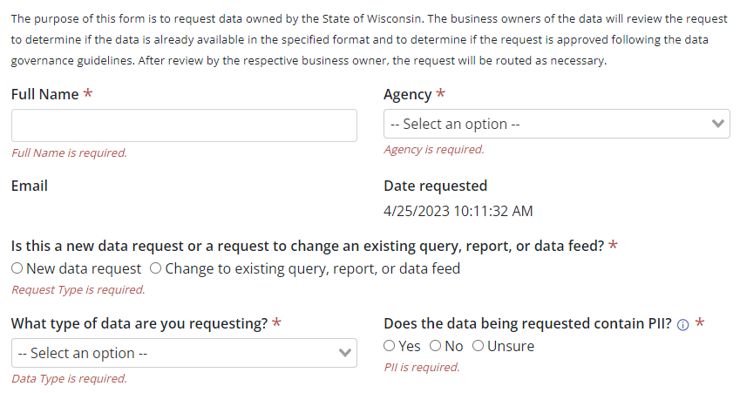
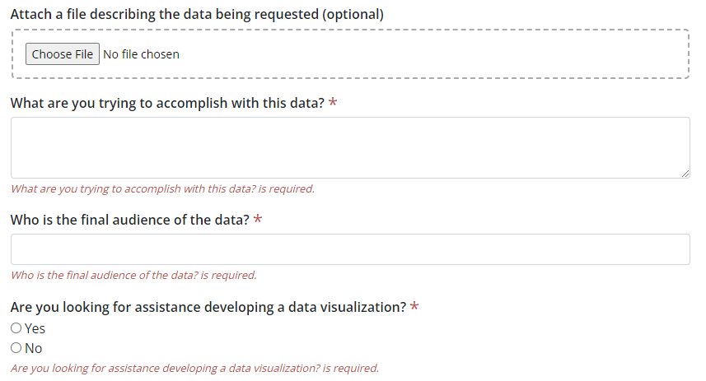

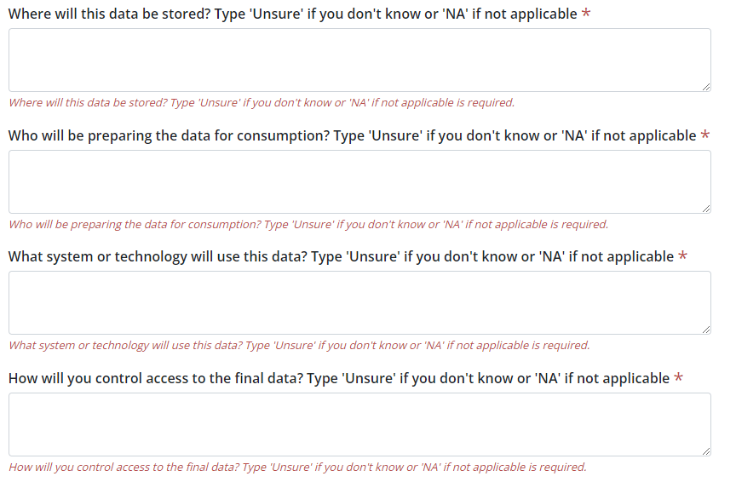
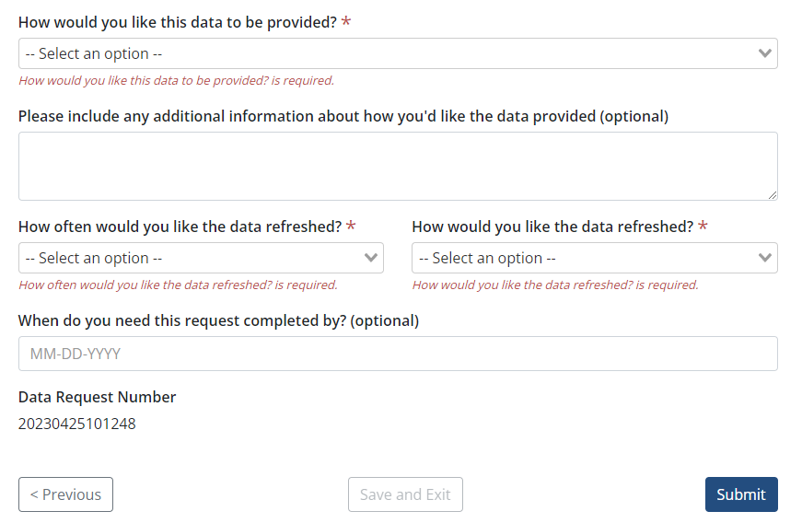

- Click to submit the completed form.
- The form will be routed to the appropriate data owner for review.
- You will receive automated emails regarding the status of the data request, such as confirmation of submission, if it is approved, if it’s denied, or if it’s forwarded for further review.
- Upon approval, the form will be sent to STAR for review. STAR will review and work with appropriate staff to determine which unit is best able to develop a solution.
- A follow-up conversation may be scheduled by STAR, DET, or the Strategic Management and Planning team.

